

TABI: The Agro-Biodiversity Initiative

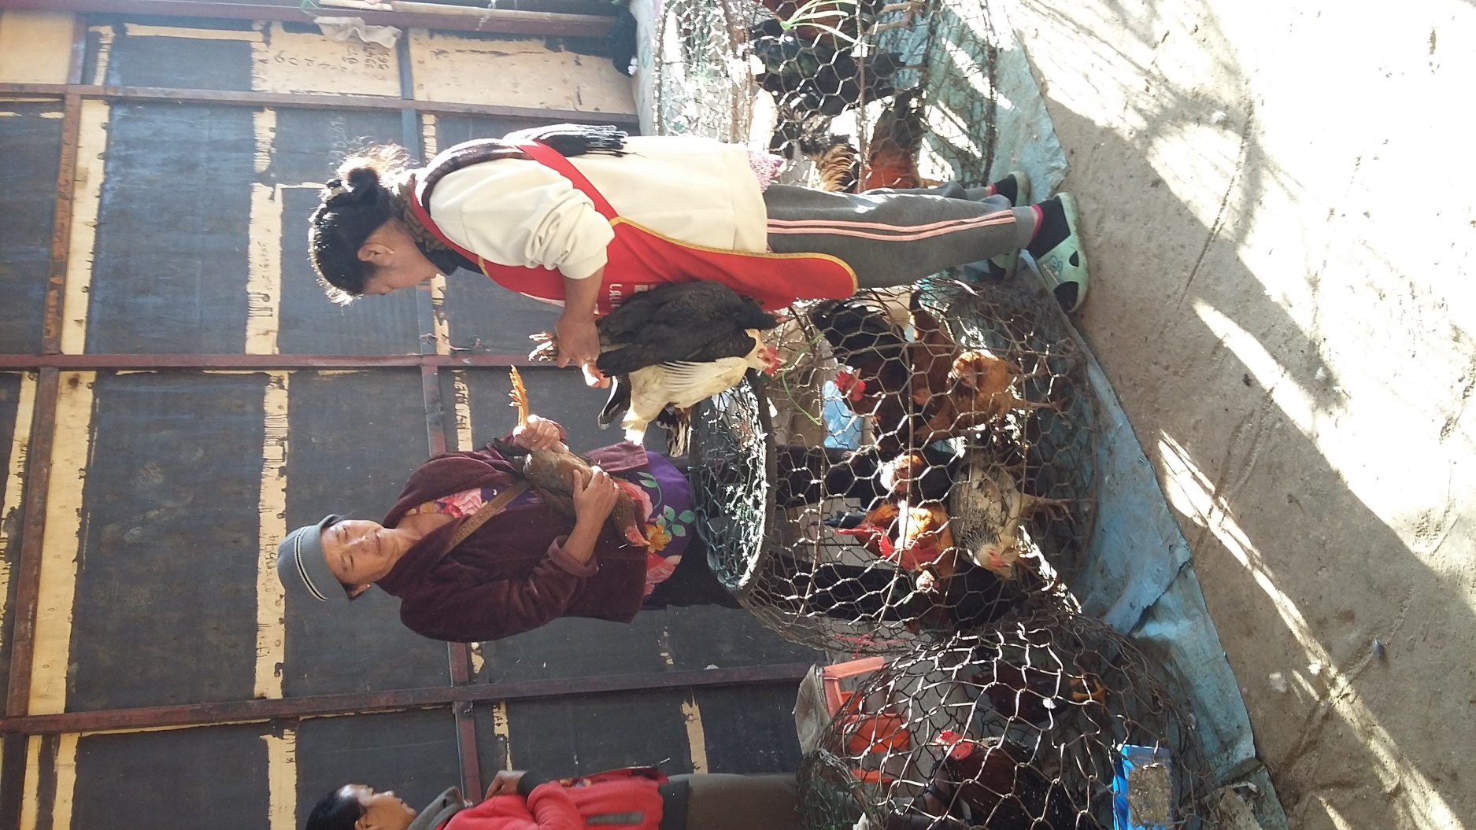

**Chicken Market**

**Value-Chain Analysis**

Xieng Khouang Province

January 2017

**GLOSSARY**

*(All terms relate to the buying and/or selling of chicken birds, chicken meat and/or chicken eggs in XKK Province).*

|  |  |
| --- | --- |
| **Kg** | Kilogram |
| **K** | Kip (Lao currency) |
| **Attached chicken panniers** | Improvised chicken holders made from chicken net and wood or bamboo which are attachable (and detachable) to the sides of motorbikes for the transportation of chickens. |
| **Bamboo chicken cages** | Light, dome-shaped cages (usually 1-1.5m diameter) made from bamboo which are used to keep live chickens in. Some of these cages are designed with a floor for the cage. These can be seen ubiquitously in Lao. |
| **Bamboo chicken holders** | Small enclosed ‘baskets’ made from bamboo which can hold one or several chickens at one time. Designs vary with some having handles or grips for easy carrying and others which can be easily mounted on motorbikes. |
| **Bulk-buyers\*** | Consumers in XKH who purchase chickens in large quantities***.*** |
| **Butchering** | Refers to the slaughtering, plucking, removal of giblets and in some cases the cutting up of chicken parts before selling to consumers. |
| **Buyer-sellers** | Considered to be any group of people who buy or sell any type of chickens where the purchase and/or sale of the chickens takes place within XKH. |
| **Chicken production** | The act of breeding and/or raising any type of chicken which can then be sold for income. |
| **Consumers** | Refers to both ‘end consumers’ and ‘bulk-buyers’ |
| **Demand** | May refer to demand for chickens from consumers or demand from traders/suppliers in order to then sell to consumers. |
| **Distributors\*** | Buyer-sellers in XKH who gain income solely by transporting chickens from a producer to a trader/supplier***.*** |
| **End consumers\*** | The final buyer-sellers in the value chain who purchase meat (either in a raw or processed form) with the intention to consume it or give it away***.*** |
| **Giblets** | The bundle of parts found inside the chicken’s cavity, including gizzards, the heart and the liver. |
| **Hybrids** | A general term for various hybrid chickens (the crossing of two or more pure breeds of chicken). In this report, ‘hybrids’ refers to ‘hybrid meat chickens’, ‘packaged hybrid chicken meat’ and/or ‘hybrid egg-laying hens’. |
| **Markets/**  **Marketplace** | May be 1). A reference to a specific market (i.e. village day market, district market, provincial market or Vietnamese market) or 2). A general reference to point-of-sale locations. (Which version this refers to is specified in the report section). |
| **Natives** | A general term for native chickens. In this report, ‘natives’ refers to ‘regular native chickens’ and/or ‘black-boned native chickens’ (specified in the report section). |
| **Point-of-purchase** | The location where chicken(s) are purchased by a buyer-seller group from a buyer-seller. |
| **Point-of-sale** | The location where chicken(s) are sold by a buyer-seller to another buyer-seller. |
| **Plucking** | The act of removing feathers from slaughtered chickens – either manually or by using a machine. |
| **Producers\*** | A buyer-seller group considered to be a household or farm which breeds and/or raises chickens which they can then sell for income. This may be for small, medium or large-scale production***.*** This includes **small-scale producers** (producers who sell less than 10 birds per week), **medium-scale producers** (who sell between 10 and 500 birds per week) and **large-scale producers** (who sell over 500 birds per week). |
| **Slaughtered chickens** | Chickens which have been killed by a buyer-seller group in order to sell them to consumers at a point-of-sale location. |
| **Source of supply** | Normally the location where the chickens have been produced but can also refer to the previous buyer-seller group in the value chain (i.e. the wholesalers were the source of supply for the market-butcher suppliers). |
| **Suppliers\*** | A general term for buyer-sellers who purchase chickens in XKH with the intention to raise the chickens to a larger size and weight and/or to slaughter, pluck and remove the giblets of chickens before selling to consumers***.*** |
| **Supply** | May refer to the quantity of chickens sold at markets within XKH or the quantity of chickens in producer villages or at producer farms (specified within the report section). |
| **Target households** | Recipients of training in chicken-raising methods provided by organisations to help maintain and increase the supply of their chickens. **‘Target families’** is also used in the same context. |
| **Target villages** | A village which has at least several target households which were recipients of training in chicken-raising methods. |
| **Traders\*** | A general term for buyer-sellers who purchase chickens, chicken meat or eggs in XKH with the intention to sell them onwards for profit in the same form which they purchased them. |
| **Value chain** | The process through which value is added to chickens by different buyer-seller groups before selling them. This includes production, transportation, additional chicken-raising, butchering and packaging. ***All buyer-sellers in the chicken value chain are provided in the ‘XKH Chicken and Egg Buyer-Seller Profile’ section.*** |
| **Wholesalers\*** | A general term for buyer-sellers who purchase chickens directly from producer farms to sell to traders, suppliers and bulk-buyers within XKH. |

***\*A more detailed description is provided in the ‘XKH Chicken and Egg Buyer-Seller Profile’ section.***

**BUYER-SELLER LOCATIONS**

*(All locations relate to the buying and/or selling of chicken birds, chicken meat and/or chicken eggs in XKH Province).*

|  |  |
| --- | --- |
| **XKH** | Xieng Khouang Province |
| **Phonsavan** | The capital of Xieng Khouang Province |
| **Bpek District** | The district within which Phonsavan and the provincial markets are situated |
| **Kham District** | A XKH district 60 km east of Phonsavan |
| **Khoun District** | A XKH district 36 km south- east of Phonsavan |
| **Mok District** | A XKH district 130 km south-east of Phonsavan |
| **Nong Het District** | A XKH district 120 km east of Phonsavan |
| **Phaxay District** | A XKH district 22 km south-west of Phonsavan |
| **Phoukhout District** | A XKH district 25 km west of Phonsavan |
| **VTE** | Vientiane (the capital of Lao) |
| **LP** | Luang Prabang |
| **Bulk-buyer locations** | Restaurants, function halls and party/event locations where bulk quantities of chicken are stored and/or prepared by bulk-buyers |
| **District Markets** | The market within the main district town of each district in XKH |
| **Nam Khan (Lao-Vietnam) Border Crossing** | A border crossing between Lao and Vietnam in Nong Het District |
| **Producer Farms** | Typically medium to large-scale commercial chicken producers in XKH or Vientiane which produce chickens and/or eggs to sell (currently all hybrid chickens) |
| **Producer Households** | Typically small-scale chicken producers who produce native chickens at their house of residence with an aim to sell them for income. Also referred to as ‘producer families’ |
| **Producer Villages** | Villages which collectively have many ‘producer households’ |
| **Provincial Markets** | The biggest market location in XKH, situated in Phonsavan. Often considered Phoukham Market but for purposes of this study, this also includes ‘Sam San’ and ‘Nam Ngam’ Markets in Phonsavan. |
| **Retail Outlets** | Shops or selling points outside of provincial, district or village day markets where hybrid chicken meat and/or hybrid eggs are sold in small quantities. |
| **Trader House** | The house of an in-district trader, cross-district trader or district supplier who keeps, stores and/or sells purchased-chickens from their house of residence to consumers. |
| **Vietnamese Markets** | A general term for markets in Vietnam which sell native chickens originally purchased by Vietnamese traders in XKH. |
| **Village Day Markets** | Small-scale markets held in villages of several districts around XKH which have scheduled days of trading ***(a list of village day markets and days of activity can be found in Appendix 12.5)*** |

**VALUE CHAIN KEY**

*(This value chain key relates to the buying and selling of chicken birds,*

*chicken meat and/or chicken eggs in XKH Province).*

|  |  |
| --- | --- |
|  | **A red box indicates a location** where chickens  are bought or sold (the names of the locations are labeled on the boxes of each value chain model). |
|  | **Different coloured boxes refer to**  **specific buyer-seller groups**  *(please refer to the ‘XKH Chicken and Egg Buyer-Seller Profile’ section to find out which buyer-seller each box represents).* |
|  | **An arrow below or before a box with the same colour** means that the buyer-seller (blue) bought chickens by collecting them from the location of the previous buyer-seller (green). |
|  | **An arrow above or after a box with the same colour** means that the buyer-seller (green) sold chickens by delivering them to the location of the next buyer seller (blue). |
|  | **A solid arrow** (i.e. not dotted) indicates the sale/transaction of chicken(s) from one buyer-seller (or the buyer-seller location) to another buyer-seller. |
|  | **A dotted arrow** indicates a buyer-seller transporting chickens to a point-of-sale location. |

**TABLE OF CONTENTS**

**[Title Page](#titlepage)**

**[Glossary](#glossary)**

**[Buyer-Seller Locations](#buyerselllocations)**

**[Value Chain Key](#vckey)**

**[Table of Contents](#tableofcontents)**

**[1. INTRODUCTION 10](#t1)**

**[1.1 Project Background 10](#t11)**

**[1.2 Objectives of the Report 10](#t12)**

**[1.3 Methodology 11](#t13)**

**[1.4 Limitations 11](#t14)**

**[2. XKH PROVINCE CHICKEN AND EGG PROFILE 12](#t2)**

**[2.1 Regular Natives 12](#t21)**

**[2.2 Black-Boned Natives 13](#t22)**

**[2.3 Hybrid Meat-Chickens 13](#hybridmeatchickens)**

**[2.4 Packaged Hybrid Chicken Meat 14](#t24)**

**[2.5 Hybrid Egg-Laying Hens (for Meat) 14](#t25)**

**[2.6 Hybrid Egg-Laying Hens (for Eggs) 15](#t26)**

**[3. XKH CHICKEN AND EGG BUYER-SELLER PROFILE 16](#t3)**

**[3.1 Regular and Black-Boned Native Chickens 16](#t31)**

[3.1.1 Small-Scale Producers 16](#t311)

[3.1.2 In-District Traders 17](#t312)

[3.1.3 Cross-District Traders 18](#t313)

[3.1.4 Vietnamese Traders 20](#t314)

[3.1.5 Market-Butcher Suppliers 20](#t315)

[3.1.6 Bulk- Buyers 21](#t316)

[3.1.7 End Consumers 22](#t317)

[**3.2 Hybrid Meat-Chickens 23**](#t32)

[3.2.1 Producers 23](#t321)

[3.2.2 XKH Wholesalers 24](#t322)

[3.2.3 Market-Butcher Suppliers 25](#t323)

[3.2.4 District Suppliers 26](#t324)

[3.2.5 District Traders 26](#t325)

[3.2.6 Bulk- Buyers 26](#t326)

[3.2.7 End Consumers 27](#t327)

**[3.3 Packaged Hybrid Chicken Meat 27](#t33)**

[3.3.1 Producers 27](#t331)

[3.3.2 Wholesalers in Vientiane 27](#t332)

[3.3.3 Provincial Market Traders 27](#t333)

[3.3.4 District Traders 28](#t334)

[3.3.5 Bulk- Buyers 28](#t335)

[3.3.6 End Consumers 28](#t336)

[**3.4 Hybrid Egg-Laying Hens (for Meat) 29**](#t34)

[3.4.1 Producers 29](#t341)

[3.4.2 XKH Wholesalers 29](#t342)

[3.4.3 Market-Butcher Suppliers 30](#t343)

[3.4.4 District Traders 30](#t344)

[3.4.5 Bulk- Buyers 30](#t345)

[3.4.6 End Consumers 30](#t346)

[**3.5 Hybrid Chicken Eggs 31**](#t35)

[3.5.1 Producer 31](#t351)

[3.5.2 Distributors 31](#t352)

[3.5.3 Provincial Market Traders 31](#t353)

[3.5.4 District Traders 31](#t354)

[3.5.5 Bulk- Buyers 32](#t355)

[3.5.6 End Consumers 32](#t356)

[**4. NATIVE CHICKENS 33**](#t4)

[**4.1 Xieng Khouang: Provincial Overview** (including Bpek District) **33**](#t41)

[4.1.1 Market Profile 35](#t411)

[4.1.2 Value Chain Analysis 34](#t412)

[4.1.3 Sources of Supply 35](#t413)

[4.1.4 XKH Provincial Market – Native Chicken Supply and Demand 35](#t414)

[4.1.5 XKH Native Chicken Provincial Markets Buyer-Seller Groups: Profile 36](#t415)

[4.1.6 XKH Native Chickens: Consumer Profile 37](#t416)

[4.1.6.1 Consumer Types 38](#t4161)

[4.1.6.2 Overall Consumer Opinion on Native Chickens 38](#t4162)

[4.1.7 XKH Province Native Chickens: SWOT Analysis 39](#t417)

[**4.2 Phoukhout District – Native Chickens 40**](#t42)

[4.2.1 Value Chain Analysis 40](#t421)

[4.2.2 Buyer-Sellers Profile 41](#t422)

[4.2.3 Phoukhout District Case Study](#t423)

*[The Impact and Benefit of TABI Chicken-Raising Method Program, Phoukhout Target Villages 42](#t423)*

[4.2.4 SWOT Analysis 47](#t424)

[**4.3 Phaxay District – Native Chickens 48**](#t43)

[4.3.1 Value Chain Analysis 48](#t431)

[4.3.2 Buyer-Sellers Profile 49](#t432)

[4.3.3 Phaxay District Case Study](#t433)

*[Native Chicken Producer Village: Hai Village](#t433)* [49](#t433)

[4.3.4 SWOT Analysis 50](#t434)

[**4.4 Khoun District – Native Chickens 51**](#t44)

[4.4.1 Value Chain Analysis 51](#t441)

[4.4.2 Buyer-Sellers Profile 52](#t442)

[4.4.3 Khoun District Case Study](#t443)

*[Small Scale Chicken Producers: Methods of Raising Chickens in Ban Toong](#t443)* [53](#t443)

[4.4.4 SWOT Analysis 53](#t444)

[**4.5 Kham District – Native Chickens 54**](#t45)

[4.5.1 Value Chain Analysis 54](#t451)

[4.5.2 Buyer-Sellers Profile 54](#khamdistrcitbuysell)

[4.5.3 Case Study 56](#t453)

[4.5.4 SWOT Analysis 56](#t454)

[**4.6 Nong Het District – Native Chickens 57**](#t46)

[4.6.1 Value Chain Analysis 57](#t461)

[4.6.2 Buyer-Sellers Profile 58](#t462)

[4.6.3. Nong Het District Case Study 59](#t463)

[4.6.4. SWOT Analysis 60](#t464)

[**4.7 Mok District – Native Chickens 61**](#t47)

[4.7.1 Value Chain Analysis 61](#t471)

[4.7.2 Buyer-Sellers Profile 62](#t472)

[4.7.3 Mok District Case Study 63](#t473)

[4.7.4 SWOT Analysis 63](#t474)

[**5. NATIVE BLACK-BONED CHICKENS 64**](#t5)

[**5.1 Xieng Khouang: Provincial Overview** (including Bpek District) **64**](#t51)

[5.1.1 Market Profile 64](#t511)

[5.1.2 Value Chain Analysis 64](#t512)

[5.1.3 Sources of Supply 65](#t513)

[5.1.4 Provincial Market: Supply and Demand 65](#t514)

[5.1.5. Chicken Buyer-Sellers Profile 65](#t515)

[**5.2Nong Het District – Native Black-Boned Chickens 68**](#t52)

[5.2.1 Value Chain Analysis 68](#t521)

[5.2.2. Buyer-Sellers Profile 69](#t522)

[5.2.3. Nong Het District Case Study 70](#t523)

[5.2.4. SWOT Analysis 71](#t524)

[**5.3 Mok District – Native Black-Boned Chickens 72**](#t53)

[5.3.1 Value Chain Analysis 72](#t531)

[5.3.2 Buyer-Sellers Profile 73](#t532)

[5.3.3 Mok District Case Study 73](#t533)

[5.3.4 SWOT Analysis 74](#t534)

[**6. HYBRID MEAT-CHICKENS 75**](#t6)

[**6.1 Xieng Khouang: Provincial Overview** (including Bpek District) **75**](#t61)

[6.1.1. Market Profile 75](#t611)

[6.1.2. Value Chain Analysis 75](#t612)

[6.1.3. Sources of Supply 77](#t613)

[6.1.4. XKH Provincial Market – Hybrid Meat-Chicken Supply and Demand 77](#t614)

[6.1.5. Buyer-Sellers Profile 78](#t615)

[6.1.6. XKH Province Hybrid Meat-Chickens: Consumer Profile 79](#t616)

[**6.1.6.1 Bulk Buyers and Decision-Making 79**](#t6161)

[**6.1.6.2 Small-Scale Buyers and Decision-Making 79**](#t6162)

[**6.2 Phoukhout District: Hybrid Meat-Chickens Trader Profile 80**](#t62)

[**6.3 Phaxay District: Hybrid Meat-Chicken Trader Profile 80**](#t63)

[**6.4 Khoun District: Hybrid Meat-Chicken Trader Profile 81**](#t64)

[**6.5 Nong Het: District Hybrid Meat-Chicken Trader Profile 81**](#t65)

[**6.6 Kham District 82**](#t66)

[6.6.1 Hybrid Meat-Chicken Value Chain Analysis 82](#t661)

[6.6.2 Hybrid Meat-Chicken Buyer-Seller Profile 83](#t662)

[**6.6.2.1 District Suppliers Profile in Kham District 83**](#t6621)

[**6.6.2.2 District Traders Profile in Kham District 83**](#t6622)

[6.6.3 Kham District Case Study](#t663)

*[Hybrid Meat-Chicken Farm Producer in Kham District: Methods of Chicken Raising 83](#t663)*

[**6.7 Mok District: Hybrid Meat-Chicken Trader Profile 84**](#t67)

[**7. PACKAGED HYBRID CHICKEN MEAT 85**](#t7)

[**Xieng Khouang: Provincial Overview** (including Bpek District)85](#t7)

[**7.1 Market Profile 85**](#t71)

[**7.2 Value Chain Analysis 85**](#t72)

[**7.3 Sources of Supply: Provincial Market Traders 87**](#t73)

[**7.4 Summarised District Profile 87**](#t74)

[**7.5 Supply and Demand 87**](#t75)

[**7.6 XKH Province Customer Profile and Decision Making 88**](#t76)

**[8. HYBRID EGG-LAYING CHICKENS (FOR MEAT) 88](#t8)**

**[Xieng Khouang: Provincial Overview](#t8)** [(including Bpek District)](#t8)

[**8.1 Market Profile 88**](#t81)

[**8.2 Value Chain Analysis 89**](#t82)

[8.2.1 Value Chain 1: Hybrid Egg-Laying Hens from CP Lao Farm, Vientiane 89](#t821)

[8.2.2 Value Chain 2: Hybrid Egg-Laying Hens from XKH Chicken Egg Farms 89](#t822)

[**8.3 XKH Province Hybrid Chicken Farm Producer: Hybrid Egg-Laying Hens (for Meat) 91**](#t83)

[**8.4 XKH Consumer Hybrid Egg-Laying Hens (for Meat) Profile 91**](#t84)

**[9. HYBRID CHICKEN EGGS 91](#t9)**

**[Xieng Khouang: Provincial Overview](#t9)** [(including Bpek District)](#t9) **[91](#t9)**

[**9.1 Market Profile 91**](#t91)

[**9.2 Value Chain Analysis 92**](#t92)

[**9.3 Hybrid Chicken Eggs 93**](#t93)

[**9.4 Summarise District Profile** (excluding Bpek District) **94**](#t94)

[**9.5 Hybrid Eggs Consumer Profile 94**](#t95)

[**10. OVERALL CHICKEN MARKET FINDINGS AND ANALYSIS 94**](#t10)

[**10.1 Market Supply and Demand Share 94**](#t101)

[10.1.1 XKH Province Chicken Type Market Share 94](#t1011)

[10.1.2 Sources of Regular Native Chickens for Market Supply by XKH Districts 96](#t1012)

[10.1.3 XKH Province Consumer Points-of-Sale for Regular Native Chickens 97](#t1013)

[**10.2 Market Supply, Demand and Obstacles 98**](#t102)

[**10.3 Consumer Opinions and Decision-Making 98**](#t103)

[**10.4 Overall Obstacles to Increasing Native Chicken Supplier Income 99**](#t104)

[10.4.1 Low Supply of Purchasable Native Chickens in XKH Villages 99](#t1041)

[**10.4.1.1 Chicken Death** 99](#t10411)

[**10.4.1.2 No Necessity/Pressure to Sell** 99](#t10412)

[**10.4.1.3 Lack of a Systematic Approach** 100](#t10413)

[10.4.2 The Buying and Selling Price of Native Chickens 100](#t1042)

[**10.4.2.1 Trader Profit and Expenses** 100](#t10421)

[**10.4.2.2 Lack of Supply** 100](#t10422)

[**10.4.2.3 Inflation from Vietnamese Demand** 100](#t10423)

**[11. RECOMMENDATIONS 101](#r11)**

**[11.1 Regular Native Chickens 101](#r111)**

[11.1.1 Increasing the Supply of Native Chickens for Markets 101](#r111)

**[11.1.1.1 Reducing the Risk of Chicken Disease Contraction 101](#r11111)**

**[11.1.1.2 Raising Producer Awareness of the Potential Income Benefit of Selling Chickens 102](#r11112)**

**[11.1.1.3 Implementing a More Systematic VC Approach to Buying and Selling Chickens](#r11113)** [103](#r11113)

[11.1.2 Using Marketing Approaches to Understand and Increase Consumer Demand 104](#r1112)

**[11.1.2.1 Branding and Promotion 104](#r11121)**

**[11.1.2.2 Market Research 105](#r11122)**

**[11.1.2.3 Product Development and Diversification 105](#r11123)**

[11.1.3 Stages of Native Chicken Market Development 105](#r1113)

**[11.2 Native Black-Boned Chickens 107](#r112)**

[11.2.1 Vietnamese Market 107](#r1121)

**[11.2.1.1 Consolidating Supply of Black-Boned Chickens in Well-Established Producer Villages 107](#r11211)**

**[11.2.1.2 Further Research to Understand Current and Potential Consumer Demand in Vietnam 107](#r11212)**

[11.2.2 Local Market Potential 108](#r1122)

**[11.3 Native Chicken Eggs 108](#r113)**

[11.3.1 Native Egg Producers Sell Directly to Restaurants 108](#r1131)

[11.3.2 Native Chicken Cross-District Traders also Purchase Native Eggs 108](#r1132)

[11.3.3 Native Chicken Meat and Egg Producer Farm 108](#r1133)

**[12. APPENDIX 109](#a12)**

[**Appendix 12.1 Provincial Market Data Collection** (Phoukham, Sam San and Nam Ngam Markets) **109**](#t121)

[12.1.1 Live Native Chickens Sold at the Phoukham Market 109](#t1211)

[12.1.2 Live Native Chickens Sold at the Nam Ngam Market 109](#t1212)

[12.1.3 Slaughtered Chickens Sold at the Phoukham Market 110](#t1213)

[12.1.4 Slaughtered Chickens Sold at the Sam San Market 110](#t1214)

[12.1.5 Slaughtered Chickens Sold at the Nam Ngam Market 111](#t1215)

[**Appendix 12.2 Chicken Sellers Template** (Compacted) **112**](#t122)

[**Appendix 12.3 Egg Sellers Template** (Compacted) **113**](#t123)

[**Appendix 12.4 Native Chicken Counting Template (Phoukham Market) 114**](#t124)

**[Appendix 12.5 List of Xieng Khouang Markets by District 115](#listofmarkets)**

***1. INTRODUCTION***

This report covers a survey of market supply and demand for chicken meat and eggs in Xieng Khouang Province (XKH), Lao PDR. This includes a value-chain analysis of the five different varieties of native and hybrid chicken meat sold in the province, with analysis of both individual districts and Xieng Khouang Province as a whold. Findings of the report show that native chickens supply an estimated one-quarter of the Xieng Khouang chicken market share, with the other three-quarters made up of hybrid varieties. The provincial markets in Phonsavan account for about 60 percent of native chicken sales, with Vietnamese markets and XKH’s district markets/other accounting for an additional 20% of sales each.

Recommendations of the report are to increase the production of native chickens for the supply of markets by reducing the risk of chicken diseases, raising chicken-producer awareness of the potential income benefit from increasing their production of native chickens and implementing a more systematic value-chain approach to the producing, buying and selling of native chickens. Additionally, marketing approaches could be used to better understand consumer demand through market research for native chickens and attempt to increase consumer demand for native chickens by developing branding and promotion, as well as product development and diversification.

1.1. Project Background

Previous TABI projects in Xieng Khouang Province have included a program for native chicken-producing households to be trained in chicken-raising methods to improve and increase the productivity of chickens - including flock management, disease treatment and prevention and the provision of a high-protein diet for chickens. This report, in part, assesses the benefit of this program at improving and increasing chicken productivity in target villages where households received training and what role these target villages play in providing chicken supply for market demand. Based on this, along with an analysis of chicken supply and demand in XKH – including the obstacles to the supply of native chickens, the findings and recommendations of this report could be used to help support native chicken producers in XKH to maximize their ability to and benefit from selling the chickens which they produce.

1.2. Objectives of the Report

The four main objectives of the report are:

* To gain a comprehensive understanding and, as/where possible, quantitative data on the XKH market supply and demand for chicken meat and eggs, and the associated value chain, of both native and hybrid chickens.
* To make an assessment of the role of native chicken meat produced by TABI target villages in the supply of chickens and chicken meat.
* To identify any common obstacles for producers, traders and suppliers regarding the market supply of chicken meat and eggs.
* To make an assessment of current consumer decision-making and future market potential for native chickens, chicken meat and eggs, in XKH.

1.3. Methodology

**Primary Data Collection**

* Observation\* by counting and categorizing quantities of chickens, chicken meat and eggs in XKH markets to assess market supply and sales.
* A survey and standardized questions were used to assess current market supply and demand – and how the value chain operates (quantitative data with some qualitative data).
* Interviewing chicken producers and traders to obtain in depth information regarding chicken meat/eggs supply and demand, and value chain.
* Interview with chicken meat/eggs consumers to understand consumer attitudes and purchasing decisions.

*\*The sample time period chosen for counting and categorizing at the provincial markets in Phonsavan was 14 days in November, divided into two periods – an initial 7-day period (where chicken supply and sales were deemed to be similar to a year average 7-day period). The second 7-day period was the lead up to the Hmong New Year – one of the busiest periods of the calendar year for the supply and demand of native chickens.*

**Secondary Data Collection**

* Native chicken program reports, examples of Lao value-chains, Lao chicken raising information.

1.4. Limitations

One to one-and-a-half days were allocated for travel to markets and producer villages in each district outside of Bpek District. Therefore, district data collection required asking market producers and traders information regarding average chicken market supplies and sales – rather than being able to count quantities over a number of days ourselves. Also, in general, prices and profit margins also relied on producers and traders giving accurate information.

Additionally, while every effort was made to ensure all significant chicken producers in the province were recorded, it is possible that – where local people in districts were unaware of small to medium-sized suppliers (chicken or eggs) – some producers could have been missed.

**2. XKH PROVINCE CHICKEN AND EGG PROFILE**

**There are five main types of chicken and chicken meat sold within XKH province. These include regular native chickens, black-boned native chickens, hybrid meat-chickens, packaged hybrid chicken meat and hybrid egg-laying hens. Hybrid chicken eggs are also a product of the hybrid egg-laying hens. Wild chickens are occasionally sold at markets but this study looks specifically at domestic varieties.**

|  |  |
| --- | --- |
| **2.1 Regular Natives**  **C:\Users\Mark\Desktop\Chicken Assessment\Photo ( Chicken'market )\Bpek District\Phou Kam Market\20161127_172252.jpg** **C:\Users\Mark\Desktop\Chicken Assessment\Phoukhout\20161207_094957.jpg** | |
| **Lao Term** | ‘Gai Lat’ |
| **Sources of Supply** | Native chicken small-scale producers |
| **Features** | * Typically with black, brown or red plumage. * Egg production: 55-78 eggs per hen annually (5 periods of 11-14 eggs). Hens begin laying eggs at 30 weeks, when 1.2 kg body weight. * Chickens chosen for breeding are the largest, brightest coloured feathers with strong – preferably yellow legs. |
| **Raising Methods** | Almost exclusively free range in producer villages, often without any organised raising methods. Some producer villages/ households – especially with external support – have adopted raising techniques such as building chicken coops, flock management, preventing and treating disease through vaccinations and antibiotics, and occasionally providing chickens with a high-protein diet. |
| **Chicken Feed** | * Rice grain/bran/hull and broken rice * corn, cassava, other vegetables and * Purchased chicken feed. |

|  |  |
| --- | --- |
| **2.2 Black-Boned Natives** | |
| **Lao Term** | ‘Gai Dam’ |
| **Sources of supply** | Native chicken small-scale producers (some producer families/ villages raise black-boned natives along with regular natives whereas others raise black-boned natives specifically). |
| **Features** | * Typically with black plumage, black skin and black meat. Bones may also be black. * Average egg production per hen annually is over 70 eggs. * Mature roosters weigh over 2kg and mature hens weigh up to 1.5kg. |
| **Raising Methods** | Same as ‘1. Regular Natives’ *(see above)* |
| **Chicken Feed** | Same as ‘1. Regular Natives’ *(see above)* |

|  |  |
| --- | --- |
| **2.3 Hybrid Meat-Chickens**  **C:\Users\Mark\Desktop\Chicken Assessment\Photo ( Chicken'market )\Bpek District\phone' chicken\DSC01769.JPG** | |
| **Lao Term** | ‘Gai Samsaipan’; ‘Gai Samsaileuat’ |
| **Sources of Supply** | * 45-60 day-old chickens produced at CP Lao Farm (large-scale producer), Vientiane and Hybrid Meat Chicken Farm in Kham District (medium-scale producer). * Kham District Farm also produces and sells 1-2 week old chicks. |
| **Features** | * Bred and raised specifically for meat and have a high ratio of meat to body weight. * Usually brown or black plumage and yellow skin. * Live hybrid meat-chickens can look similar in appearance to natives but the hybrids look physically immature as they reach over 1kg in about 6 weeks. * Other distinctive features are their black legs and a weaker leg structure. Hybrid meat-chickens do not brood their eggs. |
| **Raising Methods** | Typically semi-intensive-raising conditions in industrial farm sheds and some other intensive-raising farms with cage systems. The hybrids which are used to breed other hybrid meat-chickens are artificially inseminated. Hybrid-meat chickens are intensively fed for 30-45 days to reach over 1kg in weight (at which point they are sold). Egg incubator machines are used to hatch chicks. Some farms sell chicks at 1-2 weeks old. |
| **Chicken Feed** | * Bigger farms produce their own chicken feed * Local producers and suppliers typically use purchased chicken feed, corn and rice grain/bran/hull. |

|  |  |
| --- | --- |
| **2.4 Packaged Hybrid Chicken Meat** | |
| **Lao Term** | ‘Gai CP’ |
| **Sources of Supply** | * CP Producer Farm in Thailand (large-scale producer) * Wholesalers in Vientiane first source location in Lao |
| **Raising Methods** | Thought to be raised in semi-intensive conditions in industrial farm sheds with intensive feeding until slaughter and packaging age – at between 30 and 45 days (similar to the hybrid meat-chickens). Artificial insemination and egg incubators are also assumed to be used for producing chickens. |
| **Chicken Feed** | Processed feed (also made on the Chicken CP farms in Thailand) |
| **Market Forms** | * Packaged bags of 1kg or 2kg. * The packaged bags are made up of separate chicken cuts including breast, thigh, leg, wings and feet. |

|  |  |
| --- | --- |
| **2.5 Hybrid Egg-Laying Hens (for Meat)** | |
| **Lao Term** | ‘Gai Pan’ |
| **Sources of Supply** | * Hybrid egg-laying-hen breeding farms in Vientiane, Thailand and China. (Egg-producing farms in XKH then purchase the hens at between 1 and 2 months age and transport their farms in XKH to keep the hens for egg production). * CP Lao Farm, Vientiane |
| **Features** | * Bred and raised specifically to lay eggs for consumption. * Brown or white plumage with red comb * Weak leg structure. * 80% daily laying rate - therefore >300 eggs per chicken per year. * After about 18 months, hens start laying much fewer eggs. |
| **Raising Methods** | Hybrid egg-laying hens are purchased by producers at 1-2 months. These hens are then kept in a battery cage setup (typically 4-6 hens per cage), low level lighting, debeaking (occasionally), various disease preventative measures including vaccinations. Once these hybrid egg-laying hens start laying much fewer eggs (at about 18 months old, they are sold for meat and replaced with new hybrid egg-laying hens. |
| **Chicken Feed** | * Industrial processed feed (at breeding farms) * Corn, rice types, grain granules etc. (at egg-laying farms in XKH) |

|  |  |
| --- | --- |
| **2.6 Hybrid Egg-Laying Hens (for Eggs)** | |
| **Lao Term** | ‘Khai Gai Pan’ |
| **Features/**  **Sources of Supply/ Raising Methods/**  **Chicken Feed** | The same as ‘5. Hybrid Egg-Laying Hens (for meat)’ *(see above).* |

**3. XKH CHICKEN AND EGG BUYER-SELLER PROFILE**

**3.1 Regular and Black-Boned Native Chickens**

|  |  |
| --- | --- |
| **3.1.1 Small-Scale Producers**  C:\Users\Mark\Desktop\Trader Photos\Native\20170104_154707.jpg C:\Users\Mark\Desktop\Trader Photos\Native\20161118_071357.jpg  **Native chicken producer bringing and selling their own chickens at a village day**  **market in Phoukhout District.**  **Native chicken producer in Samje village feeding his chickens.** | |
| **Value Chain Colour** | **Green** |
| **Description/ Activity** | ‘Small-scale producers’ are exclusively households in XKH’s seven districts who breed and raise native chickens to sell for income – or those who want to sell chickens but may not currently have the ability to sell due to a specific obstacle. The vast majority of these small-scale producers do not use organized methods for raising or breeding chickens, although some households and villages in several districts have been the recipients of chicken-raising methods – such as TABI’s native chicken training program. These producers will raise their chickens to sell to in-district traders, cross-district traders and Vietnamese traders (in Nong Het and Mok Districts) as well as many of these producers also selling their chickens to end consumers within their village or at other points-of-sale, such as village day markets. Many producers will also consume some of the chickens which they have raised. Producers stated that they sold only live chickens to buyers and never slaughtered them beforehand. |
| **Points-of-Sale** | 1. At the producer’s house/within the producer’s village  2. Village day markets  3. District markets (occasionally)  4. Provincial markets (only on big occasions – i.e. Hmong New Year) |
| **Transportation** | * When small-scale producers sell native chickens at village day markets, they will usually transport chickens on motorbikes in bamboo chicken holders or cages when they are selling small quantities of chickens (i.e. less than five). * For larger quantities of chickens which they will sell at the village days markets, some have attachable panniers for their motorbike to hold chickens (typically holding up to 50 birds) and others may use a vehicle, such as a Hyundai Porter where chickens are transported in the rear of the vehicle and held within bamboo chicken cages. |
| **Associated Terms** | * The terms **‘producer household’** and **‘producer family’** are used in the report and are synonymous with the term ‘small-scale producers’. * **‘Producer village’** is also frequently used to refer to a village which has a collection of ‘small-scale producers’ which sell native chickens. * As there were no identified medium to large-scale native chicken farm producers in XKH, this buyer-seller group may also be referred to a simply **‘producer’** or **‘native chicken producer’** within the context of regular and black-boned chickens. |

|  |  |
| --- | --- |
| **3.1.2 In-District Traders**    **In-district trader in Phoukhout District who buys native chickens from producers to sell to cross-district traders from her house.**  **In-district trader selling chickens (in a bamboo holder) purchased from producer villages and sold to end consumers within his district.** | |
| **Value Chain Colour** | **Dark Blue** |
| **Description/ Activity** | In-district traders are Lao buyer-sellers who purchase live native chickens from small-scale producers in their own district which they then sell within the same district to cross-district traders and end consumers. These traders may travel to buy chickens within producer villages or have producer households deliver chickens to them. In-district traders were identified in Phoukhout District (where they typically sell the chickens to cross-district traders from the in-district trader’s house – often in a location which is convenient for cross-district traders to access) and Kham and Khoun Districts (where they sell chickens at the district market and occasionally at village day markets). All identified buyer-sellers of live native chickens at the provincial market (which is in Bpek District) who bought chickens from Bpek District small-scale producers also bought from other districts as well – and due to this these buyer-sellers are considered cross-district traders and not in-district traders. |
| **Sources of Supply** | 1. Small-scale producer households/villages  2. In-district trader’s house |
| **Points-of-Sale** | 1. In-district trader’s house  2. District Market  3. Village Day Market (occasionally) |
| **Transportation** | * Many small-scale producers will deliver and sell their chickens to the house of the in-district trader (either with or without prior arrangement) who will buy the chickens from the producer. * When in-district traders transport chickens between producer villages and their points-of-sale, they usually use motorbikes, either carrying bamboo chicken holders for individual birds or with attached panniers to carry chickens (as the small-scale producers and cross-district traders also use). * Occasionally pickup trucks such as Hyundai Porters for larger chicken quantities (i.e. during special occasions). |

|  |  |
| --- | --- |
| **3.1.3 Cross-District Traders**    **A Lao cross-district trader transporting purchased native chickens from Kham District to the Nam Khan border crossing in Nong Het to sell the chickens to Vietnamese traders.**  **Cross-district traders at the Nong Het District Market who purchased native chickens in other districts of XKH and sell the chickens to consumers from bamboo cages.**  **Cross-district traders at Phoukham Market during the Hmong New Year selling native chickens bought mainly from producer villages in Phoukhout.**  C:\Users\Mark\Desktop\Chicken Assessment\Photo ( Chicken'market )\Bpek District\Phou Kam Market\20161125_071505.jpg  **Some cross-district traders purchase native chickens in bulk and transport them by pickup truck to sell at the provincial markets – particularly during special occasions (i.e. Hmong New Year).**  **The motorbike panniers which hold the native chickens are dismountable so the chickens can be easily transferred to bamboo chicken cages when sold at market locations.**  **Motorbikes with attached panniers on the side to hold chickens can typically carry a maximum of 50 birds. Some traders also add a bamboo chicken cage on the back of the bike which can allow them to increase the quantity that they can carry at any one time.** | |
| **Value Chain Colour** | **Blue** |
| **Description/ Activity** | Cross-district traders are a Lao buyer-seller group which buys live native chickens from one district in XKH to then transport and sell them in another district. Cross-district traders include those who may sometimes buy chickens from the district within which they are selling the chickens but at least sometimes buy from other districts as well. Typically, cross-district traders will buy chickens directly from small-scale producers and in-district traders and normally then sell their chickens at the XKH Provincial Markets, the Nam Khan Lao-Vietnam Border Crossing (both regular and black-boned natives) or at some district markets. If cross-district traders are transporting chickens by motorbike, they will normally ensure they can buy a minimum of 30 birds before transporting them to the point-of-sale. |
| **Sources of Supply** | 1. Small-scale producers in district villages or at village day markets  2. In-district traders at their houses or at district markets |
| **Points-of-Sale** | 1. XKH Provincial Markets  2. Nam Khan Border Crossing  3. District Markets (in Nong Het District and Mok District) |
| **Transportation** | * The vast majority of identified cross-district traders transport purchased-chickens to their point-of-sale using motorbikes which have attached panniers on each side of the bike, typically holding up to 50 birds each trip, although occasionally some traders have adapted bamboo chicken cages so they can also be mounted behind the motorbike-rider, which can increase the total quantity of birds transported. * When some cross-district traders buy in bulk (such as over one-hundred birds), they will normally transport the chickens to the point-of-sale using a pickup truck such as a Hyundai Porter. |

|  |  |
| --- | --- |
| **3.1.4 Vietnamese Traders** | |
| **Value Chain Colour** | **Gold** |
| **Description/ Activity** | Vietnamese traders cross the border into Lao to purchase live native chickens (both regular and black-boned breeds) in Nong Het and Mok Districts. Many Vietnamese traders will buy directly from small-scale producers in these districts whereas others will buy from Lao cross-district traders at the Nam Khan Lao-Vietnam Border Crossing. The Vietnamese traders are understood to then sell the live chickens to end consumers at markets within 20km of the Border (on the Vietnamese side). Many of these traders are ethnic Vietnamese and also Vietnamese Hmong (who can speak the same language as the Lao Hmong native chicken producers who they buy chickens from). |
| **Sources of Supply** | 1. Small-scale producers in Nong Het District and Mok District  2. Lao cross-district traders at the Nam Khan Border Crossing |
| **Points-of-Sale** | 1. Vietnamese Markets |
| **Transportation** | * Similar to most Lao traders in XKH, Vietnamese traders buy chickens to hold them in the panniers attached to their motorbikes and can store up to about 50 birds each trip. * Lao chicken producers also said Vietnamese traders occasionally bring Hyundai Porters from Vietnam to the Lao producer village and purchase the maximum quantity which the vehicle can take (approximately 300 birds). |

|  |  |
| --- | --- |
| **3.1.5 Market-Butcher Suppliers**    **The sole market-butcher supplier of native chickens at Phoukham Provincial Market (red apron) buying live chickens from a cross-district trader (at the same market) to then slaughter and sell them on site to consumers.**  **Native chickens and ducks at the Kham District Market. The market-butcher supplier buys live chickens both at the market and from producer villages and slaughters, plucks, removes giblets and occasionally cuts up the chickens to sell to consumers.** | |
| **Value Chain Colour** | Light Brown |
| **Description/ Activity** | Market-butcher suppliers are buyer-sellers who purchase native chickens from either small-scale producer villages or from the provincial or district market in which they also slaughter and sell the chickens. They buy live native chickens and then slaughter, pluck and remove the giblets of the bird at the market location as it is both easier to slaughter there and means the chickens are sold as fresh as possible. The giblets of the chicken are also sold. Market-butcher suppliers for native chickens were identified at the Phoukham Provincial Market (who purchases live chickens from cross-district traders also selling at the provincial market) and at Kham District Market (who buys live chickens and ducks from small-scale producer villages and from in-district traders selling live birds at the district market). They sell mainly to end consumers, but occasionally they may sell to bulk buyers for special occasions. Market-butcher suppliers also have cool-storage units (i.e. fridges and freezers) at their houses to keep the slaughtered chickens for the next market day if they do not sell their full quantity on a given day. |
| **Sources of Supply** | 1. Cross-district traders at Phoukham Provincial Market  2. Small-scale producers in district villages  3. In-district traders at district markets |
| **Points-of-Sale** | 1. Phoukham and Nam Ngam Provincial Markets  2. Kham District Market |
| **Transportation** | * The identified market-butcher suppliers use motorbikes with attached panniers when transporting live chickens to their point-of-sale. * If slaughtered chickens have not all been sold by the end of the market day, the chickens are put into plastic bags to be transported and stored at the market-butcher supplier’s house until the next market day. |

|  |  |
| --- | --- |
| **3.1.6 Bulk- Buyers**    **Bulk-buyers purchasing live native chickens from cross-district traders at the Phoukham Provincial Market. The live chickens are put into bags so they can be weighed effectively when buying per kilogram.** | |
| **Value Chain Colour** | **Brown** |
| **Description/ Activity** | Bulk buyers purchase live and/or slaughtered native chickens in quantities of more than 5 birds each time or more than 10 birds during special occasions (such as the Hmong New Year). Bulk buyers have the intention to make food with the chickens for commercial purposes and buyers will typically be personnel from businesses such as restaurants and event organisers. Bulk buyers typically buy chickens from village day markets, district markets and provincial markets – and occasionally will buy directly within chicken producer villages. Some chicken sellers may deliver large quantities of chickens directly to the bulk-buyer. |
| **Points-of-Purchase** | 1. Village day markets  2. District markets  3. Provincials markets  4. Small-scale producer villages (occasionally)  5. Bulk buyer house/business |

|  |  |
| --- | --- |
| **3.1.7 End Consumers**  C:\Users\Mark\Desktop\Trader Photos\IMG_0201.JPG  **An end consumer selecting a native chicken to purchase at the Phoukham Provincial Market.**  **A Vietnamese end consumer purchasing a native chicken from a cross-district trader at Phaxay District Market before the trader transports the chickens to sell at the provincial markets.** | |
| **Value Chain Colour** | **Grey** |
| **Description/ Activity** | End consumers are buyers of live and/or slaughtered native chickens who aim to consume the chickens themselves and not to use the chickens for commercial purposes (i.e. not sell the chickens onwards). End consumers are generally considered to be buyers who buy less than 5 birds on normal days and 10 birds during special times (such as the Hmong New Year). End consumers buy chickens at the same points-of-purchase as bulk-buyers. |
| **Points-of-Purchase** | 1. Village day markets  2. District markets  3. Provincials markets  4. Small-scale producer villages (occasionally) |
| **Associated Terms** | The term **‘small-scale buyer’** is used synonymously with **‘end consumer’**. |

**3.2 Hybrid Meat-Chickens**

|  |  |
| --- | --- |
| **3.2.1 Producers**      **Hybrid meat-chicken hens (at the producer farm in Kham District) are kept in metal cages and lay fertilized eggs (top left and right). The eggs are collected and kept in an egg incubator *(bottom left*) for about 21 days. After hatching, chicks are kept in a pen *(bottom right)* before being sold.** | |
| **Value Chain Colour** | **Green** |
| **Description/ Activity** | There are two hybrid meat-chicken ‘producers’ which supply XKH markets:  1. The large-scale CP Lao Farm at ‘Lak 15’ in Vientiane where live hybrid meat chickens which are purchased by wholesalers from XKH at about one month old and:  2. The medium-scale producer in Piew village, Kham District, XKH Province which sells 1-2 week-old hybrid chicks to district suppliers and 50-day old hybrid meat-chickens to bulk buyers and end consumers. |
| **Points-of-Sale** | 1. CP Lao Farm, Lak 15, Vientiane.  2. Hybrid Meat-Chicken Farm, Piew Village, Kham District, XKH. |
| **Transportation** | In most cases, buyers (i.e. wholesalers and suppliers) will travel to the respective producer farms to buy chickens from there. |
| **Associated Terms** | * The farm producer in Kham District is also referred to as **‘Kham District Hybrid Meat-Chicken Producer Farm ’**. * **‘Hybrid Meat-Chicken producer’** may refer both or either of these producers (specified within the respective report section). |

|  |  |
| --- | --- |
| **3.2.2 XKH Wholesalers**    C:\Users\Mark\Desktop\Chicken Assessment\Photo ( Chicken'market )\Bpek District\phone' chicken\DSC01761.JPG  **Once XKH wholesalers bring hybrid meat-chickens from Vientiane, they will keep them at their house (top; bottom left) and sell to market-butcher suppliers, district traders and suppliers, and bulk buyers. Chickens can be purchased by consumers slaughtered, plucked and with giblets removed - the plucking machine *(above top right)* can automatically pluck a large quantity of chickens’ feathers in a short time.** | |
| **Value Chain Colour** | **Light Brown** |
| **Description/ Activity** | XKH wholesalers are several hybrid meat-chicken buyer-sellers from XKH Province who travel to and buy live hybrids (typically 500-1000 birds per wholesaler per trip) from the CP Lao Farm Producer in Vientiane (they usually buy hybrid egg-laying chickens to sell as meat in XKH on the same journey). These are then transported and kept at their houses in Phonsavan, XKH Province and then sold live to market-butcher suppliers, district suppliers and district traders (both bought by buyers at the wholesaler’s house and also delivered to the buyer’s location). Occasionally, the wholesalers may sell directly to bulk buyers or end consumers and can also slaughter, pluck and remove giblets of the hybrid meat-chickens for a fee if requested. |
| **Sources of Supply** | 1. CP Lao Farm, Lak 15, Vientiane |
| **Points-of-Sale** | 1. Wholesaler’s house, Phonsavan, XKH.  2. Wholesalers deliver to suppliers’ and traders’ houses or other agreed location. |
| **Transportation** | * Wholesalers transport hybrid-meat chickens to XKH in Hyundai Porters and larger Daehan pickup trucks. These vehicles were designed with an extra floor level halfway up the vehicle railings in the rear section so that chickens could be transported on two levels (and therefore they could double the quantity of birds they bought and transported to XKH. * Wholesalers typically travelled to and from purchasing chickens on the Route 10 road section. |

|  |  |
| --- | --- |
| **3.2.3 Market-Butcher Suppliers**  **C:\Users\Mark\Desktop\Trader Photos\20161113_080101.jpg**  **Market-Butcher Suppliers purchase hybrid-meat chickens from XKH wholesalers and typically slaughter, pluck and remove the giblets of chickens at the provincial markets from which they sell them.**  **The giblets of hybrid meat-chickens are sold separately from the whole chickens.** | |
| **Value Chain Colour** | **Maroon** |
| **Description/ Activity** | All identified market-butcher suppliers purchase live hybrid meat-chickens from the XHH wholesalers to sell at provincial markets (Phoukham, Sam San and Nam Ngam Markets). Market-butcher suppliers usually purchased chickens from the wholesaler’s house but sometimes the chickens are delivered to the supplier’s house by the wholesalers. The hybrid-meat chickens are then slaughtered, plucked and giblets are removed at the provincial markets by the market-butcher suppliers on the morning in which they will sell the chickens (with the giblets sold separately). Any slaughtered chickens which are not sold at the market that day will be stored at the supplier’s house and returned to the market to sell the next day. Buyers of hybrid meat-chickens from market-butcher suppliers are bulk-buyers (who the suppliers will occasionally deliver to) and end consumers. Some of these market-butcher suppliers will also sell some slaughtered hybrid egg-laying hens (as meat) along with their slaughtered hybrid meat-chickens. |
| **Sources of Supply** | 1. XKH wholesaler’s house  2. Market-butcher supplier’s house |
| **Points-of-Sale** | 1. XKH Provincial Markets  2. Bulk-buyer locations (within Phonsavan) |
| **Transportation** | * Market-butcher suppliers use motorbikes with attached panniers which can carry live chickens. * Any slaughtered chickens taken back from the market at the end of the day are put in plastic bags to carry to their house by motorbike. |

|  |  |
| --- | --- |
| **3.2.4 District Suppliers** | |
| **Value Chain Colour** | **Orange** |
| **Description/ Activity** | District suppliers purchase live hybrid meat-chickens from either the XKH wholesalers or at the Kham District Hybrid Meat-Chicken Producer Farm with the aim to raise the hybrids to a larger weight and size before selling them onwards to bulk-buyers or end consumers within the districts of residence. Typically they are sold live but most suppliers will slaughter the hybrid meat-chickens for a fee if requested. |
| **Sources of Supply** | 1. XKH wholesalers (bought at about 45 days old)  2. Kham District Hybrid Meat-Chicken Producer Farm (at between 7 and 14 days old) |
| **Points-of-Sale** | 1. District markets (only in Kham District)  2. District supplier’s house  3. Bulk-buyer locations |
| **Transportation** | * District suppliers use attachable panniers on the sides of their motorbikes or occasionally pickup trucks (i.e. Hyundai Porters) for larger quantities. * Slaughtered chickens which are to be transported to bulk-buyer locations are kept in plastic bags. |

|  |  |
| --- | --- |
| **3.2.5 District Traders** | |
| **Value Chain Colour** | Dark Blue |
| **Description/ Activity** | District traders are similar to district suppliers as they buy from XKH wholesalers to sell hybrid meat-chickens to bulk buyers and end consumers within their own district. However, the difference is traders will aim to sell their quantity of chickens immediately and do not intend to raise the chickens to a larger weight and size. However, they can also sell the hybrids live or slaughtered for a fee if requested. |
| **Sources of Supply** | 1. XKH wholesalers (bought at about 45 days old) |
| **Points-of-Sale** | 1. District markets (only in Kham District)  2. District supplier’s house  3. Bulk-buyer locations |
| **Transportation** | *Same as district suppliers* |

|  |  |
| --- | --- |
| **3.2.6 Bulk- Buyers** | |
| **Value Chain Colour** | **Brown** |
| **Description/ Activity** | Bulk buyers purchase live and/or slaughtered hybrid-meat chickens in quantities of more than 5 birds each time or more than 10 birds during special occasions (such as the Hmong New Year). Bulk buyers have the intention to make food with the chickens for commercial purposes and will typically include personnel from businesses such as restaurants and event organisers. |
| **Points-of-Purchase** | 1. Provincial markets  2. District markets (only Kham)  3. XKH wholesalers house  4. District supplier/trader’s house  5. Delivered to bulk-buyer location |

|  |  |
| --- | --- |
| **3.2.7 End Consumers** | |
| **Value Chain Colour** | **Grey** |
| **Description/ Activity** | End consumers are buyers of live and/or slaughtered hybrid meat-chickens who aim to consume the chickens themselves and not to use the chickens for commercial purposes (i.e. not sell the chickens onwards). End consumers are generally considered to be buyers who buy less than 5 birds on normal days and 10 birds during special times (such as the Hmong New Year). |
| **Points-of-Purchase** | 1. Provincial markets  2. District markets (only Kham)  3. XKH wholesalers house (occasionally)  4. District supplier/trader’s house (occasionally) |
| **Associated Terms** | The term **‘small-scale buyer’** is used synonymously with ‘end consumer’. |

**3.3 Packaged Hybrid Chicken Meat**

|  |  |
| --- | --- |
| **3.3.1 Producers** | |
| **Value Chain Colour** | **Green** |
| **Description/ Activity** | Chicken CP Farms in Thailand (large scale producer) raise, slaughter, butcher and package hybrid chickens which are exported to wholesalers in Lao. |

|  |  |
| --- | --- |
| **3.3.2 Wholesalers in Vientiane** | |
| **Value Chain Colour** | **Light Brown** |
| **Description/ Activity** | Wholesalers purchase the packaged chickens and store them at locations in Vientiane before distributing bulk orders from provincial market traders in XKH (as well as to other provinces around Lao). |

|  |  |
| --- | --- |
| **3.3.3 Provincial Market Traders** | |
| **Value Chain Colour** | **Blue** |
| **Description/ Activity** | Provincial market traders are buyer-sellers who have retail outlets at the provincial markets (Phoukham and Nam Ngam markets). They order and purchase packaged hybrid chicken meat from wholesalers in Vientiane who deliver to them in XKH. Provincial market traders then sell the packaged meat to bulk buyers and end consumers at their own retail outlets – as well as to district traders. Provincial market traders occasionally deliver large quantities of packaged meat to district traders in their district of residence. |
| **Sources of Supply** | 1. Wholesalers in Vientiane deliver to provincial market trader’s retail outlet. |
| **Points-of-Sale** | 1. XKH Provincial Markets  2. Delivered to some district traders. |
| **Transportation** | * Provincial market traders store their packaged chicken supply in freezers at their retail outlets and, as wholesalers deliver directly to their retail outlet, they do not have to transport the packaged chicken unless they are selling to district traders or bulk-buyer. * When they transport to these two groups, they use pickup trucks including Hyundai Porters and Toyota Vigos. |

|  |  |
| --- | --- |
| **3.3.4 District Traders** | |
| **Value Chain Colour** | Dark Blue |
| **Description/ Activity** | District traders purchase packaged hybrid chicken meat from provincial market traders – either collected by the district traders at the provincial market trader’s retail outlet or sometimes delivered by the provincial market traders. They then sell the packaged chickens to bulk-buyers and end consumers at small retail outlets within their district of residence (typically at district markets but also other retail outlets, particularly those in Phonsavan). |
| **Sources of Supply** | 1. Provincial markets traders |
| **Points-of-Sale** | 1. District markets  2. Other retail outlets within province |
| **Transportation** | District suppliers who collect packaged chicken meat from provincial market traders use pickup trucks to transport them to their point-of-sale. |

|  |  |
| --- | --- |
| **3.3.5 Bulk- Buyers** | |
| **Value Chain Colour** | **Brown** |
| **Description/ Activity** | *Same description as hybrid meat-chickens* |
| **Points-of-Purchase** | 1. Provincial markets  2. District markets  3. Small retail outlets (occasionally) |

|  |  |
| --- | --- |
| **3.3.6 End Consumers** | |
| **Value Chain Colour** | **Grey** |
| **Description/ Activity** | *Same description as hybrid meat-chickens* |
| **Points-of-Purchase** | 1. Provincial markets  2. District markets  3. Small retail outlets |
| **Associated Terms** | The term **‘small-scale buyer’** is used synonymously with ‘end consumer’. |

**3.4 Hybrid Egg-Laying Hens (for Meat)**

|  |  |
| --- | --- |
| **3.4.1 Producers**    Hybrid chicken-egg farm producers in XKH buy the hens from Vientiane or Thailand and are kept in a wooden battery-cage system at farms in XKH. These hybrid chickens typically lay eggs daily for about 18 months, after which they are then sold locally for their meat. | |
| **Value Chain Colour** | **Green** |
| **Description/ Activity** | Small, medium and large-scale producers of this hybrid variety of chicken are all chicken egg-laying farms in XKH and the CP Lao Farm in Vientiane. Once the egg-laying hens start laying much fewer eggs (usually after about 18 months), the farm producer then sells the live hybrid chickens for meat. XKH wholesalers purchase these from the CP Lao Farm in Vientiane to sell within XKH. Market-butcher suppliers, district traders and bulk buyers often buy these chickens from XKH hybrid chicken-egg farm producers directly when they know young hens are replacing old hens at the given farm. |
| **Points-of-Sale** | 1. CP Lao Farm, Lak 15, Vientiane.  2. Various hybrid chicken egg-laying farms in XKH |
| **Transportation** | In most cases, buyer-sellers will buy from these farm producers directly but occasionally farms may deliver chickens which have been reserved to bulk buyers, suppliers or traders – usually with two-tiered pickup trucks (Hyundai Porters or bigger pickups). |
| **Associated Terms** | **‘Hybrid egg-laying farm producers’** and **‘hybrid chicken-egg farm producers’** are both used synonymously with this producer group. |

|  |  |
| --- | --- |
| **3.4.2 XKH Wholesalers** | |
| **Value Chain Colour** | **Light Brown** |
| **Description/ Activity** | The XKH wholesalers are the same buyer-seller group which purchases hybrid-meat chickens from the CP Lao Farm in Vientiane. They typically travel to Vientiane several times per month to purchase live hybrid egg-laying hens (along with hybrid meat-chickens), which are then transported to XKH where they are sold (live or slaughtered) to market-butcher suppliers, district traders and bulk buyers. |
| **Sources of Supply** | 1. CP Lao Farm, Lak 15, Vientiane |
| **Points-of-Sale** | 1. Wholesaler’s house, Phonsavan, XKH.  2. Wholesalers deliver to suppliers’ and traders’ houses or other agreed location. |
| **Transportation** | *The same transportation as XKH wholesalers in the hybrid meat-chicken section.* |

|  |  |
| --- | --- |
| **3.4.3 Market-Butcher Suppliers** | |
| **Value Chain Colour** | **Maroon** |
| **Description/ Activity/Other** | *The same as market-butcher suppliers in the hybrid meat-chicken* *section for chickens purchased from the XKH wholesalers* but occasionally buy hybrid egg-laying hens at one-off occasions in bulk directly from egg-producer farms in XKH if they know the farm is selling a large quantity of the chickens at that time. These are purchased live and transported by motorbikes (or Hyundai Porters for larger quantities) to be kept at the supplier’s house until the slaughter and sell the chickens at the provincial market to bulk-buyers and end consumers. |

|  |  |
| --- | --- |
| **3.4.4 District Traders** | |
| **Value Chain Colour** | Dark Blue |
| **Description/ Activity** | District traders purchase live hybrid egg-laying chickens directly from hybrid chicken-egg producing farms in XKH to then sell to bulk-buyers and end consumers from their house within their district (either live or slaughtered). Occasionally, they may deliver to bulk-buyers where large orders have been placed. |
| **Sources of Supply** | 1. XKH hybrid chicken-egg farm producers (selling chickens) |
| **Points-of-Sale** | 1. District trader’s house  2. Bulk-buyer locations |
| **Transportation** | * District traders use attachable panniers on the sides of their motorbikes or occasionally pickup trucks (i.e. Hyundai Porters) for larger quantities. * Slaughtered chickens which are to be transported to bulk-buyer locations are kept in plastic bags. |

|  |  |
| --- | --- |
|  | **3.4.5 Bulk- Buyers** |
| **Value Chain Colour** | **Brown** |
| **Description/ Activity/Other** | *The same description as bulk-buyers in the hybrid meat-chicken section.* |

|  |  |
| --- | --- |
| **3.4.6 End Consumers** | |
| **Value Chain Colour** | **Grey** |
| **Description/ Activity/Other** | *The same description as bulk-buyers in the hybrid meat-chicken section.* |

**3.5 Hybrid Chicken Eggs**

|  |  |
| --- | --- |
|  | **3.5.1 Producer** |
| **Value Chain Colour** | **Green** |
| **Description/ Activity** | All recorded hybrid chicken-eggs came from XKH hybrid chicken egg producer farms in XKH, in which seven farms were identified, ranging in size from 500 – 20,000 chickens - with only one case of hybrid chicken eggs bought and transported from Vientiane. Most farms deliver the eggs to provincial market traders and district traders in most districts in XKH, although distributors also buy eggs directly from farms to provincial market traders and district traders. |
| **Points-of-Sale** | 1. XKH hybrid chicken-egg producer farm  2.Provincial markets (or occasionally provincial market trader’s house)  3. District markets (or occasionally district market trader’s house) |
| **Transportation** | Producer farms transport eggs with pickup trucks (Hyundai Porters or bigger trucks for large egg quantities). |

|  |  |
| --- | --- |
| **3.5.2 Distributors** | |
| **Value Chain Colour** | **Black** |
| **Description/ Activity** | Distributors buy hybrid eggs directly from the XKH hybrid chicken egg producer farms to then distribute them (sometimes with other goods) to provincial market traders and district traders which the producer farms do not deliver to (normally those who sell fewer egg trays or more remote districts (i.e. Mok District). Distributors normally do not sell the hybrid eggs although there are a few occasions where they distribute and sell eggs. |
| **Sources of Supply** | 1.XKH hybrid egg producer farms |
| **Points-of-Sale** | 1. Provincial markets(or provincial market trader’s house)  2. District markets (or district market trader’s house)  3. Other retail outlets in XKH |
| **Transportation** | All identified distributors used Hyundai Porter pickup trucks to distribute eggs. |

|  |  |
| --- | --- |
| **3.5.3 Provincial Market Traders** | |
| **Value Chain Colour** | **Blue** |
| **Description/ Activity/Other** | Provincial markets traders buy hybrid eggs which are delivered by producer farms or distributors and sell them at their retail units at the provincial markets to bulk buyers (which some traders may deliver to) and end consumers. |

|  |  |
| --- | --- |
| **3.5.4 District Traders** | |
| **Value Chain Colour** | Dark Blue |
| **Description/ Activity/Other** | Provincial markets traders buy hybrid eggs which are delivered by producer farms or distributors and sell them at their retail units at district markets, village day markets or other retail outlets (including in Phonsavan) to bulk buyers (which some traders may deliver to) and end consumers. |

|  |  |
| --- | --- |
|  | **3.5.5 Bulk- Buyers** |
| **Value Chain Colour** | **Brown** |
| **Description/ Activity/Other** | Bulk-buyers purchase hybrid eggs from provincial market traders and district traders with the intention to make food with the hybrid eggs for commercial purposes. Buyers will typically be personnel from businesses such as restaurants and event organisers. Bulk-buyers typically use motorbikes or pickup trucks to transport purchased eggs although sometimes provincial market traders and district traders may deliver to bulk-buyers. |

|  |  |
| --- | --- |
| **3.5.6 End Consumers** | |
| **Value Chain Colour** | **Grey** |
| **Description/ Activity/Other** | End consumers purchase hybrid eggs from provincial market traders and district traders with the intention use them for their own personal purposes. |

***4. NATIVE CHICKENS***

**4.1. Xieng Khouang: Provincial Overview**

(including Bpek District)

**Introduction**

Native chickens share approximately 22% of the total market sales in Xieng Khouang. Village producers typically sell live chickens to in-district and cross-district traders, and the traders then sell the chickens at markets – either at village, district or provincial level, or to Vietnamese traders at the Nam Khan Lao-Vietnamese Border Crossing. Chickens can be bought live at all provincial and district markets, or slaughtered and plucked at provincial markets and Kham District Market. This section documents ‘regular’ native chickens whereas a later section focuses specifically on the ‘black-boned’ variety.

**4.1.1 XKH Province Native Chicken Market Profile**

|  |  |
| --- | --- |
| **Regular Natives** | |
| **Average Selling Weight** | 1.2kg |
| **Average Selling Age** | >6 months |
| **Province Estimated**  **Supply per Month** | 7040 – 8850 birds |
| **Proportion of XKH Chicken Market Supply (%)** | 22.0% |
| **Supply Buying Price/kg** | Area 1: 25,000 – 35,000 Kip; Area 2: 45,000-55,000 Kip |
| **Provincial Market Selling Price/kg** | 40,000 - 45,000 Kip |
| **Market Forms** | Live chickens and slaughtered/plucked chickens |
| **Giblets Pricing** | 3 x chickens’ giblets = 10,000 Kip |

**4.1.2 XKH Province Native Chicken Value Chain**

The three main consumer points of sale for Xieng Khouang-raised native chickens are the provincial market, the Vietnamese market and local district markets. The four districts where villages sell native chickens to Lao traders, who then sell at the provincial market, are Bpek, Phoukhout, Phaxay and Khoun. The reason traders choose these districts is the lower distance between them and the provincial market, and the lower cost of buying chickens (usually bought for 25,000-35,000 Kip/kg) compared to other districts (which are usually at least 5000-10,000 Kip/kg more). Lao traders also regularly buy chickens from Bpek, Phaxay, Khoun and Kham districts to sell onwards to Vietnamese traders at the border (who purchase chickens at the higher rate of 45,000-55,000 Kip/kg). Furthermore, in Mok and Nong Het districts, Vietnamese traders cross the border into Lao and buy native chickens directly from producer villages. As a result of Vietnamese traders’ ability to pay higher prices than Lao traders – along with the relatively low demand for native chickens in Mok and Nong Het districts – the price of native chickens in those districts are high, and subsequently Lao traders normally need to buy chickens from outside their own district in order to sell on their local market.

Cross-District Traders transporting chickens to Mok District Market

Cross-District Traders and Vietnamese Traders transporting chickens to the Vietnamese Border

Cross-District Traders transporting chickens to Nong Het District Market

Cross-District Traders transporting chickens to Provincial Markets

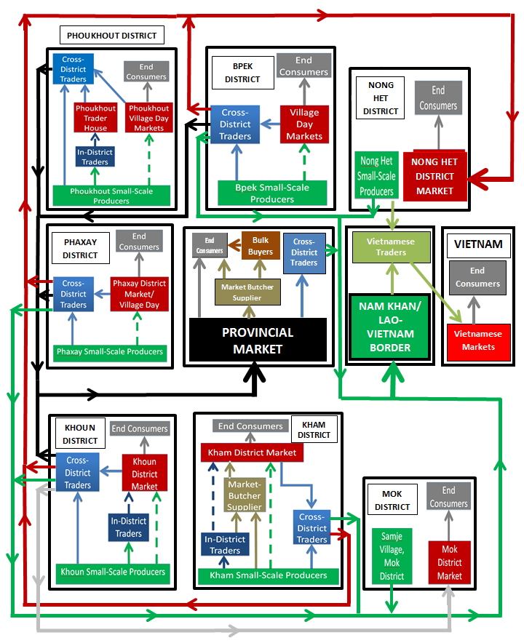

**4.1.3**  **XKH Province Native Chicken: Sources of Supply**

Phoukhout District supplies by far the largest quantity of chickens for the provincial market, with approximately half of the market’s estimated supply of 4000 native chickens each month. This is likely due to convenient transport access for traders, a number of village day markets where traders can buy chickens directly and a comparatively high chicken quantity per household, occasionally with some disease preventative measures (in part due to external support in methods to raise native chickens effectively). Bpek has an estimated 23% of the market supply, largely due to close distance and easy access from provincial markets, as well as also regularly having a number of village day markets each week which is convenient for traders of the provincial market. One reason that the provincial market share is lower than Phoukhout for native chickens is that many of the traders purchasing from Bpek villages (i.e. Nong Pet, Tajok, etc.) also sell chickens to Kham and Nong Het district markets, as well as to Vietnamese traders on the border (where Lao traders can make a higher profit). Phaxay and Khoun have 12.4% and 14.9% supply rates respectively for the local markets, lower in part due to less accessibility than Phoukhout, less phone coverage (for contact between buyers and sellers) and possibly higher rates of disease, reducing supply on a regular basis.

Bpek

Phoukhout

22.9%

49.8%

12.4%

14.9%

Khoun

Phaxay

**4.1.4 XKH Provincial Market – Native Chicken Supply and Demand**

According to native chicken cross-district traders selling at the provincial markets, the first 7 days of data collection (8th- 14th November) were a normal level of supply and the following 7 days (22nd – 28th) was the lead up to the Hmong New Year and, therefore supply and demand were notably higher. Based on the initial seven day period, average monthly sales of native chickens are about 4000 birds (averaging a weight of 1.2kg). The average supply of native chickens on a ‘normal’ market day is 261 (83% live; 17% dead) and the average sales-to-supply is 46% for live chickens and 88% for slaughtered chickens. This means that the average cross-district trader selling live chickens at the provincial market will typically sell their chicken supply within a 2-day period and therefore travel to buy chickens on an average of every two to three days. The lead up to the Hmong New Year is the busiest annual period for the supply and demand of native chickens, as many Hmong households normally ensure they have between 5 and 10 chickens to consume over their New Year. As a result, supply and sales increased by between 2.5 and 3 times for live chickens, although supply and sales for slaughtered native chickens remain about the same as during normal market periods.

|  |  |  |  |  |
| --- | --- | --- | --- | --- |
| Daily Supply & Demand | **‘Normal’ Market Day**  (8th-14th November) | | **Hmong New Year Market Day**  (22nd-28th November) | |
|  | Live | Slaughtered | Live | Slaughtered |
| **Average Sales** | 99 | 35 | 258 | 37 |
| **Average Supply** | 217 | 44 | 689 | 48 |
| **Sales-to-Supply Ratio** | 0.46 | 0.88 | 0.37 | 0.77 |
| **Average No. Sellers** | 17 | 1 | 32 | 2 |

**Daily Sales/Non-sales at Provincial Market (live and dead chickens)**

**Hmong New Year 7 Days**

**November 2016**

**Normal 7 Days**

**4.1.5 XKH Native Chicken Provincial Markets Buyer-Seller Groups Profile**

The two main buyer-seller groups which sold and/or bought native chickens at Provincial Markets in Bpek District were identified as ‘Cross District Traders’ and ‘Market-Butcher Suppliers’.

|  |  |  |
| --- | --- | --- |
| **Buyer-Seller Profile** | **Cross-District Traders** | **Market-Butcher Supplier** |
| **No of Traders** | **17** | **1** |
| **Supply Sources** | * Bpek District: Tajok, Nong Pet, Ladhouang * Other Districts: Phoukhout, Khoun, Phaxay | - Live chickens at Phoukham Provincial Market, Phonsavan |
| **Point(s) of Sale** | * Phoukham Provincial Market, Phonsavan * Nam Ngam Market, Phonsavan | * Phoukham Provincial Market, Phonsavan * Delivered event organisers on request |
| **Buying Price** | 25,000 – 35,000 Kip/kg | 40,000 Kip/kg |
| **Selling Price** | 40,000 - 45,000 Kip/kg | 45,000 – 50,000 Kip/kg |
| **Net Profit** | 5000 - 10,000 Kip/kg | 5,000 Kip/kg |
| **Quantity / trader/month** | 250-300 birds | See below |
| **Total Estimated Quantity/ month** | >4000 birds | >800 birds  (purchased from live chicken traders) |
| **Processing** | None | Slaughtered and plucked |

**Profile 1: Cross-District Traders selling at the Provincial Markets**

Supply, Demand and Obstacles

As already stated, due to access and price, cross-district traders who sell at the provincial markets buy exclusively from four districts: Bpek, Phoukhout, Khoun and Phaxay. Some cross-district traders source chickens by entering villages whilst others buy from village day markets, which take place around the province frequently. The longer term cross-district traders are often in phone contact with producers and even arrange by reserving chickens. When cross-district traders buy from producer villages, they usually need to go to several houses to find the sufficient quantity and type of chickens (weight, appearance, price, etc.) and will aim to leave with the maximum capacity that their motorbike will take – normally up to 50 chickens. Usually they will leave with a minimum of 30 chickens. Traders will stay in the producer area – even overnight – until they get a sufficient quantity to make an adequate profit.

Cross-district traders are usually able to sell at least half their chickens during the provincial market day but, if they have not sold all their supply, they will take their back to their houses overnight to sell the next day.

The biggest obstacle noted by traders is the difficulty in finding enough supply of native chickens and frequently coming back from searching for chickens to sell at the market without being able to find a sufficient amount which gives them a satisfactory profit. This is because lower chicken supply in villages increases the time and fuel costs for traders as they have to look for chickens without any guarantee of finding more and also means that their potential profit is lowered as they state that there is sufficient market demand to sell more. Often this means that the price per kilogram at the market is pushed up to between 45,000 and 50,000 Kip.

**Profile 2: Market-Butcher Supplier Selling at the Provincial Markets**

There is currently one market-butcher supplier at the Phoukham Market who purchases chickens to slaughter and sell as chicken meat and she usually buys from the cross-district traders who are selling live native chickens at the market and aims to buy enough to sell for that day (i.e. to sell fresh). If the chickens are not sold entirely she will store them at her house and is always able to sell her supply within a two-day period. Customers often reserve a bulk supply of chickens (for various events and functions) from this market-butcher supplier and she will buy, kill and pluck the chickens before delivering to the customer.

**4.1.6 XKH Native Chickens: Consumer Profile**

Market traders were generally aware of the ‘type’ of consumer who regularly purchased native chickens from them but less sure of the ratio of different consumers. Most consumer types at provincial markets were similar to those at district markets (where differences occurred, these are detailed in the given district section). The main profiles of consumers buying native chickens are:

**4.1.6.1 Consumer Types**

**Lowland Lao:** The main ethnicity in Lao tend to buy live native chickens for business purposes, such as for well-known restaurants - including noodle shops - as well as occasional cross-district traders (i.e. buying to sell onwards in other districts or to Vietnamese traders). Families with higher disposable incomes are the main group who buy dead native chickens for personal use or for special occasions, as they regard them as tastier than other breeds, as well as for the convenience of having been slaughtered and plucked already. High quality native chickens are the only breed used for Basi ceremonies, and therefore consumers buy them for this purpose.

**Hmong:** Members of the Hmong ethnicity often buy live native chickens for business purposes as well and buying them for onward trading at the Nong Het District Market or to Vietnamese traders. Hmong with a higher disposable income will often buy native chickens for personal and family use, as well as being the preferred choice for small-scale special occasions (i.e. parties, Basi ceremonies, etc.).

**Vietnamese/Chinese:** Vietnamese and Chinese consumers tend to be those working in Xieng Khouang and frequently buy native chickens for both personal and business purposes. Those who work in Phonsavan or other towns often have to buy from the market as they do not have the area to raise them themselves and those who work in the countryside are often based in one area only temporarily (i.e. electrical/construction companies) and therefore again cannot raise them. Consumers in the countryside regularly buy from the district market in which they are working, or from local villages directly which are raising chickens.

**4.1.6.2 Overall Consumer Opinion on Native Chickens**

When asking consumers about their reasons for buying native chickens, as opposed to other breeds, the three main themes which were brought up were ‘taste’, ‘nature’ and ‘freshness’. All groups stated that the native breed had a good taste and a general high quality to it (some referring to other breeds as inferior). The Lao word ‘tamasat’ came up frequently meaning ‘nature’ or ‘natural’. Consumers were also asked if they cared about chickens being ‘free-range’ and ‘organic’, to which most perceived these two words – along with ‘tamasat’ - to mean the same thing. Therefore, consumers assumed when they were buying live native chickens, they were buying free-range, organic chickens – which would have been true in most cases, unless where antibiotics or certain vitamins had been fed to chickens to prevent or treat disease. Freshness was also an attribute given to live chickens as they could choose when to kill and eat them. When asked if these qualities of native chickens made the higher price justifiable compared to lower-priced hybrid chickens, most agreed that it did although some noted that the higher price stopped them from buying a larger quantity at any one time.

**4.1.7 XKH Province Native Chickens: SWOT Analysis**

|  |  |
| --- | --- |
| **Strengths** | **Weaknesses** |
| * Some districts (notably Phoukhout) have good examples where the link between consistently high demand from cross-district traders and the ability of producers to provide a consistently high supply of chickens is evident. * There are some good examples where an increase in using chicken-raising techniques has directly increased a village’s/household’s supply of chicken to sell to potential cross-district traders. * Consumers generally perceive native chickens as the higher quality breed. | * Lack of guaranteed supply makes it difficult for cross-district traders to meet consumer demand and occasionally means increasing prices/kg. * Native chickens are regularly about 50% more expensive than hybrid chickens, which minimizes the demand from bulk buyers and end consumers. * Cross-district traders tend to work competitively and individually which may reduce the possibility for an organized approach to purchasing chickens from supply villages and markets. |
| **Opportunities** | **Threats** |
| * Increasing technical methods in rural villages and households may help producers increase their quantities of chickens. * Cross-district traders regularly state that there is sufficient consumer demand to buy native chickens so there it is financially viable to increase supply. * Given the high demand from Vietnamese traders, there may be potential to increase supply for the Vietnamese market. * The preference of consumers with higher disposable income to buy already-slaughtered native chickens shows there may be potential to sell on a wider scale. | * An increasing number of wholesalers bringing hybrid meat-chickens to Xieng Khouang, along with the possibility of large scale farms coming to the province, could reduce demand for native breeds. * Increasing supply for the Vietnamese market (with their higher buying price/kg) could increase prices on the provincial level. * Increased working hours among the populace will eventually mean increasingly convenience-orientated consumer decisions and, in the case of buying chickens, is currently likely to mean choosing slaughtered hybrid meat-chickens over live natives. |

**4.2. Phoukhout District – Native Chickens**

Phoukhout District is estimated to supply up to half of the provincial markets’ supply of native chickens. There are seven regular village day markets in the district where native chickens are sold regularly. Native chickens produced in Phoukhout District are rarely sold at the Phoukhout District market.

**4.2.1 Phoukhout District Native Chicken Value Chain**

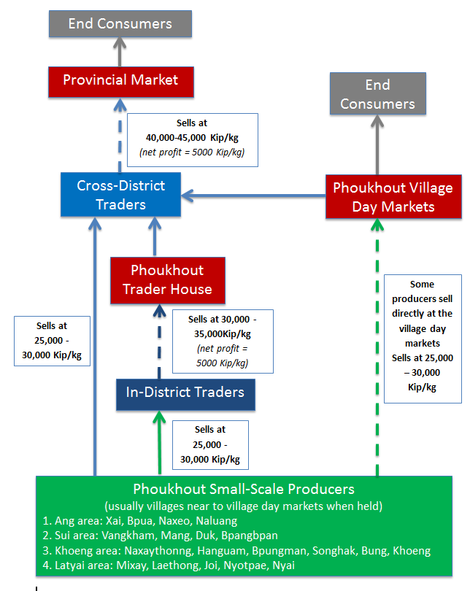

**4.2.2 Phoukhout District Native Chicken Buyer-Sellers: Profile**

Two buyer-seller groups were identified in Phoukhout District: ‘**Small-Scale Producers and In-District Traders’ and ‘Cross-District Traders’.**

|  |  |  |
| --- | --- | --- |
| **Buyer-Seller Profile** | **Small-Scale Producers and In District Traders** | **Cross-District Traders** |
| **No of Traders** | Various | 10-12 |
| **Supply Sources** | * Small-scale producers deliver to in-district traders’ houses and also sell at village day markets directly | * Small-scale producer villages * In-district traders’ houses * Village day markets |
| **Point(s) of Sale** | * Small-scale producer villages * Village Day Markets * Traders’ houses | * Provincial XKH market |
| **Buying Price** | In-district trader: 25,000 - 30,000 Kip/kg | 25,000-35000 Kip/kg |
| **Selling Price** | Small-scale producers: 25,000 - 30,000 Kip/kg  In-district trader: 30,000 – 35,000Kip/kg | 40,000 – 45,000 Kip/kg |
| **Net Profit** | 5000 Kip/kg | 5000 Kip/kg |
| **Quantity /trader/month** | See total (below) | 120 - 170 birds |
| **Total Estimated Quantity/month** | >2000 birds | >2000 birds |
| **Processing** | None | None |

**Profile 1: Small-Scale Producers and In-District Traders in Phoukhout District**

Supply, Demand and Obstacles

Village Day Markets take place in 6-7 villages in Phoukhout occurring in each village once or twice a week (therefore a maximum of 14 market days). Small-scale producers typically sell at the markets which are nearest to their villages so individual day markets have their own sellers. Many village producers will go to both the in-district trader’s house as well as the village day markets to sell chickens. Both in-district traders and village producers typically sell to cross-district traders, although also some end consumers who are working in the area but are generally not from Phoukhout. In-district traders who sell to cross-district traders are usually those whose house is on or near the main road. Both the in-district traders’ houses and village day markets are convenient locations for the cross-district traders because they usually have a better opportunity to buy a bulk quantity of chickens at one time (saving both time and cost). According to Phoukhout in-district traders and producers, chickens are seldom sold at the Phoukhout District Market.

-------------------------------------------------------------------------------------------------------------------------------

**Profile 2: Cross-District Traders in Phoukhout District**

Supply, Demand and Obstacles

All identified cross-district traders in Phoukhout were selling their purchased chickens at the provincial markets in Phonsavan. Where possible they often prefer to buy directly from in-district traders as it is usually convenient to access and they can often communicate in advance to make arrangements to guarantee supply. However, many cross-district traders also go directly to producer villages when there is not sufficient supply at the village day markets because they can potentially make an additional 5000 Kip/kg or more profit compared to buying from in-district traders. The longer-term cross-district traders often have a good relationship and network with village producers, including phone numbers to contact in advance to check current village chicken supplies. Some cross-district traders buy from in-district traders and small-scale producers in the early morning before they sell their purchased chickens at the provincial market, whereas others go in the afternoon/evening after they have finished selling at the market, and keep their purchased chickens at their home overnight before selling them the following day. These cross-district traders generally say the supply of native chickens in Phoukhout is higher than in other areas of XKH but they still want supply to increase.

**4.2.3 Phoukhout District Native Chicken Case Study**

***The Impact and Benefit of TABI Chicken-Raising Method Program, Phoukhout Target Villages***

The villages of ***Naxaytong, Bpungman, Longkham, Muangkham*** are four out of twenty-two target villages in Phoukhout where chicken producers were trained in chicken-raising techniques – including disease prevention (vaccinating), treatment (antibiotics) and providing chickens with a high protein diet in order to try to increase chicken supply per household, particularly for income from selling chickens. As part of the program, households also built chicken coops and separated the ages of the chickens. Most, if not all, other families in these villages did not use any specific methods to raise chickens.

|  |  |
| --- | --- |
| **Naxaythong Village**  (10km for Phoukhout District Town) | |
| **TABI Target Families** | **Non-Target Families in Village** |
| **No. of Families** | 9 | 141 |
| **Target families average chicken supply** | 50 birds | 30 birds |
| **Chickens sold per month** | 6 birds per family | 4 birds per family |
| **Selling Price/kg** | 35,000 Kip/kg | 30,000 Kip/kg |
| **Selling Methods** | Cross-district traders buy chickens in village, often phoning ahead (having established trading relationship). Target families also sell chicks. | Cross-district traders buy chickens in villages, often without prior contact. Some villagers take chickens to village day market. |
| **Raising Methods**  **(i.e. follow training)** | Vaccinations done frequently, separated ages with coop, feed grain pellets, rice and corn | No vaccinations and no method – free to roam, no coop. Feed is usually rice and grain |
| **Problems with disease/ death** | After program started, disease reduced significantly and chicken quantity nearly doubled. Occasionally chicks die from cold weather. | Problems with disease occur yearly and often wipe out entire household chicken quantities. No coop means predators occasionally kill and eat chickens. |
| **Obstacles to raising/selling** | Want to increase chicken supply but limited by coop capacity. |  |
| **Other details** | * Target families sell young chickens to buyers to raise and eat or sell because buyers want strong, healthy chickens * The village once sold 500 x 3 month old chickens because they vaccinated * Due to using method, target families sell chickens 5000 Kip/kg more than non-target families – and traders still buy regularly. * Target families eat chickens regularly and often give chickens away to family and friends as gifts. | Non-target families tend to be well aware of the benefits of using chicken raising methods but after disease regularly kills their chickens (sometimes all), they never adopt methods and just start raising chickens again like before. Possible reason is that they do not want to invest in a coop, etc. |

|  |  |
| --- | --- |
| **Bpungman Village**  (15km for Phoukhout District Town) | |
| **TABI Target Families** | **Non-Target Families in Village** |
| **No. of Families** | 12 | 63 |
| **Target families average chicken supply** | 100 birds | 30 birds |
| **Chickens sold per month** | 4 birds per family | 4 birds per family |
| **Selling Price/kg** | 30,000 Kip/kg | 30,000 Kip/kg |
| **Selling Methods** | Cross-district traders buy chickens in village about once or twice a week. Sometimes target families will sell directly at village day markets. | Same as target families |
| **Raising Methods**  **(i.e. follow training)** | Some say they use vaccination (but not regularly and not all vaccines), have coop, feed is usually rice and corn | No vaccinations and no method – free to roam, no coop. Feed is usually rice and corn. |
| **Problems with disease/ death** | Vaccinations done infrequently and chickens sometimes die from disease. However, families say that when disease enters the village, then they keep the chickens in the coop all day and night – and this helps significantly. | Regular/annual deaths from disease. |
| **Obstacles to raising/selling** | Occasional disease and lack of chicken feed in late rainy season | Disease. |
| **Other details** | * Target families say they have not noticed a particular difference in quantity of chickens sold between them and non-target families. However, diseases appear to occur less with families with chicken coop and there supply is much higher than that of non-target families. |  |

|  |  |
| --- | --- |
| **Longkham Village**  (65km for Phoukhout District Town) | |
| **TABI Target Families** | **Non-Target Families in Village** |
| **No. of Families** | 5 | 47 |
| **Target families average chicken supply** | 0 birds at Dec 2016  (but previously over 30 chickens per family) | 0 birds at Dec 2016  (but previously over 10 chickens per family) |
| **Chickens sold per month** | 10-15 birds (before disease in Oct 2016) | <5 birds (before disease in Oct 2016) |
| **Selling Price/kg** | 30,000 - 35,000 Kip/kg | 30,000 – 35,000 Kip/kg |
| **Selling Methods** | Cross-district traders bought chickens in village regularly. Sold in bulk when they need money. | Same as target families |
| **Raising Methods**  **(i.e. follow training)** | Vaccinations never done after training, separated ages with coop, feed rice and corn | No vaccinations and no method – free to roam, no coop. Feed is usually rice and grain |
| **Problems with disease/ death** | After program started, no big problem with disease until 2016 when unidentified disease killed all poultry as well as pigs, dogs and other animals. | Same as target families although typically had more problems with disease than target families before 2016 |
| **Obstacles to raising/selling** | Disease because they previously made good income from chickens but all died. However, target villages are eager to start again and also get training to use vaccines this time. | Disease is the biggest threat, along with predators killing chickens at night. |
| **Other details** | * Target families used to eat chickens regularly and often gave chickens away to family and friends as gifts. * The construction of coop and flock management helped them increase quantities of chickens greatly, mainly to protect them from predators. |  |

|  |  |
| --- | --- |
| **Muangkham Village**  (80km for Phoukhout District Town) | |
| **TABI Target Families** | **Non-Target Families in Village** |
| **No. of Families** | 7 | 53 |
| **Target families average chicken supply** | 0 birds at Dec 2016  (but previously over 30 chickens per family) | 0 birds (at Dec 2016)  (but previously over 10 chickens per family) |
| **Chickens sold per month** | >30 birds | <30 birds |
| **Selling Price/kg** | 30,000 Kip/kg | 30,000 Kip/kg |
| **Selling Methods** | No traders or access to market | Same as target families |
| **Raising Methods**  **(i.e. follow training)** | Vaccinations never done after training, separated ages with coop, feed rice and corn | No vaccinations and no method – free to roam, no coop. Feed is usually rice and grain |
| **Problems with disease/ death** | Annual diseases sometimes kill entire quantity of village chickens | Same as target villages |
| **Obstacles to raising/selling** | * The distance to other village day markets means it is not sufficiently profitable for traders to buy chickens * Lack of phone coverage minimises opportunity to traders to sell when they have supply * Chicken Diseases | Same as target villages |
| **Other details** | * Target families used to eat chickens regularly and often give chickens away to family and friends as gifts. * The construction of coop helped them increase quantities of chickens greatly, mainly to protect them from predators. |  |

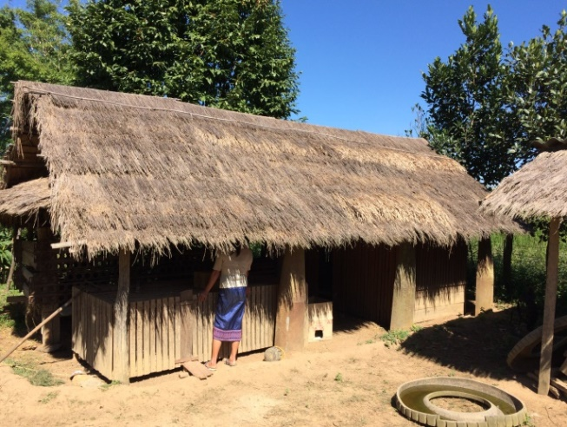 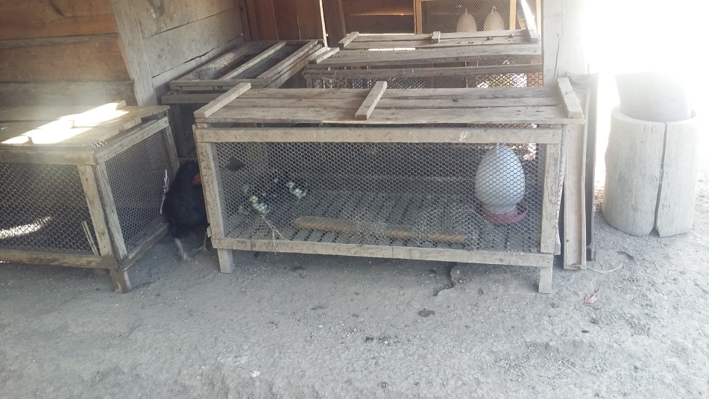

**Most villages in Phoukhout increased native chicken supply after building a chicken coop, introducing flock management to separate chickens by age. Some villages still also use vaccinations for disease prevention which they were trained in.**

***(above: Bpungman village, Phoukhout District).***

**Phoukhout Target Villages – TABI Program Benefit Analysis**

Only one of these four target villages (Naxaythong) adopted most techniques which they were trained in, including comprehensive vaccinating. Vaccinating chickens, along with using the chicken coop and flock management to separate chickens by age, allowed for a significant decrease in target family chickens contracting diseases which are present in the village on an annual basis. Directly as a result of preventing disease and using the coop, these families were able to increase their chicken quantities by up to 60 percent, therefore showing a marked benefit in using the chicken-raising methods. The difference between the target and non-target families in this village was that, with a higher supply, cross-district traders bought from the target families on a more regular basis, building up a trading relationship (including regular phone contact from cross-district traders to find out current chicken quantities) which allowed them to sell about 1.5 times more chickens than non-target villages (which would be even higher for target families but they also eat or give away chickens regularly too). Additionally, target families in this village sell chickens 5000 Kip/ kg more than non-target families as cross-district traders and end consumers who buy from them are apparently willing to pay more for vaccinated chickens, which they perceive as healthier – particularly those buyers who intend to continue to raise the chickens to a heavier weight. With the high supply of chickens from target families, this has also allowed them to sell in bulk, having previously sold over 500 3-month old, vaccinated chickens at one time.

The lack of regular vaccinating done in other target villages (Bpungman, Longkham and Muangkham) means that, similar to non-target families, chickens also die from disease. However, one difference with target families is that, during disease-free periods, the chicken coop allows them to keep more chickens, which subsequently increases their potential to sell to cross-district traders. Additionally, when target families know that there is disease in the village, they will usually keep chickens in the coop 24 hours a day to avoid contact with infected sources. Subsequently, non-target families often lose all their chickens whereas target families are not affected. As a result, cross-district traders who come to the village over the next several months will only be able to buy from target families.

In all cases, no target families provide chickens with a specifically high-protein diet. Therefore, the link between such a diet’s impact of factors such as increased fertility, chicken health (to prevent from disease) and general appearance of the birds on trader demand is not clear.

As Muangkham is too far away from village day markets or for cross-district traders to travel or suppliers to sell at markets, there is currently no market for target or non-target families to sell their chickens. Therefore, this means they are even less willing to use chicken-raising methods that they were trained in, as well as the inability to access vaccines. However, the coop allows target families to raise slightly more chickens than non-target families and these families often eat chicken daily

**4.2.4 Phoukhout District Native Chicken SWOT Analysis**

|  |  |
| --- | --- |
| **Strengths** | **Weaknesses** |
| * Phoukhout is well known by cross-district traders as the XKH district with the highest supply of native chickens. * Some households which have adopted the trained chicken raising methods and have benefited from it with regular demand from traders. | * Remote villages which want to raise chickens are have difficulty in accessing the market (poor roads, little or no phone communication) and also difficulty in accessing vaccines to prevent disease. |
| **Opportunities** | **Threats** |
| * Cross-district traders want chicken producers to increase their supply as they say more can be bought and sold. * Using the examples of target families which adopted chicken raising methods (including vaccinations) to show other villages the true benefit. * Village data which shows a correlation between trained chicken raising methods and networking with cross-district traders suggests the training is worth pursuing. | * The risk of chickens regularly dying from disease remains high in local villages and, given the market reliance on Phoukhout, high levels of disease could have an economic knock-on effect in the province. * Phoukhout already has a large hybrid chicken egg farm so any increase in the market supply of hybrid chickens for meat could potentially reduce the market supply of native chickens, especially as the hybrids are much cheaper for consumers to buy. |

**4.3. Phaxay District – Native Chickens**

Phaxay District produces an estimated 12.4% of the provincial markets’ native chicken supply, additionally providing supply which is sold to end consumers in Phaxay as well as to cross-district traders who sell to Vietnamese traders on the Nam Khan Border Crossing. There is only one village day market in Phaxay District and the District Market is only open on Sundays. Therefore cross-district traders typically have to go to producer villages to buy chickens.

**4.3.1 Phaxay District Native Chicken Value Chain**

**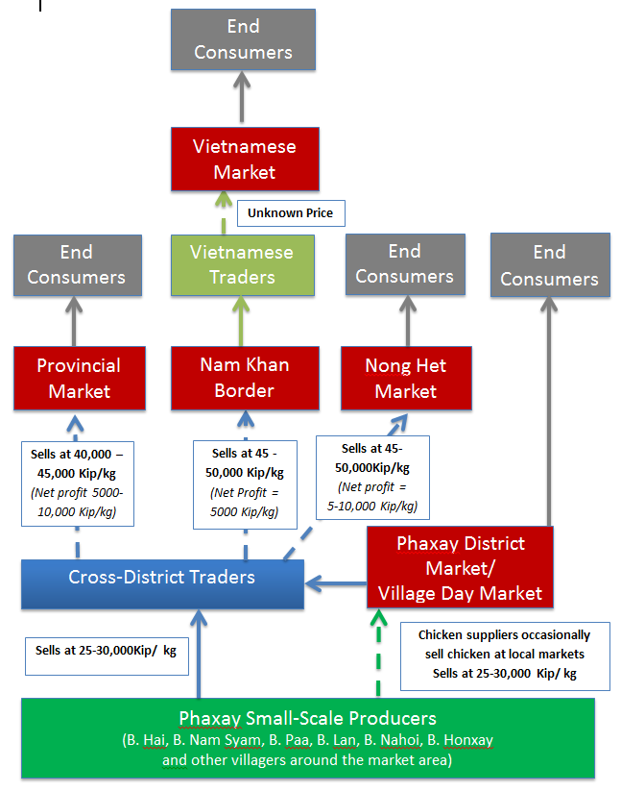**

**4.3.2 Phaxay District Native Chicken Buyer-Sellers: Profile**

One buyer-seller group was identified in Phaxay District: **Cross-District Traders**

|  |  |
| --- | --- |
| **Buyer-Seller Profile** | **Cross-District Traders** |
| **No of Traders** | **>5** |
| **Supply Sources** | * Phaxay District Market and Village Day Markets * Supply Villages: Hai, Nam Syam, Paa, Lan, Nahoi, Honxay and other villages around the market area. |
| **Point(s) of Sale** | * Provincial Markets * Nong Het District Market/ Nam Khan Border |
| **Buying Price** | 25,000 – 35,000Kip/kg |
| **Selling Price** | 30,000-35,000 Kip/kg |
| **Net Profit** | 5000 Kip/kg |
| **Quantity/trader/month)** | 80-100 birds |
| **Total Estimated**  **Chickens /month** | >500 birds |
| **Processing** | None |

**Profile: Cross-District Traders in Phaxay District**

Supply, Demand and Obstacles

More experienced cross-district traders buy from chicken producers in villages known for having a regular supply of chickens. This is often done by prior arrangement to ‘reserve’ chickens in advance. According to these traders, they tend to buy from producer villages at night as the chickens are in their coop at that time and this generally saves time as they are easier to catch. Other cross-district traders will tend firstly to go to the district market or village day market but, if there are no chickens to buy, they will enter Phaxay villages in the early morning. This is usually done without prior arrangement and most traders will buy chickens with the aim to start selling them that day. Most of these traders sell at the Phoukham Provincial Market, the Nong Het District Market and the Nam Khan Lao-Vietnam Border. Traders do not normally come to buy chickens in Phaxay every day but usually buy between 30 and 50 chickens each time. Some traders will stay overnight in producer villages or with family or friends in the district if they have not yet secured a sufficient quantity of chickens (with 30 chickens normally being the minimum).

Cross-district traders commonly complain that producer villages do not have enough chickens and therefore they would prefer chicken producers to increase their chicken supply. When local producers sell directly at Phaxay District market or the village day market, they sell mostly to Lao, Vietnamese and Chinese workers in the area (farmers, construction workers, army, etc.).

**4.3.3 Phaxay District Native Chicken Case Study**

***Native Chicken Producer Village: Hai Village***

Hai village is a relatively well-known chicken producer village for cross-district traders, which is about 6km outside the Phaxay District town on a fairly accessible dirt road. Several cross-district raders buy an average of about 20 chickens each in Hai village two to three times a week and, as a whole, the village makes a monthly income of about 5-6 million Kip from chicken sales (there are 45 households in the village). However, villagers reported that every year in January or February – a time when chicken demand is high, up to 80% of chickens die from a disease which, although hadn’t been identified, is contracted by ducks too. There has previously been some training for village chiefs and chicken group heads on raising methods, but they were largely not adopted by villagers. Very few households have chicken coops, with chickens roaming around freely, and those which did have coops are in a poor or non-useable condition.

One interesting example from several years ago was one household where the family’s son had raised chickens specifically in the chicken coop. The parents reported that every year, whilst other village chickens were dying from disease, their chickens was never affected. Later on, when the son went to work in Vientiane, the parents allowed the chickens to roam around during the daytime – not adopting the son’s method. After that, that family’s chickens also contracted disease and thereon died every year.

**4.3.4 Phaxay District Native Chicken SWOT Analysis**

|  |  |
| --- | --- |
| **Strengths** | **Weaknesses** |
| * The improved road to Phaxay has made transportation to and from Phaxay town and villages much easier for crosss-district traders. * Lao, Chinese and Vietnamese workers in Phaxay District are an important additional consumer of native chickens. | * Training methods have been taught in villages but were never adopted. As a result, large quantities of village chickens die every year (often during high chicken demand periods). * Cross-district traders still do not go to some Phaxay villages due to perceived safety concerns. |
| **Opportunities** | **Threats** |
| * Cross-district traders state that they want producer villages to increase their supply of chickens and that they will buy more if they do. * There may be potential to open the local market more than once a week – or provide more village day markets to encourage an increase in the supply and sale of native chickens. * Improved safety and security in the area may encourage more cross-district traders to buy from the district. | * Given the increased ease of access from Phonsavan, it is possible more hybrid meat-chickens may increase in Phaxay District in the coming years, which may reduce consumer demand in Phaxay District for native chickens. * The relatively low selling price of chickens in Phaxay producer villages means villagers will be even less likely to invest in vaccines and therefore chickens are likely to continue to die on an annual basis. |

**4.4 Khoun District – Native Chickens**

Khoun District produces 14.9% of the provincial markets’ native chicken supply and cross-district traders also buy chickens to sell at the Nong Het District Market and to Vietnamese traders at the Nam Khan Border Crossing. Khoun District Market is open three times per week and the district market has one regular in-district trader. Cross-district traders buy native chickens from her as well as regularly buying from Khoun producer villages.

**4.4.1 Khoun District Native Chicken Value Chain**

**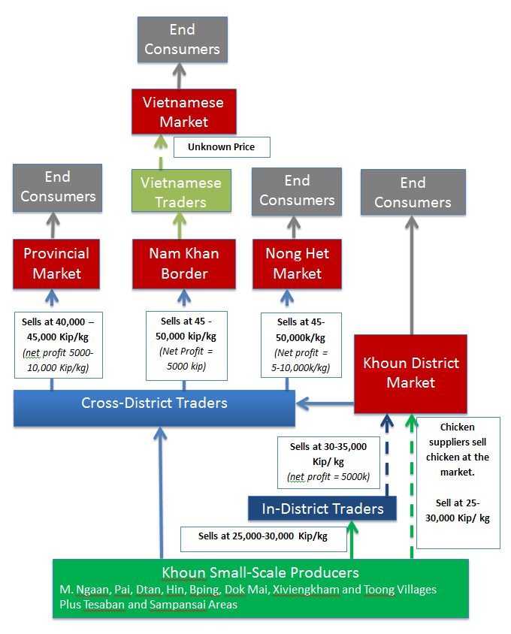**

**4.4.2 Khoun District Native Chicken Buyer-Sellers Profile**

Two buyer-seller groups were identified in Khoun District: an In-District Trader and Cross-District Traders.

|  |  |  |
| --- | --- | --- |
| **Buyer-Seller Profile** | **In-District Trader** | **Cross-District Traders** |
| **No of Traders** | **1** | **>5** |
| **Supply Sources** | * Khoun village producers deliver to in-district trader (at trader’s house or market) | * Villages in Khoun District * (as noted in above value chain) * Khoun District Market |
| **Point(s) of Sale** | * Khoun District Market | * Provincial Markets * Nong Het District Market * Nam Khan Border |
| **Buying Price** | 25,000 – 30,000 Kip/kg | 30,000-35,000 Kip/kg |
| **Selling Price** | 35,000 Kip/kg | 40,000 – 55,000 Kip/kg |
| **Net Profit** | 5000 Kip/kg | 5000-15,000 Kip/kg |
| **Quantity /trader/month** |  | 100 - 150 birds |
| **Total Estimated Quantity/month** | 120-150 birds | 600 - 750 birds |
| **Processing** | None | None |

**Profile 1: In-District Trader in Khoun District**

Supply, Demand and Obstacles

Khoun District village producers normally sell chickens to the only current in-district trader at her house, before she then sells them at the Khoun District Market. This trader is also in phone contact with many producers in these villages so she can arrange ahead and even ‘reserve’ a delivery of chickens. Sometimes, the producers sell directly to the in-district trader at the market if they go into town to buy or sell other goods or alternatively the chicken producers may try to sell themselves first (as they will make a higher profit). The in-district trader prefers to buy chickens between 1 and 1.5 kg. Whilst the main buyers of chicken from the in-district trader are cross-district traders, the in-district trader said that most of the other local consumers who buy from her are Chinese and Vietnamese, who are working in the district.

**Profile 2: District/Provincial Market Traders in Khoun District**

Supply, Demand and Obstacles

Cross-district traders buy chickens in Khoun several times a week. Initially, they often check at the district market to buy supply from there (if there is any). After that they will travel to several possible chicken producer villages – some over 30km from the Khoun District town. Cross-district traders stated that they can usually make higher profit from Khoun producer villages as sellers do not always know accurately the weight of the chicken (i.e. scales are not used) whereas cross-district traders are good at estimating weight and therefore know when they are getting a good deal. One of the conveniences of Khoun District for cross-district traders is that the district town is 36km to Phonsavan on good, relatively flat road, despite many of the supply villages being in remote, mountainous locations. Usually cross-district traders sell at the provincial market but some also sell in Nong Het district, where they usually sell at the district market or to Vietnamese traders at the border. Again, cross-district traders who buy in Khoun are frustrated by low supply, often caused by disease – and the threat of it – and therefore they want villages to increase their supply.

**4.4.3 Khoun District Native Chicken Case Study**

**Small Scale Chicken Producers: Methods of Raising Chickens in Ban Toong**

Ban Toong has 99 families in the Village and each family is estimated to have between 25 and 30 chickens. An estimated 200 chickens are sold each month to cross-district traders from the provincial market in Phonsavan, and sales usually double over the Hmong New Year and rice harvest. Cross-district traders want the village to increase their supply as there is enough consumer demand. However, as with many other villages in the area, there are little to no chicken-raising methods or resources (i.e. chicken coop) and as a result a so-far unidentified disease often kills all chickens in the village each year in November or December – the time when demand for chickens is highest. Therefore the potential to make the highest income in the year is lost and they also lose motivation and move focus away from raising chickens.

No technical support on chicken raising has previously taken place in the village – either from the agricultural department or a development organisation. When hearing news of disease spreading in the village, many households will either hurry to sell all their chickens, and also take preventive measure (i.e. using chicken nets) - which sometimes save chickens but not always – before releasing chickens after the disease is thought to have passed. However, the village chief is extremely keen to seek technical support as they see the potential to increase chicken supply, and therefore income in the village. The village chief also reported that, whilst nearly all families in the village had chickens which would contract diseases every year, there were some Hmong families who lived on a higher elevation in the village, with terraced rice fields, whose chickens were apparently known to never contract diseases.

**4.4.4 Khoun District Native Chicken SWOT Analysis**

|  |  |
| --- | --- |
| **Strengths** | **Weaknesses** |
| * There appears to be a high volume of villages in the district which raise chickens (although many are remote and far from each other). * Access to and from Phonsavan is easy for cross-district traders. | * Income security from selling chickens is low due to annual poultry diseases which often wipe out many if not all chickens in each village. * Lack of phone signal in the more remote villages reduces chance of coordination between cross-district traders and chicken producers. |
| **Opportunities** | **Threats** |
| * Cross-district traders want villagers to increase supply of chickens. * Many of the villages are actively asking for chicken raising technical support so suggests there is a desire to adopt such techniques. * There may be potential to encourage remote villages to sell chicken supplies in bulk which is more efficient for traders as well as potentially more beneficial for producers | * Increasing numbers of hybrid chickens (especially hybrid meat-chickens) supplied and sold in the district could affect demand for native chickens. * The fact that most Khoun District chickens are bought to sell in other districts means that any changes to demand and supply in those other districts could have a big impact on Khoun, out-with its control. |

**4.5 Kham District – Native Chickens**

Native chickens in Kham district are generally not bought by cross-district traders to sell at provincial markets due to the higher chicken price per kilogram compared to Bpek, Phoukhout, Phaxay and Khoun Districts. Kham District Market is open daily, where in-district traders and occasionally producers sell native chickens to local end consumers as well as to cross-district traders who then sell them in Nong Het to Vietnamese traders. Both groups of traders also buy directly from producer villages around Khoun District.

**4.5.1 Kham District Native Chicken Value Chain**

End Consumers

End Consumers

Vietnamese

Market

**Unknown Price**

Kham District Market

Vietnamese

Traders

**Sells at**

**45,000 Kip/kg**

*(Net Profit = 5000 kip/kg)*

**Sells at**

**45 - 50,000 Kip/kg**

*(Net Profit =*

*5000 Kip/kg)*

Market-Butcher

Supplier

Cross-District

Traders

**Sells at**

**40 - 45,000 Kip/kg**

*(Net Profit = 5000 Kip/kg)*

**Some chicken Suppliers sell chicken directly at the market.**

**Sells at 35-**

**40,000 kip/kg**

In-District Traders

**Sells at**

**35-40,000 kip/kg**

**Sells at**

**35 - 40,000 Kip/kg**

Kham Small-Scale Producers

(Ban Samphan, B. Piew and others around the main district town)

**4.5.2 Kham District Native Chicken Buyer-Sellers Profile**

Three buyer-seller groups were identified in Kham District: **In-District Traders, Market-Butcher Supplier and Cross-District Traders.**

|  |  |  |  |
| --- | --- | --- | --- |
| **Buyer-Seller Profile** | **In-District Trader** | **Market-Butcher Supplier** | **Cross-District Traders** |
| **No of Traders** | **3-4** | **1-2** | **1-2** |
| **Supply Sources** | * Villages around the Kham District town, often from households in their own villages (i.e Samphan, Piew villages). | * In-district traders selling live birds at the Kham District Market | * Local Villages around Kham District town * In-district traders at Kham District market |
| **Point(s) of Sale** | * Kham District Market | Kham District Market | * Nam Kham Border   (to Vietnamese traders) |
| **Buying Price** | 35,000-40,000 Kip/kg | 40,000Kip/kg | 40,000-45,000 Kip/kg |
| **Selling Price** | 40,000 - 45,000 Kip/kg | 45,000 Kip/kg | 45,000 – 50,000Kip/kg |
| **Net Profit** | 5000 - 10,000 Kip/kg | >5000 Kip/Kg | 5000 Kip/kg |
| **Quantity /trader/month** | 90-150 birds |  |  |
| **Total Estimated Chickens/month** | 270-450 birds | 90-120 birds | 340-400 birds |
| **Processing** | None | The market butcher slaughters, plucks and cuts chickens for market sale at 5000 Kip/kg | None |

**Profile 1: In-District Traders in Kham District**

Supply, Demand and Obstacles

In-district traders who sell at the Kham district market tend to buy native chickens from surrounding villages for 35,000-40,000 Kip/kg – often from their own villages. However, bulk chicken purchases from producer villages are cheaper and will normally be kept at the in-district trader’s house until they have sold them. Occasionally chicken producers from Kham villages directly sell their own chickens at the Kham market, often at the same time as purchasing goods from the market or selling other produce, although not frequently and not large quantities (i.e. 50 chickens per month all suppliers).

In-district traders have difficulty buying chickens around December as many producer villages’ chickens contract and spread diseases leading to death and wiping out most if not all of village chickens.

**Profile 2: Market-Butcher Supplier in Kham District**

Supply, Demand and Obstacles

The market-butcher supplier buys live chickens from both the in-district traders and also in local producer villages to slaughter, pluck and also cut up the meat for a profit of 5000 Kip/kg. The market-butcher supplier makes more profit when consumers buy chicken cuts rather than when selling slaughtered whole chickens. Many consumers of butchered chicken-meat are Vietnamese working in the district.

**Profile 3: Cross-District Traders in Kham District**

Supply, Demand and Obstacles

Due to the higher price of regular native chickens in Nong Het (on the Vietnam border) it is sufficiently profitable for cross-district traders to buy chickens in Kham District and then transport them live to the Vietnamese border at Nam Khan, to sell to Vietnamese traders, for a profit of about 5000 Kip/kg. Cross-district traders initially try to buy in villages around Kham District (and Bpek District) but if there is not sufficient supply there, then they will buy from market traders at the Kham District market a higher rate per kilogram. There are currently two identified cross-district traders who work together and rotate duties each week to purchase from Kham District on Saturdays and Sundays (their days off work). Arrangements regarding chicken quantity and pricing are arranged with Vietnamese traders by phone. Higher prices per kilogram, due to lower supply at the market may mean that they sometimes cannot sell to Vietnamese traders on that day.

**4.5.3 Kham District Case Study**

*See ‘Hybrid Meat-Chickens’ section.*

**4.5.4 Kham District Native Chicken SWOT Analysis**

|  |  |
| --- | --- |
| **Strengths** | **Weaknesses** |
| * The hybrid meat-chicken farm in Kham District (*See ‘Hybrid Meat-Chickens’ section)* is a good systematic example for native chickens that has well organized chicken setups that can reduce the risk of disease, increase supply and also increase demand from traders and consumers. | * Consistent lack of chicken raising techniques mean disease regularly wipes out chicken numbers and potential income, notably in high-demand seasons. * The price per kilogram in Kham district (40-45,000K/kg) is relatively expensive for district market consumers. |
| **Opportunities** | **Threats** |
| * The hybrid meat-chicken farm could be used as an example of how local chicken producers could develop systematic farms for native chickens. * The district agricultural office could encourage basic technical farming for chicken producers and/or village chiefs | * The supply of hybrid chickens from the two producer groups of hybrid meat-chickens and hybrid meat-chicks provide a potential competitive threat to the demand for native chickens in the district. * Whilst chicken sales to Vietnamese traders are beneficial, it could continue to increase prices for local consumers. |

**4.6 Nong Het District – Native Chickens**

Nong Het District does not supply for the provincial markets and the three main points-of-sale for native chickens in the district are the district market, the Nam-Khan border crossing (where cross-district traders sell chickens to Vietnamese traders regularly) and within producer villages. The district market is open one day per week and there is a Lao-Vietnam Border Market on the tenth, twentieth and thirtieth days of each month).

**4.6.1 Nong Het District Native Chicken Value Chain**

End

Consumers

End Consumers

Vietnamese Market

Nong Het District Market

**Sells at 50,000 Kip/kg**

*(Net profit =*

*10-15,000 Kip/ kg)*

**Unknown**

**Price**

Nam Khan Border

Cross-District Traders

Vietnamese Traders

**Sells at**

**45-50,000 Kip/kg**

*(Net profit = 10-15,000 Kip/kg)*

**Sells at**

**45-50,000 Kip/kg**

**Sells at**

**25,000 – 30,000 Kip/kg**

Other XKH District Markets/ Small-Scale Producers

Nong Het Small-Scale Producers

**4.6.2 Nong Het District Native Chicken Buyer-Sellers Profile**

Two buyer-seller groups were identified in Nong Het District: **Cross-District Traders and Vietnamese Traders.**

|  |  |  |
| --- | --- | --- |
| **Buyer-Seller Profile** | **Cross-District Traders** | **Vietnamese Traders** |
| **No of Traders** | **> 5** | **> 15** |
| **Supply Sources** | * Villages outside of Nong Het District (typically Bpek, Khoun and Phaxay Districts) | * Local Villages   (notably B. Khangpanien and B. Lawng Guang)   * Nong Het Cross-district traders at Nam Khan Border. |
| **Point(s) of Sale** | * Nong Het District Market * Nam Kham Border (to Vietnamese traders) | * Vietnamese Markets |
| **Buying Price** | 25,000-35,000 Kip/kg | 45,000-50,000kip/kg |
| **Selling Price** | 45,000 - 50,000 Kip/kg  (increases to 55,000-60,000 Kip/kg at Hmong New Year) | Unknown |
| **Net Profit** | 10,000 – 20,000 Kip/kg | Unknown |
| **Quantity /trader/month** | Normally bought  outside the district |  |
| **Total Estimated Quantity/month** | Normally bought  outside the district | 800-1200 birds |
| **Processing** | Requested slaughter and plucking chickens = extra 5000 Kip (occasional) | None |

**Profile 1: Cross-District Traders in Nong Het District**

Supply, Demand and Obstacles

Due to the high price that the Vietnamese traders buy native chickens from Nong Het supply villages, cross-district traders are forced to travel to and buy from village producers and in-district traders in other districts of Xieng Khouang (such as Bpek, – including at the provincial market – Khoun and Phaxay Districts) in order to buy at average provincial rates (i.e. 25,000 – 30,000 Kip/kg). However, due to the high price they charge for chicken at the Nong Het market, cross-district traders are able to maintain, and even increase their net profit. During the Hmong New Year (which is also celebrated by Vietnamese Hmong) prices of chicken of chicken increase by 5000-10000 Kip/kg. However, chicken producers in the districts where Nong Het cross-district traders buy from generally do not increase the buying price and therefore the Hmong New Year is a good opportunity for cross-district traders to maximize their profit and income. Cross--district traders said that almost no native chickens are sold to the local restaurants due to the high market price and therefore restaurants and other bulk buyers tend to purchase hybrid meat-chickens which are about 50 percent cheaper per kilogram.

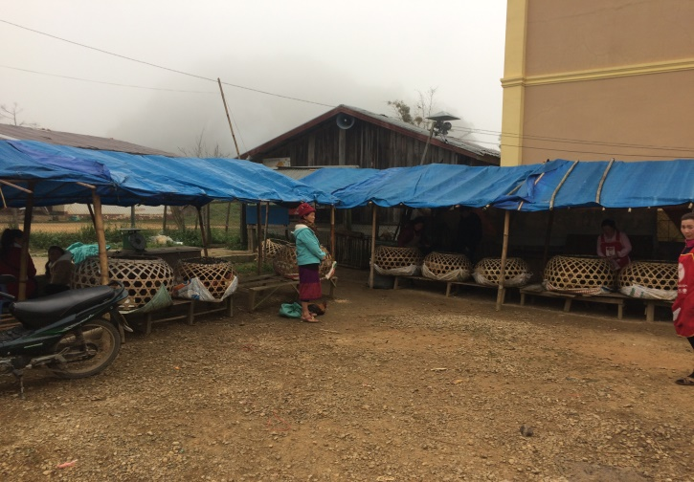

**Cross-district traders who sell at the Nong Het District Market *(above)* regularly buy from Bpek, Phaxay and Khoun Districts. This is because the Nong Het buying price for native chickens in producer villages is too high; due to the price Vietnamese traders are willing to pay for native chickens which they then sell on the Vietnamese market.**

**Profile 2: Vietnamese Traders in Nong Het District**

Supply, Demand and Obstacles

Vietnamese traders currently have tax-free access to cross into and out of Lao to buy native chickens in Nong Het (including the ‘black-boned’ breed which is detailed in a later section) particularly from Khangpanien and Lawng Guang villages as well as occasionally from some of Nong Het’s other 28 villages. Sometimes Vietnamese traders will buy other produce from the village at the same time whilst others travel specifically to buy native chickens. Other Vietnamese traders buy from cross-district traders at the Nam Khan Border. This is either done by arrangement between the two trader groups or during one of the border market days, which take place on the 10th, 20th, and 30th days of each month. Vietnamese traders almost never buy from the Nong Het Market as the price is usually at least 5000 Kip/kg more expensive. Also the district market tends to sell chickens over 2kg in weight whereas the Vietnamese prefer to buy chickens between 1 and 1.5kg. The higher prices per kilogram of chicken in Nong Het appears to largely be a result of the Vietnamese demand for native chickens and their ability to pay a higher rate than any in-district traders could for chicken.

**4.6.3. Nong Het District Case Study**

*See ‘Black-Boned Chicken’ section*

**4.6.4. Nong Het District Native Chicken SWOT Analysis**

|  |  |
| --- | --- |
| **Strengths** | **Weaknesses** |
| * Chicken producer villages are well known and tend to make a good income from chicken sales to Vietnamese traders. * There are some excellent examples in producer villages where technical raising methods (inc. vaccines) have been adopted and maintained, which have directly increased income from chicken sales. | * Chicken quantities per household in producer villages are high but extremely vulnerable to being wiped out in individual by diseases because vaccines and antibiotics are not adopted by many. * Native chicken is comparatively expensive for Nong Het consumers to buy (5000 – 10,000 Kip more expensive than the provincial markets). |
| **Opportunities** | **Threats** |
| * Show other producer households/villages the exemplary villages where technical methods and vaccinating has led to increased income. * Examining whether there is more consumer demand for native chickens in Vietnam which could allow Nong Het supply to increase. | * The high price of native chickens at the market means hybrid chickens may become increasingly popular in the future and could reduce the demand for native chicken. * If the supply of native chickens increases on the Vietnamese side of the border, it could affect the demand from Vietnamese traders for chickens in Nong Het producer villages. |

**4.7 Mok District – Native Chickens**

Native chickens in Mok District are sold at the Mok District Market and to Vietnamese traders who buy chickens from a producer village near the Vietnamese border. The district market is open on a daily basis although consumer demand for native chickens is quite low. Most end consumers who buy native chickens from the district market and producer villages are workers from various companies (i.e. electricity, construction, forestry) who are operating in the area.

**4.7.1 Mok District Native Chicken Value Chain**

End Consumers

End Consumers

Mok District Market

Vietnamese Market

**Sells at 42,000 – 46,000 Kip/kg**

*(Net Profit = 5000 Kip/kg)*

**Unknown Price**

Cross-District Traders

Vietnamese Traders

**Native Chickens.**

**Sells at 30,000 – 41,000 Kip/kg**

**Sells at 55,000 – 60,000 Kip/ kg**

Small-Scale Producers

1. Outside Mok District: Muang Ngaan

2.In Mok District: Long Mo, Yuak, Nam Jao, Namawn, Nakhae, Namsong, Dteun, Paadaeng

Samje Village, Mok District

**4.7.2 Mok District Native Chicken Buyer-Sellers Profile**

Two buyer-seller groups were identified in Mok District: **Cross-District Traders and Vietnamese Traders.**

|  |  |  |
| --- | --- | --- |
| **Buyer-Seller Profile** | **Cross-District Traders** | **Vietnamese Traders** |
| **No of Traders** | **1** | **> 7** |
| **Supply Sources** | * Villages outside of Mok District - Muang Ngaan (70%) * Mok villages: detailed above (30%) | * Samje Village |
| **Point(s) of Sale** | * Mok District Market | * Vietnamese Markets |
| **Buying Price** | 30,000 – 41,000 Kip/kg | 55,000 – 60,000 Kip/kg |
| **Selling Price** | 42,000-46,000 Kip/kg | Unknown |
| **Net Profit** | 5000 Kip/kg | Unknown |
| **Quantity/trader/month** | 120 birds |  |
| **Total Estimated Chickens/month** | 120 birds | 240 birds |
| **Processing** | None | None |

**Profile 1: Cross-District Traders in Mok District**

Supply, Demand and Obstacles

There is currently only one trader who sells at the market on a daily basis, selling on average 4 chickens per day. She buys most chickens from villages outside of Mok district (and therefore is considered a cross-district trader) - such as in Khoun District - due to a minimal supply of native chickens in villages around the Mok district market, as well as the relatively high price of chickens in Mok district. One of the reasons that the prices are high in Mok District is because up until recently there have been electricity and forestry companies in the area who tend to buy directly from nearby villages and are usually willing to pay a relatively high rate per kilogram or per chicken (i.e. more than 50,000 Kip/ kg). Afterwards, villages with chicken-producing families often set this selling price as the new benchmark rate and are unwilling to reduce the price – even to in-district or cross-district traders who would buy from them on a regular basis. The cross-district trader normally sells most chickens at the district market to Vietnamese working in Lao and sometimes to forestry workers (but not as much since the implementation of the Lao timber export ban which has meant there is less forestry work in Mok District).

Villagers also come to sell their chickens at the district market about four times a month to coincide with the lunar calendar, as locally these are considered holidays and local people tend to buy chickens on these days. Anecdotally, this amounts to about 10-15 chickens sold each moon, and therefore about 40-60 chickens in total each month.

**Profile 2: Vietnamese Traders in Mok District**

Supply, Demand and Obstacles

Vietnamese traders buy specifically in Samje village, which is 7km from the Vietnamese border. The traders come to buy several times and week and sometimes on a daily basis, buying at least 20 native chickens each time (travelling by motorbike) at 55-60,000 Kip/kg. Little was known in the village about how and where the Vietnamese traders sell the chickens in Vietnam, although there are towns about 15-20 km inside the Vietnamese border that the chickens were thought to be sold at. Similar to the Nong Het border crossing, there is relatively free and unrestricted ability for Vietnamese traders to buy and take chickens into Vietnam across the border from Mok District, and the standard tax fee per chicken of 2000 Kip per chicken is currently waived to encourage trade on both sides of the border.

**4.7.3 Mok District Case Study**

*See ‘Black-Boned Chicken’ section.*

**4.7.4 Mok District Native Chicken SWOT Analysis**

|  |  |
| --- | --- |
| **Strengths** | **Weaknesses** |
| * For a remote village, Samje villagers make a good additional income through selling chickens to Vietnamese traders. * Up until now, some villages in Mok District have received a good income from selling chickens to consumers working with electricity, construction and forestry in the district. | * The lack of chicken raising methods creates vulnerability to village chicken stocks and risks chickens regularly being wiped out from diseases (especially in Samje village as they have a high supply). * Village chicken producers’ unwillingness to lower their prices to encourage in-district or cross-district traders to buy locally may mean traders will continue to build up working relationships with producer villages elsewhere. * Given Mok’s remoteness, there is little opportunity to raise chickens for other areas of XKH. |
| **Opportunities** | **Threats** |
| * The District Agricultural Office has demonstrated some enthusiasm to encourage use of vaccinations and technical support for large-livestock raising so they could use the same training model for chickens too. * The implementation of electricity in rural Mok villages in 2017 may provide beneficial for raising chickens (i.e. storing vaccines, using light to keep chicks warm, etc.). | * The high price of native chickens in Mok District combined with the possible increased supply and demand of hybrid meat chickens could reduce consumer demand for native chickens. * The timber export ban, along with completion of electricity in Mok District in 2017 may mean that some villages will suffer a decline in income from the sale of chickens to workers temporarily living in the district. |

***5. NATIVE BLACK-BONED CHICKENS***

**5.1. Xieng Khouang: Provincial Overview**

(including Bpek District)

**Introduction**

Black-boned chickens are estimated to account for only 2.9% share of the province’s chicken market. Vietnamese traders either buy from cross-district traders at the Nam-Khan Border or buy directly from villages producing and selling this breed, at a higher per kilogram price than regular native chickens. Several villages in the province raise black-boned chickens specifically due to the demand from the Vietnamese market. Perhaps as a result of the Vietnamese demand, few if any black-boned chickens are sold at the provincial or district markets in Xieng Khouang and therefore black-boned chickens sold on the local market are those raised along with regular native chickens and normally sell at the same price per kilogram as native chickens. However, Lao end consumers also buy young chickens from certain villages to raise them in their own villages.

**5.1.1 XKH Province Native Black-Boned Chicken Market Profile**

|  |  |
| --- | --- |
| **Black-Boned Natives** | |
| **Average Market Selling Age & Weight** | 1-1.2kg |
| **Province Supply per Month (Estimated)** | >900 birds |
| **Market Share (%)** | 2.9% |
| **Average Supply Price per Kilogram** | 30,000-70,000 Kip/kg |
| **Average XKH Market Price per Kilogram** | If in small quantity, the same as regular natives (i.e. 40,000-45,000 Kip/kg) |
| **Average Profit** | 5000-25,000 Kip/kg |
| **Market Forms** | Live chickens (occasionally sold butchered at Phoukham Market) |

**5.1.2 XKH Province Native Black-Boned Chicken Value Chain**

The main producer villages of black-boned chickens identified were in Mok and Nong Het Districts. Other villages, such as Laethong village in Phoukhout District had previously raised black-boned chickens although currently all had died due to disease and suppliers had yet to breed and raise the chickens again. The reason Mok and Nong Het Districts have villages with a high proportion of households producing black-boned chickens – sometimes specifically – is because they are on the Vietnamese border and Vietnamese traders regularly enter the villages to buy these chickens, often along with other goods, to take back to Vietnam and sell at the market there. Current notable villages which produce black-boned chickens are Samje village in Mok District, and Lawng Guang and Khangpanien in Nong Het District – with the latter village being the only example where technical methods of chicken raising are comprehensively maintained. Khangpanien is also the village which specifically sells young black-boned chickens to Lao consumers who raise them to consume once they are a larger size and weight. Other supply villages may have some black-boned chickens but do not raise them specifically as they are generally sold at the same price as regular natives.

End Consumers

Vietnamese

Market

End Consumers

Vietnamese

Traders

Nam Khan Border

Provincial Market

**Sells at 40-45,000 Kip/kg**

*Net profit = 10,000-15,000 Kip/kg*

**Sells at 55-60,000 Kip/kg**

*Net profit = 20,000-25,000Kip/kg*

**Unknown Price**

Cross-District Traders

End Consumers

District Market/ Village Day Market

**Sells at 55-60,000k/kg**

**Sells at 30,000-35,000 Kip/kg**

Net profit = 5-10,000 Kip/kg

**Sells at 70,000 Kip/kg**

In-District Traders

End

Consumers

**Sells 2 Chickens at 100,000 Kip**

**Sells at 25,000-30,000 Kip/kg**

Mok District Producer Villages

(large scale, organised raising)

Nong Het District Producer Villages

(large scale, organised raising)

Other XKH Producer Villages

(small scale, non- organised raising)

**5.1.3 XKH Province Native Black-Boned Chicken: Sources of Supply\***

Lawng Guang

Samje

10%

34%

Vietnamese Market

5%

51%

XKH Markets

Khangpanien

Other Villages

\*Details of sources by district can be found in the following Nong Het and Mok District black-boned chicken sections.

**5.1.4 XKH Native Black-Boned Chicken Provincial Market: Supply and Demand**

As previously stated, few black-boned chickens are sold at provincial or district markets. Several live chickens were observed at provincial and district over a 14-day period with some traders asking a higher price per kilogram for them but most asked the same price as regular natives.

**5.1.5. XKH Province Native Black-Boned Chicken Buyer-Sellers Profile**

Three buyer-seller groups were identified in the province: **In-District Traders, Crosss-District Traders &** **Vietnamese Traders.**

|  |  |  |  |
| --- | --- | --- | --- |
| **Buyer-Seller Profile** | **In-District Traders** | **Cross-District Traders** | **Vietnamese Traders** |
| **No of Traders** | **Variable** | **Variable** | **> 15** |
| **Supply Sources** | * Non-specific producer villages which at the current time do not specifically breed black-boned chickens | * Non-specific supply villages which at the current time do not specifically breed black-boned chickens | * **Nong Het**   (B. Khangpanien and B. Lawng Guang - rarely others)   * **Mok**   (B. Samje)  **- Vietnam Border** |
| **Point(s) of Sale** | **District Markets** | * **Provincial Markets** * **Nam Khan Border (to Vietnamese traders)** | * **Vietnamese Markets** |
| **Buying Price** | **25,000 - 30,000 Kip/kg**  (usually the same price as regular native breeds) | **30,000-35,000 Kip/kg**  (usually the same price as regular native breeds) | **55,000-60,000K/kg**  (60,000K at Hmong New Year; Lower price for bulk-buying) |
| **Selling Price** | **Local Markets: 30,000-35,000 Kip/kg** | * **Provincial Markets: 40,000 – 45,000 Kip/kg** * **Nam Khan Border:**   **55,000 – 60,000 Kip/kg** | **Unknown** |
| **Net Profit** | 5000 – 10,000 Kip/kg | 10,000 – 25,000 Kip/kg | **Unknown** |
| **Quantity /trader/month** |  |  | **50-70 birds** |
| **Total Estimated Quantity /month** | **>50 birds** | **>50 birds** | **>950 birds** |
| **Processing** | None | None | None |

**Profile 1: In-District Traders in XKH Province**

**Supply, Demand and Obstacles**

Most in-district traders come across black-boned chickens when they are purchasing regular native chickens in producer villages or when the producer brings to the trader. This is generally sold at district markets for the same rate as regular natives (typically 30,000 – 35,000 Kip/kg, making a 5000 Kip profit/kg).

**Profile 2: Cross-District Traders in XKH Province**

**Supply, Demand and Obstacles**

Cross-district traders who sell at the provincial market generally do not distinguish between regular and black-boned native chickens and therefore sell at the normal native chicken rate of 40,000 – 45,000 Kip/kg at the provincial market. However, for cross-district traders who regularly sell in Nong Het district know that they will be able to sell the black-boned chickens directly to the Vietnamese traders for about 55,000 Kip/kg (therefore making 20,000 – 25,000 Kip/kg profit). The main obstacle for these traders is the low supply of black-boned chickens in districts other than Mok and Nong Het, making it difficult to justify the cost of travelling to those provinces to sell black-boned chickens unless they are already selling regular native chickens there.

**Profile 3: Vietnamese Traders in XKH Province**

**Supply, Demand and Obstacles**

Vietnamese traders buy ‘black-boned’ chickens in a similar way to when they buy regular native breeds, and often traders will purchase both breeds at the same time. However, there are currently only two main observed producer villages in Nong Het – Khangpanien and Lawng Guang villages – as well as Samje village in Mok District. Occasionally this includes buying from cross-district traders at the Nam Khan border but Vietnamese traders who specifically want black-boned chickens normally go directly to one of these three villages. Where smaller quantities are concerned (10-20 chickens), traders will enter the village without prior arrangement but for purchases of 50 chickens or more, normally the trader will contact the village in advance. Motorbikes are used by traders to transport small quantities of chickens to Vietnam but bigger vehicles (i.e. Hyundai Porters) are typically used for transporting purchases of 100 chickens or more.

**5.2Nong Het District – Native Black-Boned Chickens**

**5.2.1 Nong Het District Native Black-Boned Chicken Value Chain**

End

Consumer

Vietnamese

Market

**Unknown Price**

Nam Khan

Border

Vietnamese

Traders

**Sells at 55-60,000k/kg**

**Net profit =**

**20-25,000 Kip/ kg**

End

Consumer

**Sells at 55-60,000 Kip/kg**

In-District Traders

**Sells other chickens at**

**55-60,000 Kip/kg**

**Sells 2 x**

**2-month Chickens (male & female) at 100,000 Kip**

**Sells at 30-35,000 Kip/kg**

Khangpanien Producer Village, Nong Het

Lawng Guang Producer Village, Nong Het

Other Nong Het Producer Villages (rarely)

**5.2.2. Nong Het District Native Black-Boned Chicken Buyer-Sellers Profile**

Two main buyer-seller groups were identified in Nong Het District – **‘In-District Traders’** and **‘Vietnamese Traders’**. Additionally, the **‘End Consumer’** group is included here as this is an interesting example of this group buying young chickens directly from the producer village.

|  |  |  |  |
| --- | --- | --- | --- |
| **Buyer-Seller Profile** | **In-District Traders**  **(rarely)** | **Vietnamese Traders** | **End Consumers**  **(Lao)** |
| **No of Traders** | Unknown | > 15 | >50/year |
| **Supply Sources\*** | * Various villages in Nong Het | * Local Villages   (Khangpanien and Lawng Guang villages- rarely others) | * Specific households in Khangpanien village |
| **Point(s) of Sale** | Nam Kham Border (to Vietnamese traders) | * Vietnamese Markets | Raised and consumed in various provinces including XKH, Xaysomboun, Luang Prabang |
| **Buying Price** | 30-35,000 Kip/kg | 55,000-60,000K/kg  (60,000K at Hmong New Year; Lower price for bulk-buying) | 100,000K/ sets  (1 male & 1 female per set) |
| **Selling Price** | 55-60,000 Kip/kg | Unknown | n/a |
| **Net Profit** | 20-25,000 Kip/kg | Unknown | n/a |
| **Total Estimated Chickens /month** | Unknown – but minimal  (i.e. <30 birds) | >830 birds | 23 sets (46 young birds) |
| **Processing** | None | None | None |

\*Rarely at the Nong Het District Market but priced at 55,000-60,000K when they are sold there

**Profile 1: In-District Traders in Nong Het District**

**Supply, Demand and Obstacles**

Very occasionally, when a village or family outside of Khangpanien or Lawng Guang villages have several black-boned chickens, in-district traders purchase the chickens at a typical rate of 30-35,000 Kip/kg and transport them to the Nam Khan border for Vietnamese traders to buy. This is usually done without arrangement and without guarantee of selling. However, if they can sell them, their net profit is about 20-25,000 Kip/kg.

**Profile 2: Vietnamese Traders in Nong Het District**

**Supply, Demand and Obstacles**

Vietnamese traders buy ‘black-boned’ chickens in a similar way to when they buy regular native breeds, and often traders will purchase both breeds at the same time. However, there are currently only two main suppliers in Nong Het – Khangpanien and Lawng Guang villages. Occasionally this includes buying from Lao traders at the Nam Khan border but Vietnamese traders who specifically want black-boned chickens normally go directly to one of these two villages. Where smaller quantities are concerned (10-20 chickens), traders will enter the village without prior arrangement but for purchases of 50 chickens or more, normally the trader will contact the village in advance. Motorbikes are used by traders to transport small quantities of chickens to Vietnam but bigger vehicles (i.e. Hyundai Porters) are typically used for transporting purchases of 100 chickens or more.

As with regular native chickens being taken into Vietnam, there is currently no border tax. According to black-boned chicken producers, the Vietnamese traders can set a higher market selling price for the ‘black-boned’ chickens compared to the regular native breeds, although market rates in Vietnam are currently unknown. No direct contact was made with Vietnamese traders for information but black-boned chicken producers also said Vietnamese traders may want the supply of ‘black-boned’ chickens to increase, but that they were not entirely sure about this

**Profile 3: End Consumers (Lao) in Nong Het District**

**Supply, Demand and Obstacles**

Every year, a number of Lao people – either passing through or working in Nong Het travel to Khangpanien Village to purchase a ‘set’ of young black-boned chickens. A set includes one male and one female at about 2 months of age and costs 100,000 Kip. When asked if these consumers would sell the black-boned chickens in their village, the Khangpanien producer who sells these chicken sets stated that the buyer will then take the chickens back to their province to raise them to breed and then be able to consume the chickens when they are a larger size and weight. Vietnamese traders do not tend to purchase these chickens sets as they look to sell larger chickens at Vietnamese markets.

**5.2.3. Nong Het District Native Black-Boned Chicken Case Study**

**Methods of Raising Native Black-Boned Chickens: Khangpanien and Lawng Guang Villages**

The two black-boned chicken producer villages in Nong Het are Khangpanien and Lawng Guang. Both villages had chicken-raising support from an organization which began in 2014 and completed in 2016, through which several households adopted the program. This involved technical support of raising native chickens, including black-boned chickens such as vaccinating, flock management and providing high protein food. Whilst investment and the provision of equipment was not an objective of the organization, some roofing materials were supplied so recipients could build their own chicken coops.

Khangpanien village has some excellent examples of how these techniques have been maintained, and as a result the production of chickens has been highly successful. Of the households who adopted the program, all of them 1). Built chicken coops, 2). Separate chicken ages (sometimes with up to 4 age categories), 3). Follow the protein diet to some extent and 4). Use methods to keep chicks warm in the cold weather. Most households do also follow the disease prevention and treatment techniques (vaccines and antibiotics) to some degree. One household in Khangpanien – the head of the chicken group whose specific occupation is now to raise black-boned chickens – follows these techniques in their entirety by vaccinating chickens every 2.5 months and providing vitamins and antibiotics, particularly to chicks at about 2 weeks old. They also use chicken nets to prevent the chickens from contact with other village chickens and never bring poultry to the house from outside. These methods appear to have been highly beneficial as when a large percentage of the village chickens died from disease last year, none of group head’s chickens died as none contracted the disease. Perhaps as a result of this and a constant supply of black-boned chickens, this producer has established a good network with Vietnamese traders and Lao consumers and reported an income from black-boned chickens of about 50 million Kip in 2016.

Lawng Guang village has also maintained the techniques similar to Khangpanien village. However, no vaccinations are done in this village and their reason for this is that they have never had any disease in the village (the village is 4km from the next village). They do have strict regulations which restrict anyone bringing poultry into the village from outside, and any visitors who bring poultry-based food must eat it or leave it outside the village. However, due to the lack of disease the perceived security has meant that there are now several thousand native chickens (regular and black-boned) in the village. This makes the village highly vulnerable as one diseased chicken could potentially wipe out the whole village flock and may mean the village losing its entire income from the chicken market.

It should also be mentioned that there are villages closer to the Vietnamese border than these two villages where Vietnamese traders want to buy chickens but disease has entirely wiped out these numbers – ‘Din Dam’ village being one example.

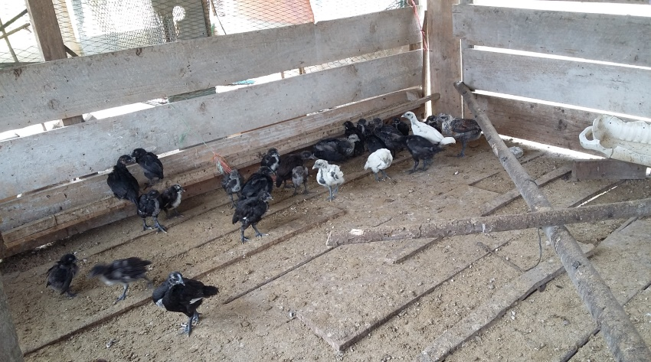 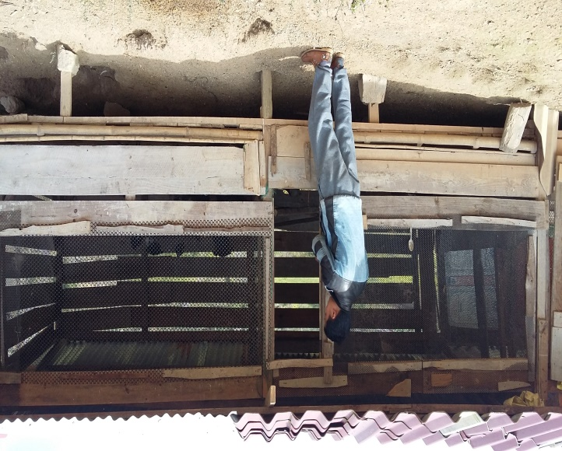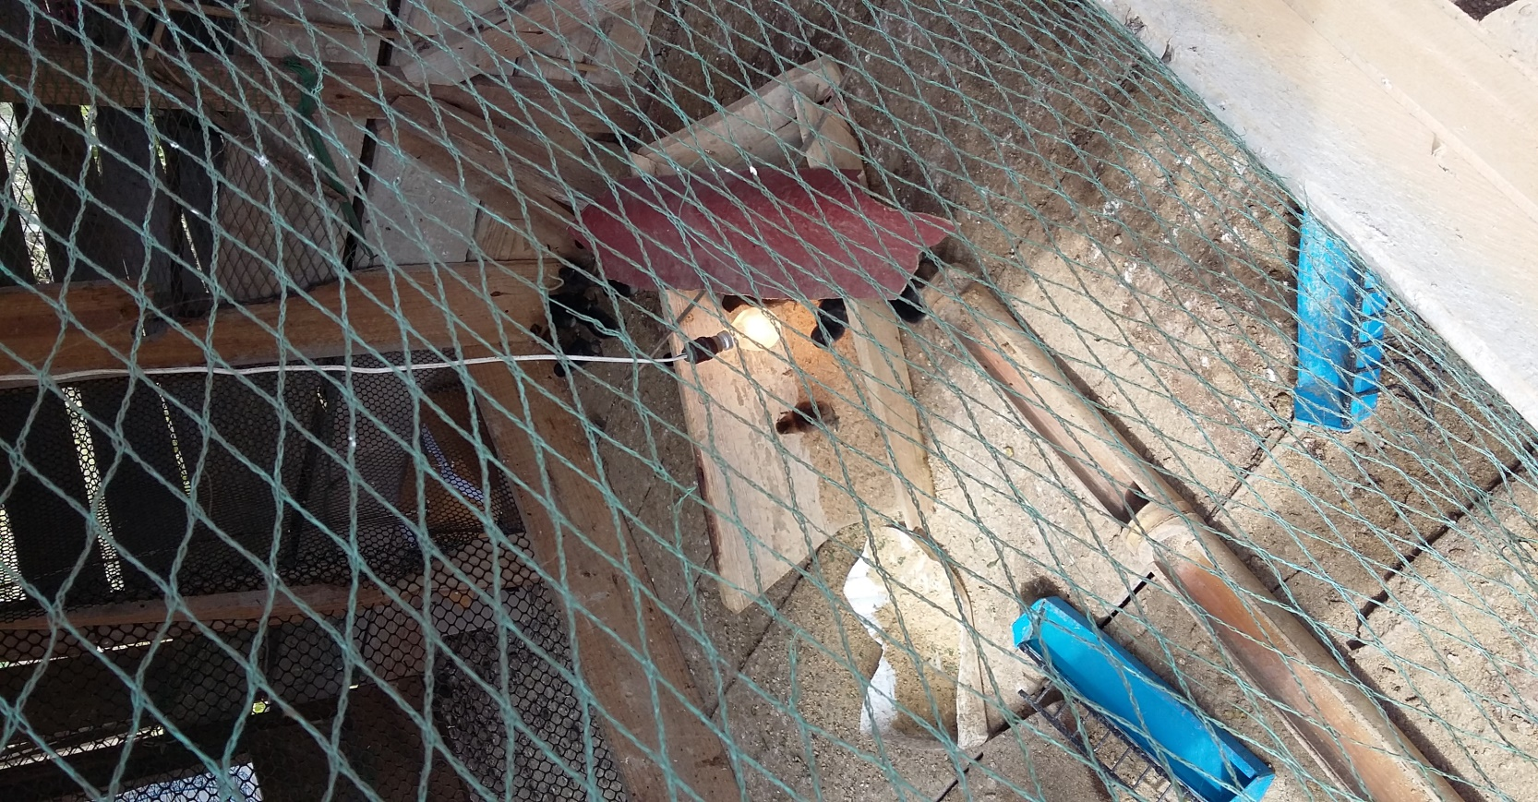 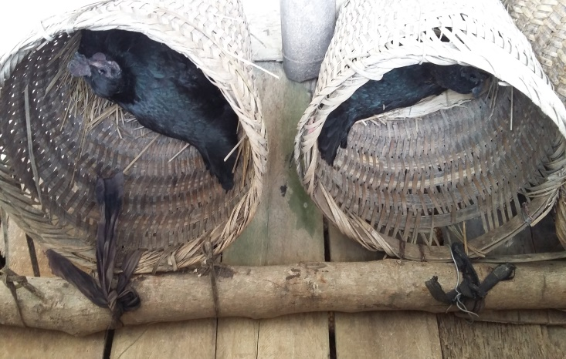

**The village of Khangpanien in Nong Het District sold a high number of black-boned chickens to Vietnamese traders and some Lao consumers and maintained an organized system of chicken raising, including the separation of four different age groups in the chicken coop *(top left and right),* using electric lights to keep chicks warm in cold weather *(bottom left)* and using baskets for brooding hens to assist the fertility of eggs *(bottom right).* Vaccinations are also maintained regularly by some families.**

**5.2.4. Nong Het District Black-Boned Chicken SWOT Analysis**

|  |  |
| --- | --- |
| **Strengths** | **Weaknesses** |
| * Excellent examples of raising black-boned chickens using technical methods. * Due to consistent supply of chickens, the two main villages have a high reputation for producing black-boned chickens and sell them frequently. * Some black-boned chicken producers have been on a Lao news network regarding raising of the chickens, and this could provide a good example to other villagers to produce black-boned chickens. | * Some villagers choose not to vaccinate their chickens and sometimes catch disease, which subsequently increases the risk for all other chicken producers (even those who do vaccinate). |
| **Opportunities** | **Threats** |
| * Despite producers stating that black-boned chickens supply is currently sufficient for Vietnamese traders, research of market demand for black-boned chickens may determine if there is potential to increase supply. * The waiving of tax for purchased livestock on the border crossing to Vietnam is extra incentive for Vietnamese traders to buy in Nong Het. | * If other villages (particularly in Vietnam) increase their production of black-boned chickens – especially if they can sell at a lower price – it could drastically reduce income in Nong Het villages whose income is largely from producing black-boned chickens. |

**5.3 Mok District – Native Black-Boned Chickens**

**5.3.1 Mok District Native ‘Black-Boned’ Chicken Value Chain**

End Consumer

Vietnamese Market

**Unknown Price**

Vietnamese Traders

**Black-Boned Chicken Sells at 70,000 Kip/ kg**

Samje Producer Village,

Mok District

**5.3.2 Mok District Native Black-Boned Chicken Buyer-Sellers: Profile**

The single identified buyer-seller group of black-boned chickens in Mok District was **Vietnamese Traders**.

|  |  |
| --- | --- |
| **Buyer-Seller Profile** | **Vietnamese Traders** |
| **No of Traders** | **> 7** |
| **Supply Sources\*** | Samje Village |
| **Point(s) of Sale** | Vietnamese Markets |
| **Buying Price** | 70,000 Kip/Kg |
| **Selling Price** | Unknown |
| **Net Profit** | Unknown |
| **Quantity /trader/month** |  |
| **Total Estimated**  **Chickens /month** | >90 birds |
| **Processing** | None |

**Profile: Vietnamese Traders in Mok District**

Supply, Demand and Obstacles

Vietnamese traders buy specifically in Samje Village, which is about 7km from the Vietnamese border. Traders come to buy several times and week and sometimes on a daily basis, buying at least 20 chickens each time at 70,000 Kip/kg. Village producers stated that about 20 percent of sold chickens were the black-boned breed (the rest being regular native chickens) and therefore about 4 black-boned chickens are sold each time on average. The Vietnamese traders also buy other supplies in Samje, such as dogs, for the Vietnamese market. Little is known about how and where the Vietnamese traders sell the chickens in Vietnam. However, similar to the Nong Het border crossing, there is relatively free and unrestricted ability to take chickens into Vietnam from the Mok District border and the standard tax fee per chicken is 2000 Kip per chicken is currently waived to encourage trade.

**5.3.3 Mok District Native Black-Boned Chicken Case Study**

**Samje Village: Native Black-Boned Chickens’ Producer - Methods of Chicken Raising**

Samje village, in Mok District, is about 32km from the District town and 7km to the Vietnam border – where there is a small official border crossing between Lao and Vietnam. Several Vietnamese traders cross the border to buy native chickens in the village every week, buying about 20 chickens each time to take back to Vietnam on their motorbikes. No Lao in-district or cross-district traders buy from the village as the price is too high to sell on the local market. Given the remoteness of the village – and the fact electricity is only to be implemented in 2017, the sale of native chickens is a good source of income for village households.

There are 60 families in the village and each family has between 25-50 chickens per family (with about 20% being the black-boned breed). Therefore there is estimated to be somewhere between 300 and 600 black-boned chickens in the village. This breed is sold at the higher price of 70,000 Kip/kg (10,000 – 15,000 Kip/kg more than regular natives) as there is high demand from Vietnamese consumers for the black-boned variety. The monthly sale of chickens is over 90 black-boned birds, giving an total village income of about 6.3 million kip each month.

Despite the income from Vietnamese traders, chickens in the village are raised entirely naturally with no chicken coop, flock management, prevention/treatment of diseases or high protein food. As a result, frequent diseases have previously wiped out the village’s quantity of chickens. Additionally, during the cold season, chicks frequently die from the cold weather and one of the problems is that with the lack of electricity in the village they cannot use lights to keep the chicks warm.

There has previously been technical support in the village. An Australian organisation provided vaccination techniques to one household but they did not follow the training as they said they had no access to vaccines. The District Agricultural Office also had centralised training in the district town for the village chief but this was for cattle only.

**5.3.4 Mok District Black-Boned Native Chicken SWOT Analysis**

|  |  |
| --- | --- |
| **Strengths** | **Weaknesses** |
| * Samje villagers generally make a good additional income through selling black-boned chickenss as the techniques for raising them are exactly the same as regular natives but they can get an extra 10-15,000 Kip/kg profit more. | * The lack of chicken raising methods creates vulnerability to village chicken stocks and risk regularly being wiped out from diseases (especially in Samje village). |
| **Opportunities** | **Threats** |
| * With the higher profit obtained from black-boned chickens compared to regular natives, producers may be more willing to invest in chicken-raising methods, such as vaccinations. * There may be potential to focus demand on and increase supply of black-boned chickens for the Vietnamese – and possibly Lao – markets. The Lao-Viet border is open and it appears that the Vietnamese traders would buy more black-boned chickens if supplied. | * Similarly to the potential threat in Nong Het District, if Vietnamese traders or other groups start raising their own black-boned chickens in Vietnam (and regular natives too), it may decrease the need for Vietnamese traders to cross the border and buy black-boned chickens in Samje Village. |

***6. HYBRID MEAT-CHICKENS***

**6.1 Xieng Khouang: Provincial Overview**

(including Bpek District)

**Introduction**

According to buyer-sellers, hybrid meat-chickens were first brought to and sold in Xieng Khouang in 2010. They currently make up about 37.8% of the province’s chicken market supply. Most hybrid meat-chickens sold in Xieng Khouang are transported by wholesalers, although there is also a small hybrid meat-chicken producer farm in Kham District.

**6.1.1. XKH Province Hybrid Meat-Chicken Market Profile**

|  |  |
| --- | --- |
| **Hybrid Meat-Chickens** | |
| **Average Market Selling Age** | Between 45 and 60 days old |
| **Selling Weight**  **(at 45 days)** | 1.2 - 1.4 kg |
| **Province Supply per Month (Estimated)** | 11,000 - 12,000 birds |
| **Proportion of XKH Chicken Market Supply (%)** | Hybrid meat-chickens produced in XKH = 2.3%  Hybrid meat-chickens produced in VTE = 35.5%  Total = 37.8% |
| **Provincial Market Price** | 35,000 Kip/chicken  (typically between 1.2 and 1.4kg) |
| **Market Forms** | slaughtered/plucked chickens (live forms very occasional) |
| **Giblets Pricing** | 3 x chickens’ giblets = 10,000 Kip |

**6.1.2. XKH Province Hybrid Meat-Chicken Value Chain**

There are three main wholesalers of hybrid meat-chickens in Xieng Khouang who purchase the chickens from the CP Lao Farm at ‘Lak 15’ in Vientiane and supply over 93% of the Xieng Khouang hybrid meat-chicken market. The vast majority of their hybrid meat-chicken supply is sold in Bpek District – particularly to market-butcher suppliers at the provincial market as well as bulk buyers, who are usually businesses such as restaurants and event organisers. The rest of the supply is distributed district traders in all of XKH’s districts. In other districts, hybrid meat-chickens are mostly sold to bulk-buyers – such as restaurants and various events (weddings, parties, etc.) but these chickens are not yet sold in district markets, with Kham District being the only exception (which sells live hybrids). The wholesalers buy the hybrid meat-chickens at 20,000 Kip/ kg (at about 45 days old and weighing about 1.2kg weight) and sell them in Xieng Khouang at 30,000 Kip per chicken – at about the same weight. Therefore gross profit is about 6,000 Kip. Traders stated that expenses per trip whilst travelling to buy 1000 chickens is about 1.5 million kip.

The hybrid meat-chickens farm in Kham District produces chickens to supply to a number of district suppliers in Kham District as well as end consumers both within and outside Kham District. The farm predominantly sells hybrid meat-chicks at 5000 Kip from 1-2 week old chicks which district suppliers buy to raise themselves until they reach over 1kg in weight, before selling them at the Kham District market.

**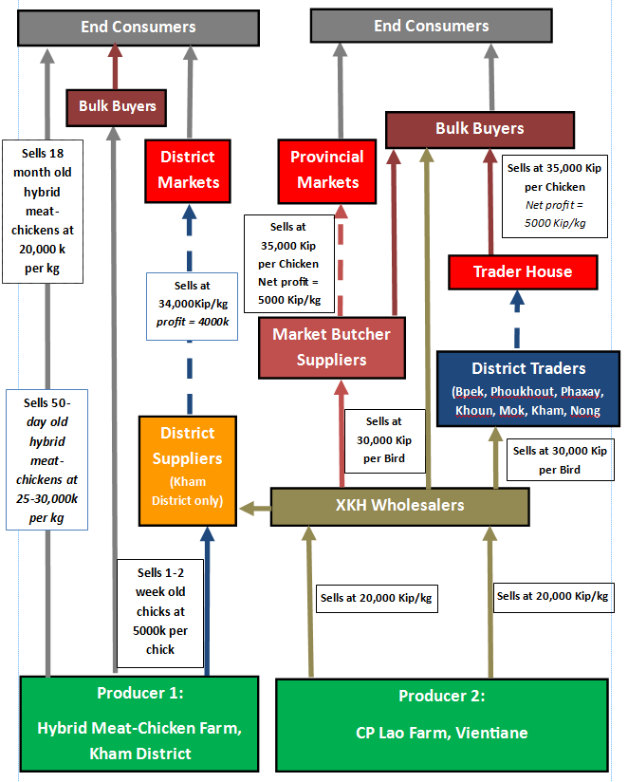**

**6.1.3.**  **XKH Province Hybrid Meat-Chickens: Sources of Supply**

The total market supply of hybrid meat-chickens in Xieng Khouang each month is estimated to be about 11,700 chickens, of which 86% is supplied for Bpek District (for the provincial markets and bulk buyer locations). The main XKH wholesaler (Wholesaler 1) purchases about 5000 hybrid meat-chickens per month (1000 chickens per trip, five times a month), with Wholesalers 2 & 3 buying 3000 each per month. These are sold to market-butcher suppliers (who sell at the provincial markets), bulk-buyers within Bpek District or district suppliers around the province. The Kham District hybrid meat-chickens farm produces about 750 birds per month – including both chick and chicken sales.

Wholesaler 2

Wholesaler 1

**Provincial Markets & Bpek District:**

(>9400/month)

**Other XKH Districts:** (>2300)

25.5%

42.5%

25.5%

6.5%

Kham District Hybrid Meat-Chicken Farm

Wholesaler 3

**6.1.4. XKH Provincial Market – Hybrid Meat-Chicken Supply and Demand**

Hybrid meat-chickens are sold in each of Phonsavan’s three ‘provincial’ markets – Phoukham, Sam San and Nam Ngam. There are no live chickens sold as all hybrid birds are slaughtered, plucked with giblets removed by each market-butcher supplier who buys the chickens from the XKH wholesalers. The average supply of slaughtered hybrid meat-chickens on a ‘normal’ market day is about 230 and the average sales-to-supply rate is 68% - so this is higher than the live native chicken sales-to-supply rate but about 20% lower than the slaughtered native bird rate. Therefore, market-butcher suppliers tend to sell the number of chickens they have slaughtered, plucked and butchered in about 1.5 days. Hybrid meat-chicken supply stays consistent through the year although it increases to about 1.5 times the normal supply over the Hmong New Year period.

|  |  |  |
| --- | --- | --- |
| Daily Supply & Demand | **‘Normal’ Market Day** | **Hmong New Year Market Day** |
| **Average Sales** | 157 | 232 |
| **Average Supply** | 230 | 284 |
| **Sales to Supply Ratio** | 0.68 | 0.82 |
| **Average No. Sellers** | 8 | 10 |

**Daily Sales/Non-sales of Hybrid Meat-Chickens at XKH Provincial Market**

November 2016

Normal 7 Days

Hmong New Year 7 Days

**6.1.5. XKH Province Hybrid Meat-Chicken Buyer-Sellers Profile**

The two main buyer-seller groups which produce or supply hybrid meat-chickens for XKH province are the **XKH Wholesalers** (who transport hybrid meat-chickens from Vientiane) and the **Kham District Hybrid Meat-Chickens Farm Producer** (who produces hybrids for district suppliers and end consumers). *District suppliers and district traders’ profiles are detailed in the following district sections.*

|  |  |  |
| --- | --- | --- |
| **Buyer-Seller Profile** | **XKH Wholesalers** | **Kham District Hybrid Meat-Chicken Farm Producer** |
| **No of Traders** | **3** | **1** |
| **Supply Sources** | CP Lao Farm, Vientiane | Hybrid Meat-Chicken Farm in Kham District |
| **Point(s) of Sale** | All districts: Bpek, Phoukhout, Khoun, Phaxay, Kham, Mok,  Nong Het | Traders, bulk buyers and consumers come to purchase at the farm from most districts in Xieng Khouang |
| **Buying Price** | 20,000 Kip/kg | n/a |
| **Selling Price** | 30,000 Kip per chicken | * Chicks = 5000 Kip each * 50-day hybrid meat chickens = 25,000-30,000 Kip/kg * 18 month old hybrid meat chickens = 20,000 Kip/kg |
| **Net Profit** | 6,000-11,000 Kip/ chicken | unknown |
| **Quantity (/trader/month)** | 1 x 5000 birds ;  2 x 3000 birds | See below |
| **Total Estimated Quantity/month** | 11,000 birds | Up to 600 x chicks  300 x 50-day old hybrid meat-chickens  4 x 18-month old hybrid meat-chickens |
| **Processing** | Requested slaughter and plucking chickens = extra 5000 Kip | None |

**6.1.6. XKH Province Hybrid Meat-Chickens: Consumer Profile**

Consumers in Xieng Khouang who buy hybrid meat-chickens on a regular basis can be distinguished by two categories – bulk buyers and small-scale buyers.

**6.1.6.1 Bulk Buyers and Decision-Making**

**Businesses** are the main group who tend to buy hybrid meat-chickens in bulk – particularly restaurants such as noodle soup shops, grilled chicken outlets and ‘op kin suk’ shops (Lao eateries where the food has already been prepared) – and also event organisers who provide catering services (i.e. wedding function halls). There are also bulk buyers who are preparing **personal/family events** and buying hybrid meat-chickens to cook for the event, such as weddings, parties, other celebrations and also funerals. Usually the above buyers will buy by arrangement.

These groups tend to buy hybrid meat-chickens because, as they are buying in bulk, they want both convenience and a lower price. Hybrid meat-chickens are convenient because they have already been slaughtered and plucked so all that has to be done in preparation for cooking is cutting off the head and feet. There are also slaughtered and plucked native chickens sold at the provincial market (and Kham District) but the reason these consumer groups do not purchase them is that each slaughtered native chicken is about 50% more expensive than the slaughtered hybrid meat-chickens. Also, for regular buyers, and also those who may need to request a large order of hybrid meat-chickens at short notice, the large-order requests can always be met whereas with native chickens, supply and selling price cannot be guaranteed.

**6.1.6.2 Small-Scale Buyers and Decision-Making**

Consumers who purchase less than five chickens per week at the provincial markets can be considered small-scale buyers. These tend to be families living in Phonsavan, typically working through the week – or running a business – and buy hybrid meat-chickens to cook for their families at home.

Again, these chickens tended to be bought for their convenience of already having been slaughtered and plucked, as well as the comparatively low price. They will also usually be able to store the chicken in a fridge at their home if they are not going to cook straight away. Market-butcher suppliers of hybrid meat-chickens stated that some consumers were unaware that these were hybrids and did not notice any difference to slaughtered native chickens (in either appearance or taste) and therefore some consumers assumed they were buying native chickens. Other consumers did know the difference between the hybrid and native chickens and, although many stated that they viewed hybrid meat-chickens to be inferior in quality to native chickens, considerations of ‘price’ vs ‘taste/quality’ made hybrid meat-chickens the preferred choice. Consumers who were asked about hybrid meat-chickens generally had a good awareness of the concepts of ‘free-range’ and ‘organic’, whilst several consumers also perceiving the production of hybrid meat-chickens to ‘using chemicals’ – referring to both the food the chickens ate and the environment which they were raised in. Again though, price was the biggest factor in this decision.

**6.2 Phoukhout District: Hybrid Meat-Chickens Buyer-Seller Profile**

|  |  |
| --- | --- |
| **Buyer-Seller Profile** | **District Traders** |
| **Supply Sources** | Wholesalers  (who buy from CP Lao Farm in Vientiane) |
| **Point(s) of Sale** | Bulk-buyers and other consumers buy from traders’ houses in Phoukhout – or are sometimes delivered by the district traders if sufficiently large quantities are purchased. |
| **Buying Price** | 28,00-30,000 Kip/chicken |
| **Selling Price** | 35,000-40,000 Kip/chicken |
| **Net Profit** | 5000-10,000 Kip/chicken |
| **Quantity (/trader/month)** | 50-75 birds |
| **Total Estimated Chickens/month** | 150-220 birds |
| **Processing** | Requested slaughter and plucking of chickens = extra 5000 Kip |
| **Value Chain Analysis** | The district trader goes to Phonsavan to buy hybrid meat-chickens from one of the wholesalers who regularly buys and transports hybrid meat-chickens from CP Lao farms in Vientiane. The district trader may sell straight away or raise the hybrid meat-chickens to a slightly larger size and weight, after which they typically sell to local businesses – restaurants, party functions, etc. but also some small-scale buyers. If businesses request for the district trader to slaughter and pluck the hybrid meat chickens, most are willing to do this and an additional fee of 5000 Kip is added per chicken. |

**6.3 Phaxay District: Hybrid Meat-Chicken Buyer-Seller Profile**

|  |  |
| --- | --- |
| **Buyer-Seller Profile** | **District Traders** |
| **Supply Sources** | Wholesalers  (who buy from CP Lao Farm in Vientiane) |
| **Point(s) of Sale** | Bulk-buyers and other consumers buy from traders’ houses in Phaxay – or are sometimes delivered by the district traders if sufficiently large quantities are purchased. |
| **Buying Price** | 28,000 – 30,000 Kip/kg |
| **Selling Price** | 35,000 - 40,000 Kip/chicken |
| **Net Profit** | 5000-10,000 Kip/chicken |
| **Quantity (/trader/month)** | 50-75 birds |
| **Total Estimated Quantity/month** | 150-220 birds |
| **Processing** | Requested slaughter and plucking chickens  = extra 5000 Kip |
| **Value Chain Analysis** | The main district trader meets wholesalers on the main road (Route 10) when they are transporting hybrid meat-chickens from CP Lao farms in Vientiane and is arranged by phone contact. The district trader either sells at the purchased size or raised to a slightly larger size and weight, after which they are typically sold to bulk buyers, such as local businesses and event organisers – restaurants, party functions, etc. If businesses request for the district trader to slaughter and pluck the hybrid meat-chickens, an additional fee of 5000 Kip is added per chicken. |

**6.4 Khoun District: Hybrid Meat-Chicken Buyer-Seller Profile\***

|  |  |
| --- | --- |
| **Buyer-Seller Profile** | **District Traders** |
| **Supply Sources** | Wholesalers  (who buy from CP Lao Farm in Vientiane) |
| **Point(s) of Sale** | Bulk-buyers and other consumers buy from traders’ houses in Khoun – or are sometimes delivered by the district traders if sufficiently large quantities are purchased. |
| **Buying Price** | 28,000-30,000 Kip/chicken |
| **Selling Price** | 35,000-40,000 Kip/chicken |
| **Net Profit** | 5000-10,000 Kip/chicken |
| **Quantity (/trader/month)** | 50-75 birds |
| **Total Estimated Chickens/month** | 150-220 birds |
| **Processing** | Requested slaughter and plucking chickens = extra 5000 Kip |
| **Value Chain Analysis** | The district trader gets the hybrid meat-chickens by meeting the wholesaler on the main road in Khoun when they are coming back from buying hybrid meat-chickens at the CP Lao farm in Vientiane. The district trader raises the hybrid-meat chickens to about 1.5kg, after which they are sold to various bulk buyers in the district. If businesses request for the district trader to slaughter and pluck the hybrid meat-chickens, an additional fee of 5000 Kip is added per chicken. |

\*There was previously a farm owner who was raising over 1000 hybrid meat-chickens on his farm for the XKH market. However, he is currently changing to hybrid-chicken egg production.

|  |  |
| --- | --- |
| **Buyer-Seller Profile** | **District Traders** |
| **Supply Sources** | XKH Wholesaler  (who buys from CP Lao Farm in Vientiane) |
| **Point(s) of Sale** | Bulk-buyers and other consumers buy from traders’ houses in Nong Het – or are sometimes delivered by the district traders to bulk-buyers if sufficiently large quantities are purchased. |
| **Buying Price** | 28,000 – 30,000 Kip/chicken |
| **Selling Price** | 35,000 - 40,000 Kip/chicken |
| **Profit** | 5000-10,000 Kip per Chicken |
| **Quantity /trader/month** | 50 - 110 birds |
| **Total Estimated Chickens/month** | 150 - 330 birds |
| **Processing** | Requested slaughter and plucking chickens = extra 5000 Kip |
| **Value Chain Analysis** | The district trader gets the hybrid meat-chickens delivered to Nong Het by one of the XKH wholesalers who regularly buys and transports hybrid meat-chickens from CP Lao farms in Vientiane. The district trader either sells the chickens straight away or sometimes raise them to about 1.5kg, after which they are sold to bulk buyers – restaurants, party functions, etc. If bulk-buyers request for the district trader to slaughter and pluck the hybrid meat-chickens, an additional fee of 5000 Kip is added per chicken. |

**6.5 Nong Het: District Hybrid Meat-Chicken Buyer-Seller Profile**

**6.6 Kham District**

**6.6.1 Kham District: Hybrid Meat-Chicken Value Chain**

End Consumer

End Consumer

**Sells 18 month old meat- chickens at 20,000 k per kg**

Bulk Buyers

Kham District Market

District Trader House

**Sells at 34,000Kip/kg**

***(profit = 4000k per kg)***

**Sells 50*-day old meat- chickens at 25-30,000k per kg***

District Supplier

District Trader

**Sells at 30,000k per chicken**

**Sells 1-2 week old chicks at 5000k per chick**

XKH Wholesalers

**Sells at 20,000 Kip/kg**

Producer 2:

CP Lao Farm, Vientiane

Producer 1:

Hybrid Meat-Chicken

Farm, Kham District. XKH.

**6.6.2 Kham District: Hybrid Meat-Chicken Buyer-Seller Profile**

Two buyer-seller groups were identified who purchased hybrid meat-chickens in Kham District: **District Suppliers**, and **District Traders.**

|  |  |  |  |
| --- | --- | --- | --- |
| **Buyer-Seller Profile** | **District Suppliers** | | **District Traders** |
| **Supply Sources** | Hybrid meat-chicken farm in Piew village  (near district town). | | XKH Wholesalers |
| **Point(s) of Sale** | Nong Het, Mok, Khoun, Kham and Bpek districts | Consumers come to buy at farm | Kham District Market (live)  Local Restaurants, or party functions |
| **Hybrid Meat-Chicken Types** | Chicks (at 1-2 weeks) | Chickens at 50 days | Chickens at about 45 days |
| **Buying Price** | 5000 Kip per chick | 25,000 – 30,000 Kip/kg | 30,000 Kip/chicken |
| **Selling Price** | 35,000 kg  (once raised to over 1kg) | Unknown | 34,000Kip/kg |
| **Profit** | 30,000-35,000 K/chicken (before raising costs) | Unknown | 4000-9000 Kip/chicken |
| **Quantity /trader/month** | Refer to total | Refer to total | 50-75 birds |
| **Total Estimated Chicks/chickens /month** | 600 birds | 180 birds | 150-220 birds |
| **Processing** | Slaughtered and plucked on request for 5000K/kg | none | Slaughtered and plucked on request for 5000K/chicken |

**6.6.2.1 District Suppliers Profile in Kham District**

According to the Kham Hybrid Meat-Chicken Farm owner, district suppliers come from most districts of XKH province to purchase 1-2 week-old chicks to take back and raise in their district. The hybrid meat-chicks are then raised until they are about 1-1.5kg, at which point they will be sold on to bulk-buyers or end consumers. The chicks are usually bought at the 1-2 week stage and therefore, in order to raise them to over 1kg, it will take about another 30 days. Buyers will typically not be able to breed the hybrid meat-chickens as this hybrid variety normally requires an egg incubator to achieve an optimum temperature for hatching. Hybrid meat-chickens at 50-days old and 18-months old tend to be purchased by bulk-buyers rather than district suppliers.

**6.6.2.2 District Traders Profile in Kham District**

Local Traders tend to buy the hybrid meat-chickens from the XKH wholesalers (who have transported them from the CP Lao Farm in Vientiane) as they will send the hybrid meat-chickens to Kham District for them. These chickens are then sold to bulk buyers (such as restaurants, event organisers, etc.) and at the district market (along with native chickens). These district traders buy each hybrid meat-chicken (about 1.2 kg weight) for 30,000 Kip and then can usually sell at the market for about 34,000 Kip/kg (between 4000-9000 Kip net profit), occasionally raising them to a larger size and weight.

**6.6.3 Kham District Case Study**

**Hybrid Meat-Chicken Farm Producer in Kham District: Methods of Chicken Raising**

An employee from the Kham District Agricultural Office started a hybrid meat-chicken farm just outside of the district town in 2012, buying the hybrid chickens from China initially, and is now self-subsistent. At any one time, he keeps 50-60 hens and breeding roosters (10:1 ratio respectively) for the purpose of producing hybrid meat-chicks using artificial insemination. Normally, within a one to two week period, the farm produces 300 fertilised eggs which, once hatched are sold as chicks to district suppliers (and some consumers) who raise them to sell onwards.

Despite breeding hybrid meat-chickens usually being raised as at least partially free-range, the farm owner has a cage setup built above a fish farm pond (however with slightly more space than battery cages for hybrid egg-laying hens allow). Fertilised eggs are collected on a daily basis and are put into an egg incubator for up to 21 days to optimise temperature and the likelihood that fertilised eggs will hatch. Once the eggs have hatched, or are hatching, the chicks are moved to a pen for up to one week and then after that to another pen for a final week before they are sold in bulk.

All chicks are usually sold within a 2-week period. District traders typically buy the chicks in order to raise them to between 1 and 1.5 kg, after which they are commonly sold to bulk-buyers, such as restaurants, event organiser and others for personal household use. The farm owner stated that district suppliers and some bulk buyers come to the farm from all around the province. Chickens at 50-days old and 18-months old are sold to bulk buyers or end consumers. The owner stated that the amount he supplies for the market is sufficient and there is no current potential to expand hybrid meat-chicken-raising operations. However, he is currently looking at the possibility to use the same farming system to produce and sell native chickens.

Vaccinations are done on a regular basis and the farm owner says he has never had problems with disease before. Chicken feed is purchased and mainly includes grain pellets and corn. The business is currently secure from similar local competition unless they purchase a large-scale egg incubator, which the farm owner purchased from China for about $3000.

The significance of this farm is that it shows the techniques of how these hybrid meat-chickens can produce eggs and chicks in a systematic manner to meet consumer demand. Therefore, it could be feasible other local farm producers to use a similar – perhaps smaller scale – model for native chickens. It could even be possible for local farm producers to raise hybrid meat-chickens too but this would rely on the purchase of an incubator for the hybrid meat-chicken eggs.

**6.7 Mok District: Hybrid Meat-Chicken Buyer-Seller Profile**

|  |  |
| --- | --- |
| **Buyer-Seller Profile** | **District Traders** |
| **Supply Sources** | XKH Wholesalers  (who buys from CP Lao Farm in Vientiane) |
| **Point(s) of Sale** | Bulk-buyers and other consumers buy from district traders’ houses in Mok – or are sometimes delivered by the district traders to bulk-buyers if sufficiently large quantities are purchased. |
| **Buying Price** | 28,000 – 30,000 Kip/chicken |
| **Selling Price** | 35,000-40,000 Kip/chicken |
| **Net Profit** | 12,000 – 17,000 Kip/kg  (with some small raising costs) |
| **Quantity /trader/month** | 50-110 birds |
| **Total Estimated Quantity/month** | 150-330 birds |
| **Processing** | Requested slaughter and plucking chickens = extra 5000 Kip |
| **Value Chain Analysis** | The district trader makes arrangements to meet the XKH wholesaler on the main road near Thasi when they are transporting hybrid meat-chickens from the CP Lao farm in Vientiane. The hybrid meat-chickens are then mostly sold to bulk-buyers for weddings, parties or any other big local events. If events request for the district trader to slaughter and pluck the hybrid meat-chickens, an additional fee of 5000 Kip is added/chicken. |

***7. PACKAGED HYBRID CHICKEN MEAT***

**Xieng Khouang: Provincial Overview**

(including Bpek District)

**Introduction**

Packaged hybrid chicken meat at market outlets in Xieng Khouang is currently exclusively produced by the Chicken CP Company in Thailand. Packaged hybrid chickens (thought to be a similar type to the hybrid meat-chickens detailed in the previous section) are imported from Thailand by large wholesale companies to Vientiane. These companies then distribute bulk orders to provincial market traders in Xieng Khouang. This packaged chicken meat makes up 20.4% of the Xieng Khouang chicken market supply.

**7.1 XKH Province Packaged Chicken Meat Market Profile**

|  |  |
| --- | --- |
| **Packaged Hybrid Chicken Meat** | |
| **Province Supply per Month (Estimated)** | 7600 kg |
| **Proportion of Chicken Market Supply (%)** | 20.4% |
| **Provincial Market Price per Kilogram** | 20,000 Kip/kg for chicken breast, thigh, leg and feet cuts  25,000 Kip/kg for chicken wings |

**7.2 XKH Province Packaged Chicken Meat Value Chain**

Provincial Market Traders (at Phoukham and Nam Ngam markets) make orders with theChicken CP wholesaler in Vientiane. The wholesaler arranges orders of packaged chicken in big bags which hold 60kg of chicken. This is then transported by the wholesaler to the provincial traders in Xieng Khouang within a specific time frame. The provincial market traders then sell at their own retail outlets at the provincial markets as well as often distributing packaged chicken to district traders in different districts around XKH (although some district traders travel to the provincial markets to purchase the packaged chicken meat themselves). In addition to selling to district traders, the provincial market traders also sell to consumers buying in bulk (i.e. for weddings, events and other functions) - often at a reduced selling price, and to end consumers who are buying relatively small quantities of chicken at a market price of 20,000 Kip/kg.

End Consumers

End Consumers

Provincial Market Traders

**Sells at 20,000k/kg**

**(less for bulk purchases – i.e. restaurants, events, market traders)**

End Consumers

Provincial Market, Phonsavan

Bulk Buyers

District Markets

**Sells at 23,000-25,000 Kip/kg**

*Net profit 3000-5000 Kip/kg*

District Traders

**Unknown selling price for purchases in bulk**

Wholesaler in Vientiane

Producer

(Chicken CP Farm in Thailand)

**7.3 XKH Province Packaged Chicken Sources of Supply: Provincial Market Traders**

The main provincial market traders (and distributors) of packaged CP Chicken are as follows:

|  |  |  |  |  |  |  |
| --- | --- | --- | --- | --- | --- | --- |
| **No.** | **Name** | **Market Location** | **Quantity/ Month** | **Share of XKH packaged chicken market (%)** | **Selling Distribution** | **Other Details** |
| **1** | Noy | Phoukham | 4000kg | 52.6% | - District traders from  Kham, Phaxay and  Nong Het  - Weddings (XK Mai,  Lao Sampan in  Phonsavan) & other big  events/functions | Has an industrial freezer in outlet which can store several tons of meat. |
| **2** | Kham | Phoukham | 960-1200kg | 14.2% | Transports to local/district traders in Kham District Market |  |
| **3** | Nang | Nam Ngam | 960-1200kg | 14.2% | Traders from districts (i.e. Phaxay) |  |
| **4** | Bpet | Phoukham | 720kg | 9.5% | Various consumer groups |  |
| **5** | ‘Mae Thao’ | Phoukham | 720kg | 9.5% | Various consumer groups |  |

**7.4. Packaged Hybrid Chicken Meat: Summarised District Profile**

All identified district traders in Xieng Khouang districts (outside Bpek District) sold packaged CP chicken meat for between 23,000 and 25,000 Kip/kg.

|  |  |
| --- | --- |
| **District** | **General Details** |
| Phoukhout | No recording was made of packaged meat at markets/main retail outlets |
| Phaxay | Two district traders sell a total of 12 x 1kg bags at the Sunday district market (total 12kg per week). Purchased from provincial trader at Nam Ngam Market |
| Khoun | One district trader at the Khoun District Market sells 3-4kg/day (21kg/week) |
| Kham | Four district traders sell about 3-4kg/day (84kg/week) |
| Nong Het | No packaged chicken meat was observed in Nong Het but one of the provincial market traders said that a district trader from Nong Het bought 10-20kg each week. |
| Mok | From observation and query, no recording of any packaged meat was noted at points of sale in Mok District |

**7.5. XKH Province Supply and Demand**

Provincial market traders and district traders stated that their monthly supply (detailed in’5.3’ above) was usually sufficient and that supply met demand. If, however, big orders were placed for big events, provincial market traders can order extra from Vientiane and that month’s supply will increase slightly. Regarding seasonal variations, all provincial market traders stated the busiest season was from about October to April (end of the Buddhist Lent when weddings and most big events take place, as well as the Hmong New Year and Lao New Year). The rainy season/Buddhist Lent (May to September) saw most provincial market traders and district traders decrease monthly supply to between 30 and 40% of their busy season quantity, to reflect lower consumer demand – largely a result of less weddings and other big events taking place at this time.

**7.6. XKH Province Customer Profile and Decision Making**

Most bulk buying consumers are **businesses** (i.e. restaurants, event organisers) or **groups of people holding personal events** for friends, family or work colleagues. Due to requiring a large quantity of meat within a short period of time, consumers in this category are usually looking for convenience and low cost. Compared to other local chicken varieties, Chicken CP requires only washing and cooking before consumption. Most of these groups have small to large sized fridge/freezer units to store the chicken. These consumers generally consider the chicken of a lower quality than native chickens (i.e. associated as being ‘factory chickens’ with “inferior taste”) but consider the quality satisfactory considering there are no alternatives (due to time and money constraints). Similarly to hybrid meat-chickens, small-scale buyers of Chicken CP are often **families who work** during the week and may have families and therefore considerations of convenience and relatively low cost are the main considerations for them.

***8. HYBRID EGG-LAYING CHICKENS (FOR MEAT)***

**Xieng Khouang: Provincial Overview**

(including Bpek District)

**Introduction**

Xieng Khouang Province has at least seven hybrid egg-laying-chicken farms, ranging from 500 to 20,000 chickens. Some hybrid egg-laying chickens are also transported from Vientiane hybrid-chicken-egg farms to XKH by wholesalers in order to also sell them as chicken meat. Hybrid egg-laying hens latterly sold for meat make up 16.9% of the chicken market share in Xieng Khouang Province.

**8.1 XKH Province Hybrid Egg-Laying Hens (for Meat) Market Profile**

|  |  |
| --- | --- |
| **Hybrid Egg-Laying Hens (for Meat)** | |
| **Average Market Selling Age** | 18 months |
| **Weight at Selling Age** | 1.7 – 2kg |
| **Province Supply per Month (Estimated)** | >5200 birds |
| **Proportion of Chicken Market Supply (%)** | Hybrid egg-laying hens (for meat) raised in XKH = 10.5%\*  Hybrid egg-laying hens (for meat) raised in VTE = 6.4%  Total = 16.9% |
| **Provincial Market Price per Kilogram** | From Vientiane Farms: 14,000-15,000 Kip/kg  From Xieng Khouang Farms: 12,500 Kip/kg |
| **Market Forms** | Slaughtered, plucked and innards removed; Sometimes bought live from farms |
| **Giblets Pricing** | 3 x chickens’ giblets = 10,000 Kip |

\* most hybrid egg-laying hens are bought as young chickens and transported

from Vientiane or Thailand but raised and produce eggs at farms in XKH

**8.2. XKH Province Hybrid Egg-Laying Hens (for Meat): Value Chain**

8.2.1 Value Chain 1: Hybrid Egg-Laying Hens from CP Lao Farm, Vientiane

XKH wholesalers – the same group which bring hybrid meat-chickens to XKH – also buy and transport about 2000 live hybrid egg-laying hens to XKH from the CP Lao Farm in Vientiane to sell as chicken meat each month. Similarly to the hybrid meat-chicken value chain, these hybrid egg-laying hens are usually sold to market-butcher suppliers who then slaughter, pluck and remove the giblets of the hens and sell them at the provincial markets. These are often the same market-butcher suppliers who sell slaughtered hybrid meat-chickens at the provincial markets too (there were no identified separate market-butcher supplies selling only slaughtered hybrid egg-laying hens at the provincial markets). Consumers of the hybrid egg-laying hens for meat are typically bulk-buyers or small-scale buyers. The wholesaler also sells directly to bulk buyers and they can either be purchased live or slaughtered, as the wholesaler also offers to slaughter, pluck and remove giblets from the hybrid egg-laying chickens if large quantities are purchased.

8.2.2 Value Chain 2: Hybrid Egg-Laying Hens from XKH Chicken Egg Farms

Hybrid chicken egg farms sell an average of just over 3000 hybrid egg-laying hens each month to consumers in Xieng Khoang. However, usually the hens are sold in block periods rather than every month and therefore normally they are only available from each farm every several months or so. These are sometimes purchased at the farms by market-butcher suppliers to slaughter and sell at the provincial markets as well as being purchased live by district traders to sell within their own district, usually with the point of sale being at their own houses. Bulk-buyers (typically businesses or event organisers) also buy directly from the farms if they know the farm is looking to sell a large quantity at that time. Hybrid egg-laying hen prices at farms are typically between 25,000 Kip and 30,000 Kip/ Kg (about 50% less expensive than native chickens).

**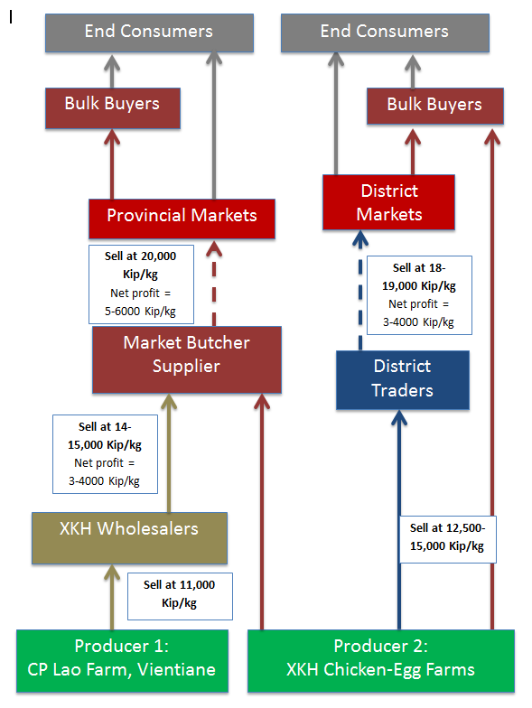**

**Traders’**

**Houses**

**8.3 XKH Province Hybrid Chicken Farm Producer: Hybrid Egg-Laying Hens (for Meat)**

|  |  |  |  |  |  |
| --- | --- | --- | --- | --- | --- |
| **No.** | **Supplier**  **(Market**  **Share %)** | **Location** | **No. Chickens** | **Avg Chicken Sales per Month** | **Price per chicken/kg** |
| **1** | **Viengsot Farm** | Ban Ngoi, Bpek | 20,000 | 1100 | 25,000 K/kg |
| **2** | **Titwai Farm** | 643 Area, Bpek | 1400 | 75 | 30,000 K/ chicken |
| **3** | **Farm Laai** | 643 Area, Bpek | 4000 | >220 | 30,000 K/ chicken |
| **4** | **Saejao Farm** | Ban Ngoi, Bpek | 6000 | >330 | 25,000 K/ chicken |
| **5** | **Farm Loem** | Phonsavan Dtai | 500 | 55 | 30,000 K/ chicken |
| **6** | **Ahui Farm**  **(Chinese-Owned)** | Phoukout  District | 20,000 | 1100 | 25,000 – 30,000 K/ chicken |
| **7** | **Military Farm** | 702 Area | 500 | 30 | 25-30,000 K/ chicken |
| **Total** | |  | **52,400** | **>2910** |  |

**8.4 XKH Consumer Hybrid Egg-Laying Hens (for Meat) Profile**

Consumers who purchase this variety of chicken often buy in bulk, either for businesses (restaurants or event functions) or personal use (also typically event organising). As this variety of chicken is the cheapest chicken variety on the market (both when comparing prices directly from farms and markets), low price is usually the main consideration for this consumer group, particularly given that the chickens are usually about 18 months old and therefore the meat tends to be tougher and a lower quality.

***9. HYBRID CHICKEN EGGS***

**Xieng Khouang: Provincial Overview**

(including Bpek District)

Introduction

The hybrid chicken eggs which are produced on XKH farms make up nearly 100% of the XKH market supply of eggs (compared to native chicken eggs). In nearly all recorded cases, traders and distributors of hybrid eggs in XKH had purchased the eggs directly or indirectly from farms within XKH, with one example of eggs purchased and transported from Vientiane.

**9.1 XKH Province Hybrid Eggs Profile**

|  |  |
| --- | --- |
| **Hybrid Eggs** | |
| **Provincial Supply of Eggs/Month (trays)** | 43,975 |
| **Hybrid share of Province Egg Market** | >99% |
| **Provincial XKH Market Price per Kilogram** | 18,000-24,000 Kip/kg |
| **Supply Variations** | 20% increased supply in rainy season (May to September) |

**9.2 XKH Province Hybrid Eggs: Value Chain**

The larger hybrid chicken-egg producer farms tend to deliver eggs to provincial market traders at the provincial markets in Phonsavan and also to the district traders at the district markets around XKH province. However, where these farms do not deliver to certain traders – either because quantities are too small for the farm to deliver, there are separate egg distributors who buy hybrid eggs from the producer farms and then provide to other provincial market traders, district traders or other retail outlets typically for about 2000 Kip more per egg tray. Provincial market traders then sell the eggs at their retail outlet at the Provincial markets to bulk buyers and end consumers. District traders also sell to bulk-buyers and end consumers in their given district. Both provincial market traders and district traders typically make between 3000-4000 Kip profit per tray before any expenses are factored in. Due to difficulties of accessing food in the rainy season – particularly in the countryside, hybrid egg supply increases by about 20% between May and September.

**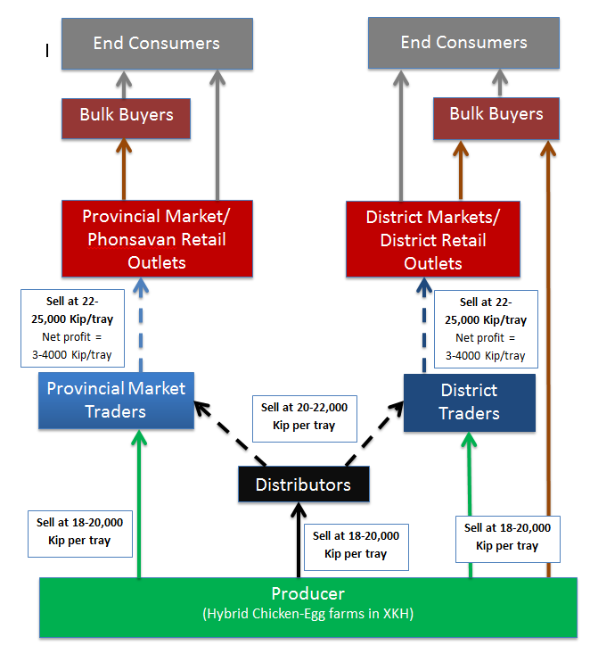**

|  |  |  |  |  |  |  |
| --- | --- | --- | --- | --- | --- | --- |
| **1** | **Supplier**  **(Market Share %)** | **Location** | **No. Chickens** | **Trays/ month** | **Distribution** | **Price per Tray** |
| **2** | **Viengsot Farm** | Ban Ngoi, Bpek | 20,000 | 16,000 | Sends to Bpek, Phoukhout & Nong Het | 18-22,000 Kip |
| **3** | **Titwai Farm** | 643 Area, Bpek | 1400 | 900 | Sends to Bpek, Lak 20. Kham traders collect | 22,000 Kip  (25,000 Kip for big eggs) |
| **4** | **Farm Laai** | 643 Area, Bpek | 4000 | 3400 | Traders buy at farm | 23-24,000 Kip |
| **5** | **Saejao**  **Farm** | Ban Ngoi, Bpek | 6000 | 4800 | Sends to Bpek and Khoun | 21-24,000 Kip |
| **6** | **Farm Loem** | Phonsavan Dtai | 500 | 475 | Sends to Phoukham Market | 22,000 Kip |
| **7** | **Ahui Farm**  **(Chinese)** | Phoukout  District | 20,000 | 18,000 | Send to Bpek, Phoukout & Kham. Collectors from Hua Phan | 15-21,000 Kip |
| **8** | **Military Farm** | 702  Area | 500 | 400 | Bpek District, including Phoukham Market | 22,000 Kip |
| **Total** | |  | **52,400** | **43,975** |

**9.3 XKH Province Hybrid Chicken Farm Producer: Hybrid Chicken Eggs**

**XKH Farm Producers’ Market Share of Hybrid Chicken Eggs**

**9.4 Summarise District Profile (excluding Bpek District)**

|  |  |  |  |  |  |  |
| --- | --- | --- | --- | --- | --- | --- |
| **Trader Profile** | **Phoukhout** | **Phaxay** | **Khoun** | **Kham** | **Nong Het** | **Mok** |
| **No of Traders** | 3-5 | 3 | 5 | 3 | 3-5 | 2 |
| **Supply Sources** | Viengsot and Ahui | Viengsot,  Phoukout,  Vientiane | Viengsot and Ahui | Laai Farm | Viengsot | Viengsot and Ahui |
| **Point(s) of Sale** | Nong Het Market, Retail Points, Village Markets | Phaxay Market, Retail Points | Khoun Market, Retail Points, Restaurants | Kham Market, Retail Points | Nong Het Market, Nam Khan Border, Retail Points | Mok Market, Retail Points, Restaurants |
| **Buying Price/ tray** | 21,000 Kip | 22-25,000 Kip | 21,000 Kip | 22,000 Kip | 21,000 Kip | 21-22,000 Kip |
| **Selling Price** | 24,000 Kip | 25,000 Kip | 25,000 Kip | 24,000 Kip | 24,000 Kip | 28,000 Kip |
| **Profit/tray** | 3000 Kip | 3000 Kip | 3000 Kip | 2000 Kip | 3000 Kip | 6-7000 Kip |
| **Total Estimated trays/month** | 600-2000 | <1100 | >480 | 600-1200 | 600-1800 | 150-300 |

**9.5 Hybrid Eggs Consumer Profile**

As these eggs have a monopoly on the Xieng Khouang market, nearly all types of consumers – for business or personal use – buy and use these eggs on a regular basis. Native eggs are sometimes used in more well-known restaurants and noodle shops (but this is minimal) – and eaten by families who raise chickens. However, consumers asked specifically about chicken eggs stated that, given the choice of eating hybrid or native chicken eggs, the choice would always be native eggs because they are considered much tastier and generally higher quality. The main restricting factor is the price – often between 1500 and 2000 Kip per native egg compared to about 800 Kip per hybrid egg – along with minimal supply (as chicken raisers tend to use their own eggs rather than sell). The suggestion was that, if there was a way to increase native egg supply at a lower price (around 1000 Kip per egg) then there would certainly be consumer demand for native eggs in XKH.

***10. OVERALL CHICKEN MARKET FINDINGS AND ANALYSIS***

**10.1. Market Supply and Demand Share**

**10.1.1 XKH Province Chicken Type Market Share**

Based on calculating monthly market supplies, native chicken varieties (including black-boned natives) currently control about one-quarter of Xieng Khouang Province’s market share. According to various market traders, their market share has decreased over the last few years as more hybrid varieties have been sold on the local market (coming from both large-scale farms in Vientiane small and medium-scale farms in Xieng Khouang). With the possibility of more hybrid farms to start up in the province – including ‘CP Lao’ Company’s aim to start hybrid farm production in Xieng Khouang in the future – there is the possibility that the native chicken market share may reduce further. Whether increased supply of hybrid varieties on the local market would actually cause a decrease in native chicken market demand and supply remains to be seen.

|  |  |  |  |  |
| --- | --- | --- | --- | --- |
| **No.** | **Chicken Type** | **Average Provincial Sales of Chicken** (birds) | **Average Provincial Sales of Chicken** (kg)**\*\*** | **Share of XKH Market** (%) |
| **1** | **Regular Natives** | 6825 | 9756 | 22.0 |
| **2** | **Black-Boned Natives** | >900 | 1080 | 2.9 |
| **3** | **Hybrid Meat-Chickens**  Produced in VTE | 11,000 | 13,200 | 35.5 |
| **4** | **Hybrid Meat-Chickens**  Produced in XKH | 700 | 840 | 2.3 |
| **5** | **Packaged Hybrid Chicken Meat**  **(Chicken CP)** | 6330\* | 7600 | 20.4 |
| **6** | **Hybrid Egg-Laying Hens (for Meat)**  Produced in XKH | 2910-3245 | 6003 | 10.5 |
| **7** | **Hybrid Egg-Laying Hens (for Meat)**  Produced in VTE | 2000 | 3700 | 6.4 |
| **Total** | | **>31,000** | **>42,179** | **100** |

\*Not a direct comparison as this includes various chicken cuts and not only whole chickens

\*\*Based on average market weight per chicken

**XKH Chicken Type Market Share**

**10.1.2 Sources of Regular Native Chickens for Market Supply by XKH Districts**

The estimated production of native chickens for market supply in Xieng Khouang by district shows that Phoukhout has the highest supply share at about 31%. Some main reasons for this are the accessibility of the area, relatively low chicken buying prices for in-district traders and cross-district traders, active village day markets in the district (6-7 in total), and a number of villages who have adopted TABI chicken-raising program methods to some degree which have helped target families increase their supply of native chickens. Other districts’ chicken production is between 10 and 14% of the XKH market supply each district except for Mok District supplying only 6% (which is the most remote district and the one furthest away from end consumer points of sale) and Nong Het with 18% (largely due to its proximity to Vietnam and the demand for native chickens from Vietnamese traders.

|  |  |  |  |
| --- | --- | --- | --- |
| **District** | **Chicken Quantity (birds)** | **Average Chicken Quantity (kg)** | **Share of Provincial Supply (%)** |
| **Bpek** | 920 | 1104 | 14.2 |
| **Phoukhout** | >2000 | >2400 | 30.8 |
| **Phaxay** | 500 - 800 | 780 | 10.1 |
| **Khoun** | 600 – 750 | 819 | 10.5 |
| **Kham** | 610 – 850 | 876 | 11.2 |
| **Nong Het** | 900 – 1400 | 1380 | 17.7 |
| **Mok** | >360 | >432 | 5.5 |
| **Total** | **5890 - 7080** | **>7791** | **100** |

**10.1.3 XKH Province Consumer Points-of-Sale for Regular Native Chickens**

Overall data collected on native chicken points-of-sale in producer villages and market locations, suggests that provincial markets in Phonsavan (Phoukham, Sam San and Nam Ngam) are the biggest consumer points-of-sale in Xieng Khouang with an estimated 59% of native chickens sold there. Vietnam traders, who buy native chickens from both cross-district traders and Lao producer villages (in Nong Het and Mok Districts) are thought to make up a fifth of ‘consumer’ points-of-sale in Lao, with native chickens sold to end consumers in Vietnam. A final one-fifth of native chicken supply is thought to be sold to consumers at district markets, village day markets and also sold directly to various other bulk buyers (such as event organisers and restaurant owners) where there may be a large number of point-of-sale locations.

|  |  |  |  |
| --- | --- | --- | --- |
| **Consumer Point-of-Sale** | **Chicken Quantity (birds)** | **Average Chicken Quantity (kg)** | **Share of Consumer Market (%)** |
| **Provincial Markets**  (Phoukham, Sam San, Nam Ngam) | 4020 | 4824 | 59.3 |
| **Vietnamese Traders** | >1400 | >1680 | 20.7 |
| **District/Village Markets & Other** | 1355 | 1626 | 20.0 |
| **Total** | 6775 | 8130 | 100 |

**10.2 Market Supply, Demand and Obstacles**

Market observation and information from in-district traders and cross-district traders at the provincial and most district markets were in agreement that current consumer demand for native chickens was higher than what the current market could supply and therefore they wanted chicken producers in district villages to increase the quantities they raise and sell. These traders were not sure how much supply could be increased by but often state that they are only able to buy about 60 percent of the supply they want to buy in villages. These traders also stated that increased chicken supply in each household and village would mean they would be able to spend more time selling at the market due to less time searching to buy native chickens in villages. As a result of the difficulties of supplying native chicken, this currently also reduces the possibility for traders to buy native chickens in bulk - such as for restaurants and large scale events as supply can often not be guaranteed. Subsequently, low supply can also increase prices per chicken and, while that may maintain a profit for traders in the short term, the low demand and subsequent higher price may encourage more regular native chicken consumers to start purchasing hybrid varieties instead.

This compares to all other hybrid chicken versions – slaughtered hybrid meat-chickens, packaged hybrid meat-chickens and hybrid egg-laying hens (for meat) – which can currently always meet current demand and, where there are bulk purchases at short notice, these can all be arranged within a one to two day notice at the same standard price.

**10.3 Consumer Opinions and Decision-Making**

The majority of chicken consumers at market locations in Xieng Khouang – both those who buy native or hybrid varieties - consider native chickens to be the highest quality breed with the better taste/flavour. Many consumers seem to be aware and care about the way chickens are raised (i.e. factory vs. free range; use of “chemicals” vs. organic). However, when balancing this against the price of native chickens, which are about at least 50% more expensive than hybrid varieties (along with issues relating to lower supply of natives and, to some consumers, the inconvenience of having to slaughter, pluck and butcher their own chickens) the option to buy hybrids still outweighs the above benefits of buying native chickens, or at least reduces the quantities of native chickens they would otherwise buy.

Consumers were asked hypothetically, if changes could be made to address these native chicken decision-making issues by increasing supply, offering both live and slaughtered chickens, and selling native chickens at only 20-30% more expensive than hybrid versions, would they be more likely to buy native chickens. Most individual consumers and some bulk buyers stated that they would be interested to very interested if this could be established. However, other bulk buyers stated that they would likely still buy hybrid versions due to the fact natives would still be more expensive than hybrids.

**10.4. Overall Obstacles to Increasing Native Chicken Supplier Income**

Assuming that the overall aim is to increase income for native chicken suppliers, the data collected shows that the two main obstacles to maintaining and/or increasing the native chicken market supply is **1. The current low supply of purchasable native chickens in XKH villages** **and 2. The buying and selling price of native chickens**. These two obstacles are causally related and have a number of identified reasons, as detailed below:

10.4.1 Low Supply of Purchasable Native Chickens in XKH Villages

Most producer households and villages in Xieng Khouang’s district will raise some native chickens. However, considerations of chicken age, health, appearance, supplier’s desire to sell, price and trader’s ability to find suppliers can all affect the in-district and cross-district traders’ efforts to buy a sufficient quantity to sell at the market. Factors which can directly or indirectly lead to lowering a trader’s supply of chickens include:

**10.4.1.1 Chicken Death**

Chicken death is by far the biggest drawback for in-district and cross-district traders, as well as the main loss of potential income for chicken producers. The main causes of chicken deaths in Xieng Khouang villages are various chicken diseases (although the chick mortality rate from cold weather and death from predators are also important areas for consideration). Without exception, all villages which were visited as part of this research - where no disease preventative measures were taken - had lost chickens through death from disease. Many producers reported times when chicken quantities in households, villages and even whole areas were entirely wiped out and, as a result, they lost potential income of selling to these traders. The unpredictable nature of chicken diseases was also a big factor as many producer villages lost most of their chicken quantities at times when consumer demand was highest – particularly October to April, when the Hmong and Lao New Year, rice harvest and various weddings and parties take place. This means that, villages where the traders typically have a guaranteed supply of chickens - where they bought from producers regularly - can lose all their chickens in a very short space of time. The trader then has to try to find new source villages, often in completely new supply locations if the disease has affected and killed many chickens in that area. This can increase the trader’s time and expenses trying to find new chicken producer areas and villages. If it can be assumed that native chickens are usually brought to market at about 6 months’ old, then that means it will take several months before in-district and cross-traders will re-enter and buy from the village.

**10.4.1.2 No Necessity/Pressure to Sell**

One of the frustrating aspects for in-district and cross-district traders when buying from chicken producer families and villages is that many current chicken producers in XKH districts do not have a necessity to – or feel they must - sell their chickens. Many producers raise chickens knowing that they may have the opportunity to sell them but equally they can consume or give away their chickens. Many producers perceive chicken raising as a non-investment activity and therefore they are not losing any investment by not selling them. Additionally, the window of opportunity to sell their chickens is quite big (i.e. they could sell chickens at 4, 5 or 6 months of age – or older). Therefore they do not feel pressured into selling at any one time and will only sell to traders or consumers at a price which the producers are happy with. This is a problem when traders spend much of their time in villages where they think there is a high chicken supply where actually sometimes there is minimal interest from producers to sell their chickens. However, data collected in TABI program target villages shows that household producers, who are market-oriented, can make a good income from raising chickens and appear to provide a larger supply to in-district and cross-district traders than other non-target households. Therefore, it depends on the awareness and willingness of producer households to take a more market-oriented approach to chicken raising.

**10.4.1.3 Lack of a Systematic Approach**

The more experienced market traders (particularly cross-district traders) tended to be able to obtain the largest supply of chickens from producer villages – sometimes up to 4 times more than less experienced traders. When asked why they were so good at finding chickens, these traders stated that over the years they had built up a network of native chicken producers in different districts (mainly Bpek, Phoukhout, Phaxay and Khoun). This allowed the trader to guarantee the supply and price of chickens in a village before spending time and money to get there – even ‘reserving’ chickens in advance typically through phone contact. If contacted villages did not have chickens at that time, they would contact and go to other villages where there were chickens. This approach is mutually beneficial for the trader and producer as they worked together to gain income. However, the majority of cross-district traders are less experienced and, whilst they may have a small network, it is not sufficiently big to guarantee chicken quantities on a regular basis and, as a result, cross-district traders often have to go into villages ‘blindly’ to try to find chickens to buy. This therefore reduces the traders’ potential supply, increasing fuel expenses and taking away potential time from selling at the market. Additionally, although some traders work in small groups with friends and family, most work competitively against each other. The lack of working together in a systematic approach minimises the potential for traders to buy together in bulk quantities from each village – something which may also be beneficial for chicken producers. Finally, there are no current large-scale native chicken farms in Xieng Khouang – or any wholesaler of native chickens – where cross-district traders can purchase their chicken supply.

10.4.2 The Buying and Selling Price of Native Chickens

The high price of native chickens was identified as being a big decision-making factor for consumers choosing to buy native chickens over lower-priced hybrid versions. Three identified reasons for the high price of native chickens in XKH are as follows:

**10.4.2.1 Trader Profit and Expenses**

Native chickens are typically sold at 25,000-30,000 Kip/kg in Bpek, Phoukhout, Phaxay and Khoun Districts and, after cross-district trader expenses (fuel costs, market stand, etc.) traders report a 5000 Kip profit – although, as they sell chickens at 40,000-45,000 Kip at the provincial market – it is possible that their profit is actually higher. However, these traders often buy for a higher price from producers, forcing them to increase their market price when they sell their purchased chickens. It should also be noted that, whilst native chickens cost very little to raise naturally, most producers who do invest in chickens (i.e. build chicken coops, purchased vaccinations, etc.) usually increase their selling price to reflect the investment – rather than reducing cost due to a potential higher supply of chickens.

**10.4.2.2 Lack of Supply**

If producer households have fewer chickens to sell, they will typically increase the price. Additionally, where producer villages have previously sold to other consumers (i.e. short term workers in the area) for a higher price than cross-district traders normally pay, the village often sets that as the new benchmark price, meaning these traders have to make the decision to either buy at the higher price or stop buying from that village altogether.

**10.4.2.3 Inflation from Vietnamese Demand**

Another longer term reason for higher native chicken prices may be the demand from the Vietnamese market. In Nong Het and Mok Districts, Vietnamese traders are able to purchase chickens at nearly double the price which in-district and cross-district traders pay when purchasing from chicken producers. Therefore this creates demand at district and provincial market level to buy chickens to sell to Vietnamese traders. While this is potentially good, one problem is that if more native chickens are bought by Vietnamese traders, it can reduce the supply of chickens for consumers in XKH, and consequently, the lower supply can also increase XKH buying prices for native chickens.

**11. RECOMMENDATIONS**

**11.1 Regular Native Chickens**

In order to increase the long-term income benefit for native chicken producer families from the sale of chickens, the two most important forms of action to maximize the potential of achieving this are **increasing the** **supply of native chickens for markets** and **using marketing approaches to understand and increase consumer demand**. This action should help to lower the overall cost of native chickens (for all traders and consumers) and, as a combination of increased supply and lower pricing, this could allow an increase in consumer demand. Looking over the longer term, increased consumer demand and sales from native chickens should help the Xieng Khouang native chicken value-chain to become increasingly efficient through more organized and systematic approaches to buying and selling, as well as opening up new potential markets to sell native chickens to. As a result, this could be the stimulus for other forms of value chain development and diversification for native chickens in the longer term, similar to the value chains of the hybrid chickens sold in XKH.

**11.1.1 Increasing the Supply of Native Chickens for Markets**

Action from both producers and in-district and cross-district traders – often jointly – will be required to help increase the supply of native chickens in producer households and villages for selling at Xieng Khouang markets. This will include focusing on:

1. Reducing the risk of chicken disease contraction (and other causes of chicken deaths)

2. Raising producer awareness of the potential income benefit of selling chickens

3. Implementing a more systematic value-chain approach to buying and selling chickens

**11.1.1.1 Reducing the Risk of Chicken Disease Contraction (and other causes of chicken deaths)**

The reduction of chicken diseases by promoting the use of disease prevention is by far the most crucial step which needs to be taken to consolidate and guarantee the regular supply of native chickens in XKH. This will mean the continuation of chicken-raising support programs – such as that undertaken by TABI in target villages which encourage the use of methods to prevent and treat chicken diseases - but with a few additional recommendations:

* Ensure training recipients have a thorough understanding of why they are doing the training and why they should adopt these methods. This will mean trying to show them how preventing disease will help increase and maintain their chicken supply, which they can regularly sell to increase their income. This should be at the core of any training and should possibly be integrated with other training such as methods to sell chickens, work with traders, understand income and expenses, etc. Therefore it is crucially important for training providers to also have a holistic understanding that the purpose of disease prevention is ultimately for supply families to increase their income.
* Following on from above, allowing training recipients to see and understand local village or family examples where using disease preventative methods (and other chicken-raising methods in general) have directly benefitted increased chicken supply and income. A possible method for this may be recording a short filmed interview with example families/villages which can be shown in target villages to show a real life example of the connection between disease prevention methods and increasing income. This could help provide target families with a vision of what the potential is and how the process works. Possible example villages and families could be Khangpanien village in Nong Het District (which has previously been featured on Lao news for its chicken-raising methods) or Naxaythong village in Phoukhout District.
* In order to encourage target families to start vaccinating once they have been shown training, it may be worth considering providing vaccines at a subsidized rate or free of charge for the first few months (if storage is available in the village). Then afterwards, the training recipients should be able to buy vaccines with the income they make from chickens. Subsidized or free vaccines should not be a long term aim but it may encourage villagers to commence using them and allow them to use them long enough to see the benefit (i.e. healthier chickens) – and also to retain the techniques (as previously many training recipients did not start vaccinating, therefore they forgot the technique and often later regretted not vaccinating when they saw the their chickens dying from disease).
* To ensure that the chicken-raising training methods to prevent disease are highly effective when carried out properly, it would be beneficial to choose target households in a village or whole villages where training methods are guaranteed to be implemented fully (i.e. vaccinations). This may even mean technicians carrying out the vaccinations themselves at the necessary vaccinating times. The purpose of this is to use the target households/villages as ‘prototypes’ to ensure that there are no flaws in the disease prevention methods. In other words, if vaccinations and other disease preventative methods are implemented comprehensively but chickens are still dying from disease in these households, then it would suggest there is a fundamental flaw in the disease prevention method which villagers have been being trained in, and therefore the training methods would then need to be reassessed.
* Given that many villages reported losing a high number of chicks in the cold season, training to show villagers how to protect chicks during cold weather could be included within the chicken-raising training methods.
* There should be organized following-up from agricultural technicians for training recipients to see if methods are being adopted and, if not, gaining an understanding of the obstacles to adopting these methods (also a possible area for further research) with an aim to address any identified problems during the following up. There should also be an effective line of communication so that if the technicians do not have the ability to address identified problems, they can quickly raise the problems to personnel who do have the ability to address them.
* Unless chicken producers are selling to consumers directly, in-district and cross-district traders are the people who have most interest in producers being able to raise chickens effectively. Therefore it might be worth considering training these traders with some chicken-raising methods which they can then train to producer households and villages, in order to help them increase chicken supply, which the trader can then purchase from them.

**11.1.1.2 Raising Producer Awareness of the Potential Income Benefit of Selling Chickens**

Whilst it is entirely the choice of producers whether they want to sell chickens to in-district and cross-district traders and consumers, and at what price, it may be advantageous to consider ways to help show producers how a higher chicken supply and a more standard selling price could benefit them more in the long term. Possible ways of doing this are as follows:

* Providing target households/villages with simple, business and profit-oriented training to help them understand concepts such as profit and expenses, economies of scale, etc. which may help them to raise and sell more chickens. This could be done using tangible and easy-to-understand examples of the expenses and income associated with raising and selling chickens. This could also be included within the chicken-raising methods training.
* In villages where there appears to be little interest in raising chickens to sell, it may be beneficial to find at least one target household who would be interested in raising chickens to sell. Providing that traders would be willing to buy from this household producer, this could then provide an example to other households in the village whether raising chickens to sell is beneficial and increases household income.

**11.1.1.3 Implementing a More Systematic Value-Chain Approach to Buying and Selling Chickens**

A more organized and systematic approach to buying and selling native chickens between producers, traders and consumers in XKH could help to guarantee producers that they will be able to sell chickens. This could therefore encourage household producers to raise and sell more chickens and the likelihood that traders will buy from them at a fair price for both buyer-sellers. This should help make the value-chain more increasingly more efficient and over time continually help to increase native chicken supply and reduce chicken prices. The following recommendations are separated for producers and traders, although requires significant partnership between the two buyer-seller groups:

**Native Chicken Producers**

* In addition to disease preventative measures, encouraging the building of cheap-but-strong chicken coops should reduce chances of chicken death (from disease, cold or predators) and help producers maintain a consistent supply. In time, if there is a constantly increasing demand for native chickens from traders and consumers, there may even be the potential for households and villages to look at further systematic raising approaches – such as artificial insemination and use of egg incubators – where producer households or villages aim to expand their production of chickens.
* In producer villages where traders come to buy chickens less frequently or not at all (usually due to remoteness), it may be beneficial for producers and traders to coordinate the bulk-selling and buying of chickens at set periods of time. This may be the best approach to encourage such producer villages to maintain a chicken production and still gain an income from selling chickens. Bulk selling could also be more beneficial for traders as they will have a guaranteed supply and could save them considerable time searching to purchase chickens.
* Allocating one person per village or area (ideally the chicken head member if there is one) who can act as the main chicken producer representative in the village regarding the sale of chickens to in-district and cross-district traders. This person would be the first point of phone contact for these traders who want to enquire about the village’s current quantity and price of chickens before deciding whether to travel and buy from that village. It could also be the role of the representative to actively ‘seek out’ in-district and cross-district traders at provincial and district markets through networking and providing contact information (or a list of village/area contacts) and the location of the village – perhaps even taking the trader to the village so the trader knows where it is, in order to encourage them to travel and buy from that producer village in the future.
* Village day markets seem to be a successful centralized location where producers can sell to in-district and cross-district traders so there may be potential to increase either the number of markets or number of days they are held.

**Native Chicken Traders** (in-district and cross-district traders)

* Promoting the building of good business relationships between producers and traders will increase trust and that could encourage traders to buy from the producer household or village on a regular basis. This could include the exchanging of phone numbers between the two groups, having occasional meetings with village producers to look at how each group can assist the other and, as previously stated, if traders were taught in some basic chicken-raising methods, they could demonstrate these to producer households and villages.
* Assess whether there is future potential benefit from having a wholesaler who buys from the producer and sells mainly to cross-district traders. The main role of the wholesaler could be to buy from producer villages and then to sell to cross-district traders from a centralized, accessible location within XKH. This could mean that traders would be guaranteed to purchase chickens albeit at a slightly higher rate than they would buy in small-scale producer villages. However, buying from a centralized wholesaler could significantly reduce their fuel expenses and time and therefore traders would have more time to sell chickens to consumers. Alternatively, there may be the possibility of an investor setting up a medium-scale native chicken farm in XKH (most likely as a business but possibly as a cooperative). The operators could also purchase native chickens from village producers around the province to supplement their own supply of chickens for traders to buy.

**11.1.2 Using Marketing Approaches to Understand**

**and Increase Consumer Demand**

Whilst an increase in the supply of native chickens, along with a subsequent lowering of price may help to stimulate an increase in native chicken customer demand, marketing is another important consideration to achieve this objective. Recommendations for marketing approaches are:

1. Branding and Promotion

2. Market Research

3. Product Development and Diversification

**11.1.2.1 Branding and Promotion**

Branding and promotion are likely to be important methods to increase consumer product awareness, distinguish native chicken from hybrid varieties and increase overall consumer demand by:

* Designing and building a product brand or trademark for native chickens from Xieng Khouang. This should focus on its unique selling points and the features which mark native chickens as distinct from hybrid chicken varieties. This should include branding native chickens as a higher quality product compared to the hybrids and associate the brand with concepts such as ‘local’, ‘native’ and ‘free-range’. ‘Organic’ is another possible association to use but will depend on the ability to control and guarantee organic production – therefore this branding should possibly be developed at a later stage when organic chickens are specifically raised and promoted for consumer purchase.
* Once the brand has been developed and established, consideration should be given to the marketing channels which could be used to promote the native chicken brand. This may include the use of native chicken trademark signs at market locations where both live and slaughtered native chickens are being sold. This could serve not only as a promotional tool but could also help consumers to distinguish and understand the difference between native and hybrid varieties of chicken. Such trademark signs could even be given to chicken producers to display at their houses in their villages. This could not only help the overall promotion of native chickens in the province, such logos could also help traders who have come to buy chickens in the village to identify which houses have – and are willing to sell – chickens. Other possible marketing channels within Xieng Khouang may include farmers’ markets, livestock festivals or any agricultural or Xieng Khouang based events which allow the opportunity to promote local produce.
* Product promotion and branding should continually develop to correspond with any native chicken product diversification at later stages of production – such as if native chickens were ever sold as packaged products like Chicken CP.

**11.1.2.2 Market Research**

Further market research aimed at consumers and consumer demands should further help to explore the potential for product diversification in current markets and product expansion into new markets, particularly at more advanced stages of product development. This may include large-scale market surveys to try to understand potential demand for packaged native chicken meat, prices consumers would be willing to pay for the product and also producing product prototypes where consumer data could be collected to assess whether consumer feedback has been positive or negative.

**11.1.2.3 Product Development and Diversification**

Once native chicken supply has sufficiently increased to meet consumer demand – and ideally when chicken prices per kilogram have reduced sufficiently for other native chicken meat productions to become financially viable, there may be potential to diversify and native chicken products to consumers with an additional aim to sell native chickens to bulk-buyers (restaurants, event organisers, etc.). This may include copying some of the ways in which hybrid chickens are sold in local markets, or looking to develop niche native-chicken products.

Native Chicken meat-product diversification may include:

* **Increased selling of slaughtered, plucked and removed-giblet chickens for provincial market sale** (currently done using 80% hybrid meat-chickens and 20% native chicken supply at provincial markets).
* The same as above but also **packaging the whole chicken** to sell at retail outlets with fridges/freezers.
* **Butchering and packaging chicken meat parts** (chicken breast, thighs, legs, wings and feet) – similar to Chicken CP’s packaged products.

Native Chicken Products diversification may include:

* **Organic chickens**
* **Black-Boned Chickens\***
* **Native Egg Production\***

\* Recommendations for these two products are in the following section.

**11.1.3 Stages of Native Chicken Market Development**

In addition to aiming to increase native chicken supply, use marketing to increase consumer demand and diversify native chicken products to help develop the native chicken value chain in XKH, the process of how to develop the value chain within the market context is important to consider – from short term to long term strategies of development. The following model is an example of how native chickens might develop in the marketplace – either locally or on a wider scale. This may not require an entirely linear approach but it is likely that would this would allow some stages to be consolidated before further development is taken.

**Increased Native Chicken Market Supply**

(Reducing risk of disease, encouraging supply & systematic approach)

**Lower Pricing**

(Resulting from increased supplier, easier trading

for traders and increased competition)

**Increased Consumer Demand**

(Resulting from increased supply, lower pricing and

promotional/ branding campaign)

**Increasingly Systematized Production**

(Sufficient supply and demand to increase diversification into processing and supply of native chicken products)

**Product/Market Diversification**

(Processing: slaughtering, plucking, butchering, packaging.

Developing niche products: organic and black-boned chickens; native eggs)

**Expansion of Supply for**

**Existing or New Markets**

(Using market research to evaluate consumer demand)

**Increasingly efficient value chain**

**Continued use of brand promotion**

**Bulk Buyers** (restaurants, event organisers)

**Local Retail Outlets**

**District and Provincial Markets**

**Potential Markets** (Vietnam, Vte, LP, etc.)

**11.2 Native Black-Boned Chickens**

Analysis from four produced villages which raise, or have previously raised, native black-boned chickens has identified that a market development strategy for this chicken breed should be divided into two market categories: the **Vietnamese market** and the **Lao market**.

**11.2.1 Vietnamese Market**

With over 90 percent of Xieng Khouang’s estimated nine-hundred black-boned chickens being exported to Vietnam by Vietnamese traders each month, this is an important current market for black-boned producers to receive income – particularly as selling prices are high at between 55,000 and 70,000 Kip per kilogram. Two recommendations regarding native black-boned chickens and the Vietnamese market are:

1. Consolidating supply of black-boned chickens in the well-established villages

2. Further research to understand current and potential consumer demand in Vietnam

**11.2.1.1 Consolidating Supply of Black-Boned Chickens in Well-Established Producer Villages**

The established black-boned chicken-producing villages of Khangpanien, Lawng Guang (Nong Het) and Samje (Mok) generally make good incomes from selling chickens to Vietnamese traders but, with quantities of 100-200 chickens per family (with a value of 6-12 million kip), these villages are extremely vulnerable to having their chicken quantities wiped out as, despite most households having chicken coops, few choose to vaccinate. The priority here should be to support these producer villages to protect their current supply – and also assess the potential for them to increase their supply of black-boned chickens for Vietnamese traders.

**11.2.1.2 Further Research to Understand Current and Potential Consumer Demand in Vietnam**

As part of assessing the potential to increase supply:

* Market research on Vietnamese markets – particularly those on the Lao-Vietnam border across from Nong Het and Mok districts – could be done to establish if there is further consumer demand for black-boned chickens, and understanding the obstacles to meeting such demand (i.e. chicken price per kilogram, the ability to supply an increased quantity, etc.)
* Consideration should possibly be given to trying to reduce the price of black-boned chickens bought by Vietnamese traders – such as through increased supply in Nong Het and Mok Districts – to try to stimulate increased consumer demand in Vietnam. However, care should be taken to ensure that this does not undermine well-established black-boned chicken producer villages.
* If there was found to be more Vietnamese consumer demand, other families in the established producer villages (or possibly new villages) could be encouraged to start raising black-boned chickens to sell to the Vietnamese market. This should include training in chicken-raising methods including disease prevention, basic accountancy and some marketing advice. Use of vaccinations should be more feasible for black-boned chicken producers as the income from these chickens is higher than regular natives (therefore they should be able to better afford to invest in raising methods).

**11.2.2 Local Market Potential**

As black-boned native breeds are quite well-known and well-reputed in Xieng Khouang, there is likely to be some consumer demand for market supply – mainly as a niche product. At the moment there is too little and irregular supply on XKH markets (provincial and district) for consumers to know when to expect them to be sold. Therefore, recommendations to test and possibly develop black-boned chickens on the local markets are:

* Choose a village with at least several target families willing to start raising black-boned chickens (possibly Laethong village in Phoukhout as they previously raised this breed to a small degree). The aim should be to try to raise a sufficient amount so that there are always several black-boned varieties sold on the local market at any one time (either district or provincial) and encourage producers to set a standardized price for selling to traders and consumers.
* Training should be given to these target families in chicken-raising methods - including disease prevention as well as some basic accountancy and business information.
* If demand for black-boned natives continually increases, the same model as detailed in the regular native chickens’ recommendations section (9.1) could be followed (i.e. increase supply, brand promotion, pricing, diversification and market expansion).

**11.3 Native Chicken Eggs**

Due to the near-100% monopoly which hybrid chicken egg farms have on the Xieng Khouang market - and the low net profit per native egg, it will be very difficult for producers or traders to sell native eggs on anything other than a small scale. Therefore the following three possibilities are ways in which native eggs could be supplied for a niche market in the province (and if these show that there is sufficient demand, more organized methods of selling and promotion could be developed at a later stage):

**11.3.1 Native Egg Producers Sell Directly to Restaurants**

Some local restaurants, including in Phonsavan, do have a preference for native chicken eggs but cannot always source them easily. Therefore the best option would be for egg producers to check with local restaurants to see if they would be interested in a regular supply at a reasonable price (i.e. 1000-2000 Kip). That producer could also collect from other households in the village to sell. If demand is high, there may be potential to increase supply.

**11.3.2 Native Chicken Cross-District Traders also Purchase Native Eggs**

As cross-district traders are going to villages to buy native chickens regularly, it may be feasible for them to purchase native chicken eggs from the producer at the same time. Then they could sell the eggs along with their supply of chickens at their market location, perhaps with a small advertising sign. If they do it regularly enough, they may get well known for it and more consumers may buy eggs from that trader.

**11.3.3 Native Chicken Meat and Egg Producer Farm**

If there are ever any small to medium-scale native chicken producer farms for meat, there may also be potential to supply eggs as well from the same location. Similarly to the example with a native chicken meat producer farm (in section 9.1), such a farm could also supplement their supply of native chicken eggs for XKH market locations by purchasing native eggs from villages who raise native chickens.

**12. APPENDIX**

**Appendix 12.1: Provincial Market Data Collection**

(Phoukham, Sam San and Nam Ngam Markets)

**12.1.1 Live Native Chickens Sold at the Phoukham Market**



**12.1.2 Live Native Chickens Sold at the Nam Ngam Market**



**12.1.3 Slaughtered Chickens Sold at the Phoukham Market**



**12.1.4 Slaughtered Chickens Sold at the Sam San Market\***

\* No slaughtered native chickens were observed during 14 days data recording at Sam San Market



**12.1.5 Slaughtered Chickens Sold at the Nam Ngam Market**

\* No slaughtered hybrid egg-laying chickens were observed during 14 days data recording at Nam Ngam Market



**Appendix 12.2 Chicken Sellers Template** (Compacted)

**District ……..……………. Market …………………. Chicken Type……………………**

**Buying price per kilo**………………………………………….... **Selling price per kilo** ………………………………….…….……..

**Seasonal Price change(s):** Buy………………………………………………. Sell…………………………………………….…….……..

**% Seasonal Supply/Demand change:** Dry ……………………….Hot………………………….Rainy……………………….…

**Average weight of chickens at market**………………………………………………………………………………………………….…

**% of chickens from**: Bpek……………………. Phoukhout…………………………. Khoun ………………………………….…..

Kham ………………………………….. Nong Het…………………………………………. Mok………………………………………….…..

Other location?............................................................%................................................................................

**If Phoukhout, which village(s**)………………………………………………………………………………………………………….……..

**Other Sales Outlets?**

1 ………………………………………… No. Kg per month:……………………………Selling Price (kg)……………………………….

2 ………………………………………… No.Kg per month:……………………………Selling Price (kg)……………………………….

3 ………………………………………… No. Kg per month:……………………………Selling Price (kg)……………………………….

4 ………………………………………… No. Kg per month:……………………………Selling Price (kg)……………………………….

**Method(s) of Purchase**

1…………………………………..……………………………………………………………………………………………………………………..….

**Customer Profile** ………………………………………………………………………………………………………………………………..…….

**Average chickens sold per month** (per seller)………..………………………………………………………………………..……..

**Costs of Selling**: transport…………………………………..……………market stand…………………………………………………

feed……………..…….………………………………….other…………………………………………………………….

**What are the main obstacles/problems to selling chickens for the seller** ……………………………………………………

**What would help you the most as a seller?**

………………………………………………………………………………………………………………………………………………………..…..……

**Other Info**

…………………………………………………………………………………………………………………………………………………………..……..

**Appendix 12.3 Egg Sellers Template** (Compacted)

**District ……..……………. Market …………………. Egg Type……………………**

**Buying price per tray**……………………………………….... **Selling price per tray** ………………………………….…….……..

**Seasonal Price change(s):** Buy………………………………………………. Sell…………………………………………….…….……..

**% Seasonal Supply/Demand change:** Dry ……………………….Hot………………………….Rainy……………………….…

**Average no of trays sold per day**………………………………………………………………………………………………………….…

**% of chickens from**: Bpek……………………. Phoukhout…………………………. Khoun ………………………………….…..

Kham ………………………………….. Nong Het…………………………………………. Mok………………………………………….…..

Other location?............................................................%................................................................................

**Other Sales Outlets?**

1 ……………………………………… No. trays per month:…………………………Selling Price (tray)…………………………….

**Method(s) of Purchase**

1…………………………………..……………………………………………………………………………………………………………………..….

**Customer Profile** ………………………………………………………………………………………………………………………………..…….

**Average eggs sold per month** (per seller)………..………………………………………………………………………..……..

**Costs of Selling**: transport…………………………………..……………market stand…………………………………………………

feed……………..…….………………………………….other…………………………………………………………….

**What are the main obstacles/problems to selling eggs for the seller** …………………………………………………………………………………………………………………………………………………………………

**Would you consider selling native chicken eggs if there was sufficient supply?**

………………………………………………………………………………………………………………………………………………………..…..……

**Other Info**

…………………………………………………………………………………………………………………………………………………………..……..

**Appendix 12.4 Native Chicken Counting Template (Phoukham Market)**

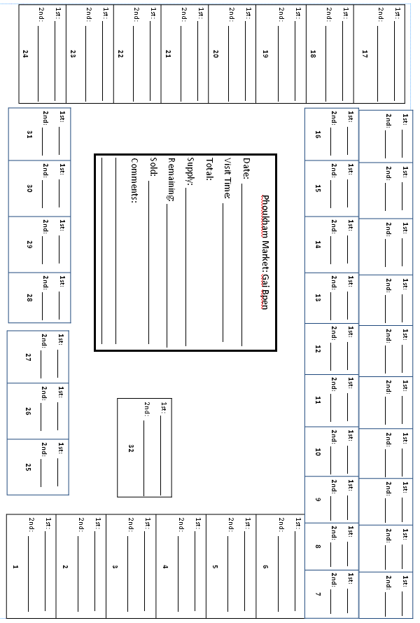

**Appendix 12.5 List of Xieng Khouang Markets by District**

|  |  |  |  |  |
| --- | --- | --- | --- | --- |
| ***List of XKH Markets and Days of Activity by District*** | | | | |
| No. | District | No. | Market Name | Market Days |
| 1 | Bpek | 1 | Sam San | Every day |
| 2 | Phoukham | Every day |
| 3 | Nam Ngam | Every day |
| 4 | Siibounheuang | Every day |
| 5 | Ladhouang | Sunday, Tuesday, Thursday |
| 6 | Ladkhaui | Thursday, Sunday |
| 7 | Khangkhai | Friday, Wednesday, Sunday |
| 8 | Nong Pet | Wednesday, Sunday |
| 9 | Ban Saang | Sunday |
| 10 | Khangvieng | Tuesday, Friday |
| 11 | Ladbuak | Unknown |
| 2 | Phoukout | 1 | District Market | Tuesday, Thursday, Saturday |
| 2 | Nam Chat | Friday |
| 3 | Nong Dtang | Monday, Wednesday…Every 2nd day |
| 4 | Vieng Ngua | Monday, Friday |
| 5 | Ban Loem | Tuesday, Saturday |
| 6 | Naxaythong | Wednesday |
| 7 | Ladyai | Wednesday, Sunday |
| 8 | Bpungman | Saturday |
| 3 | Khoun | 1 | District Market | Wednesday, Friday, Sunday…Every 2nd day |
| 2 | Meuang Dtan | Monday |
| 3 | Meuang Ngan | Every 2nd day in the week |
| 4 | Kham | 1 | Jawmtawng | Every day |
| 2 | Naabpaa | Wednesday |
| 3 | Phakae | Thursday |
| 5 | Nong Het | 1 | District Market | Saturday |
| 2 | Nam Khan Border | 10th, 20th and 30th day of every month |
| 6 | Phaxay | 1 | District Market | Sunday |
| 2 | Day Market | Unknown |
| 7 | Mok | 1 | Naakon (District Market) | Every day |
| 2 | Khang Vieng | Unknown |
|
|