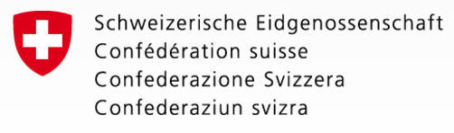

Sub Sector Working Group on
Farmers and Agribusiness (SSWG-FAB)

Agenda: Thursday, 03 October 2018

Venue: Meeting Room, Dept of Technical Extension and Agro-Processing (DTEAP)

08:30 – 09:00 | Coffee and Registration
09.00 – 09.10  10 min | Opening remarks and Introductions  Chair – Mr. Somxay Sisanonh, Director General, DOPLA/MAF  Co-Chair – Mr. Christian Engler, Deputy Director of Cooperation, SDC
09:10 – 10:00  30 min P  20 min D | Presentation of Draft Report on Rural Labour and Employment  This meta-study, carried out by the MAF Department of Policy and Legal Affairs, provides a synthesis of reports and data from 65 sources which has important implications for planning by both Government and donors. The report is titled “Towards ‘People Centered Agriculture’: Rethinking rural labour, youth employment and the agrarian transition in Laos”.
10:00 – 10:15  10 min P  5 min D | Update on the activities of the Lao Farmer Network  The Lao Farmer Network now has over 30 member organisations representing more than 4,000 farmers across the country. A summary of recent activities and plans will be presented by an LFN representative.
10:15 – 10:45 | Coffee break
10.45 – 11.35  30 min P  20 min D | Agribusiness and Climate Change  The current cropping season has included a drought, exceptional pest attacks and severe flooding. Climate change is playing a part in these developments, which makes us ask how Laos can promote climate-friendly agribusiness? This presentation is given by Dr Phanhpakit Onphanhdala, Deputy DG, Center for Enterprise Development and International Integration Policy, National Institute for Economic Research (NIER),
11:35 – 11:45  10 min | Update on development of new extension materials  A new video on management of Fall Army Worm will be shown, and progress of new print materials will be summarised
11:45 – 12.00  20 min | Closing remarks  Co-Chairs
12:00 – 13:00 | Lunch provided

Approximate timing: P = presentation, D = discussion

